Guess The Word

Louie Sherman

Contents:

**Analysis: 5**

Outline: 5

Stakeholders: 6

Stakeholder 1 - Monty Sherman: 6

Stakeholder 2 - Stuart Sherman: 6

Computational Methods: 6

**Research: 7**

Wordle: 8

Hangman: 9

Pictoword: 10

Research overview: 11

**Requirements: 12**

Client Requirements: 12

Home Menu: 12

Settings Menu: 13

Statistics Menu: 14

Victory Page: 15

Play Game Menu: 15

Game Page: 16

Hardware / Software Requirements: 19

Limitations: 19

Prototype 1: 20

Prototype 2: 20

Prototype 3: 20

**Design: 20**

**Overview of the Structure: 20**

**UI Design: 21**

Home Menu: 21

Play Game Menu: 22

Statistics Menu: 23

Game Page: 24

Settings Menu: 25

Victory Page: 26

Login Page: Extra 27

Explanation: 27

**Breakdown of the Structure: 27**

Player class: 27

Game class: 28

Settings class: 28

Database class: 28

Hint class: 28

**Database: 29**

**Algorithms: 29**

**Usability Features: 30**

**Test Data: 31**

Home Menu: 31

Play Game Menu: 31

Settings Menu: 32

Game Page: 33

Victory Page: 34

**Implementation - Prototype 1: 35**

**Instantiation: 35**

**Home Menu: 35**

**Play Game Menu: 37**

**Settings Menu: 38**

**Victory Page: 39**

**Game Page: 40**

Removed features: 40

Additional features: 40

**Game class: 47**

**Hint class: 49**

**Database class: 50**

**Player class: 51**

**Settings Class: 52**

**Errors: 54**

Victory Page Label Error: 54

Displaying the hidden word error: 54

Selecting default settings / updating them: 55

Secret hint display: 56

Game Page: 57

**Post Prototype Test Data: 58**

**Implementation - Prototype 2: 60**

**Database: 60**

**Database class: 61**

Text Files: 61

Class Code: 61

**Statistics Menu: 67**

**Game Page (Updates): 69**

**Victory Page (Showing Statistics): 75**

**Quit Buttons (Writing all text to file): 77**

**Errors: 77**

Most Successful Letter Word Error: 77

Fourth Hint Error: 78

Percentage of Wins Statistic Error: 78

Post Percentage of Wins Statistic Error: 78

Special Characters Input Error: 79

**Post Prototype Test Data: 80**

**Prototype 3 plans: 83**

**Implementation - Prototype 3: 83**

**Optimisation: 83**

Selectors: 83

Redundant code: 84

Combining labels: 85

**Visuals: 85**

**Hints: 86**

Reveal secret hint: 87

Reveal hint: 89

New hints: 91

Hint 7: 91

Hint 8: 93

Secret Hint: 94

Hint Consequences: 95

**Timer: 95**

**Customise Page: 98**

Design: 98

Customise Page Code: 98

Updated Play Game Menu: 98

Game Class: 102

Game Page (Updates): 103

Hint class: 105

**Game Page (Updates): 106**

Reset Random Word: 106

**Victory Page (Updates): 106**

**Keybinds: 107**

**New statistic - Streaks: 108**

**Errors: 109**

Reveal Hint Button Error: 109

Settings Menu Error: 110

Multiplying Factor Error: 110

Reveal Hint Button + Selector: 112

**Post Prototype Test Data: 112**

**Evaluation: 113**

**Post Development Testing: 113**

**Success Criteria: 115**

**Success Criteria Review: 118**

Essential Features: 118

Additional Features: 119

**Usability Testing: 121**

**Stakeholder Feedback: 121**

Universal feedback: 121

Older generation: 122

Younger Generation: 122

**Maintenance: 123**

**Limitations: 123**

**Future development: 124**

**Bibliography: 126**

**All Code: 127**

# Analysis:

### Outline:

My aim is to create a word guessing game - Guess The Word. This will allow people of all ages and intelligence levels to test their luck or even test out the user’s memory and knowledge of the English dictionary (in which the words will be used via a premade library / file). I believe that this programme (created in Windows Forms Application (WFA) will appeal to people who like problem-solving as well as solving problems with as few hints and help as possible (such as myself). Therefore I think this application will be of great value to those who wish to challenge themselves and lexophiles to test their knowledge of words. Guess the word will be more difficult than Wordle, will be a more innovative and fun challenge due to certain features of the application such as:

* Use of AI integration to find hints to assist you.
* A word limit (if triggered or requested) to increase the difficulty.
* An impossible (challenge) mode which limits the number of hints allowed and enables a word / time limit.
* An improved data analysis system will show you your quickest times, the letter word at which you are the best at guessing, the percentage of words you have guessed overall and many more.
* Hints include:
  + Giving the first / last letter of the word.
  + Reveal the number of characters.
  + Number of vowels in word.
  + Number of constants in word.
  + Most frequent vowel.
  + Reveal synonym(s).

In order to appeal to people of all age groups and intellect levels, I am going to give the user options to either select a hint or ask an AI for a random hint to make the user able to guess the word with ease. On top of this, the user will be able to choose how many letters they want the word to be at the start of the test, therefore giving the user more options and ways to guess the word, furthermore, it allows the user to increase / decrease the difficulty as they wish.

### Stakeholders:

#### Stakeholder 1 - Monty Sherman:

Monty is my brother and is a part of the younger generation. He is also a lexophile, meaning that he will be the perfect stakeholder for my Guess The Word programme. Monty will be able to give me valuable feedback and information about how difficult it is to guess the word with and without hints as well as test the difficulty of the ‘challenge’ mode, allowing me to alter the difficulty to perfect it. Due to my brother being a lexophile, he is also able to test out my hints and more specifically, the synonym hint which will be used in case anyone gets stuck on the word. Overall my brother will be my main and most valuable stakeholder for my project.

#### Stakeholder 2 - Stuart Sherman:

Stuart is my father and is a part of the older generation. Like my brother, he is a lexophile and completes crossword puzzles daily to widen his knowledge. Thus Stuart will be another perfect stakeholder for this programme. Like my brother, Stuart will be able to assist me in testing out different difficulties as well as the ‘challenge’ mode. Due to Stuart being part of the older generation, he will be able to give me valuable feedback and insights on how attractive this sort of programme is to older generations compared to other alternatives (such as Wordle, Hangman and Pictoword). Overall Stuart will be a valuable stakeholder due to him being of the older generation and therefore will be a representative of the older generation.

| Stakeholder | Benefits | Drawbacks | Available |
| --- | --- | --- | --- |
| Monty Sherman   * Brother * Family | * Lexophile * Young age demographic * Grade 7 / 8 / 9 student (GCSE) * Supportive * Available * Willing to criticise | * Family, may be biassed * May not have time due to exams / revision. | Daily / Weekly |
| Stuart Sherman   * Dad * Family | * Older generation demographic * Willing to criticise * Didn’t go to university * Supportive * Available | * Family, may be biassed | Daily / Weekly |

### Computational Methods:

Due to my project involving the use of the English dictionary, I will make use of pre-made libraries in order to obtain the words required to run the programme. This would overall make my project a lot easier to understand and read as well as allow me to reuse the same subroutines to generate a new word.

My project will contain inputs (via touchscreen / mouse) in the form of; inputting guesses, asking AI for specific hints and clicking buttons in order to challenge yourself / make guessing easier with hints / generating a new word. The data inputted will all be converted to upper / lowercase letters using ASCII and then compared to the hidden word. If the words match then the game ends and a report is generated and outputted.

My Guess The Word project will make use of decomposition by splitting the whole programme up into different segments. This ensures my programme is well documented and easy to read and understand, due to different segments referring to different topics. For example, there will be a segment for AI, hints, generating the word and databases.

Furthermore, my project will make use of databases in order to store data. The data stored will range from the time taken to guess the word to how many high-letter words you have guessed. All of the data stored will be used to generate statistics such as your win percentage and your most successful letter word. Overall all of the storing and processing of data will be used in order to create a report which can be generated whenever the user wants as well as after a word has been guessed / when the game ends.

In terms of thinking concurrently, I don’t believe that anything would need to be processed at the same time. However, with future potential upgrades of expanding to different languages, finding and generating a word could be done in conjunction with loading the main game screen with the use of multi-threading. Although, currently multi-threading is not required because the vast majority of processing requires user input.

With my project, I will aim to make my code efficient and easy to understand. In order to do this I aim to use reusable components such as functions which generate a random word as well as using comments to ensure my code is clearly documented.

## Research:

My first step is to analyse my target audience, which is the puzzle gaming market. After knowing this, I asked my stakeholders what features they would expect to see on a word guessing game as well as giving them many ideas. This proved to be beneficial because it showed me what my target audience expected compared to the reality of most programmes / applications. This led me to wonder what my target audience’s needs and wants are from a word guessing game. I asked my stakeholders (who have entirely different characteristics) what features they want to see in a word guessing game which would make the programme / application more appealing whilst giving them examples of what features I think would appeal to my target audience. This provided me with useful answers such as adding AI for consumers to ask for any help as well as different difficulty modes which would allow for more diversification.

### Wordle:

<https://www.nytimes.com/games/wordle/index.html>

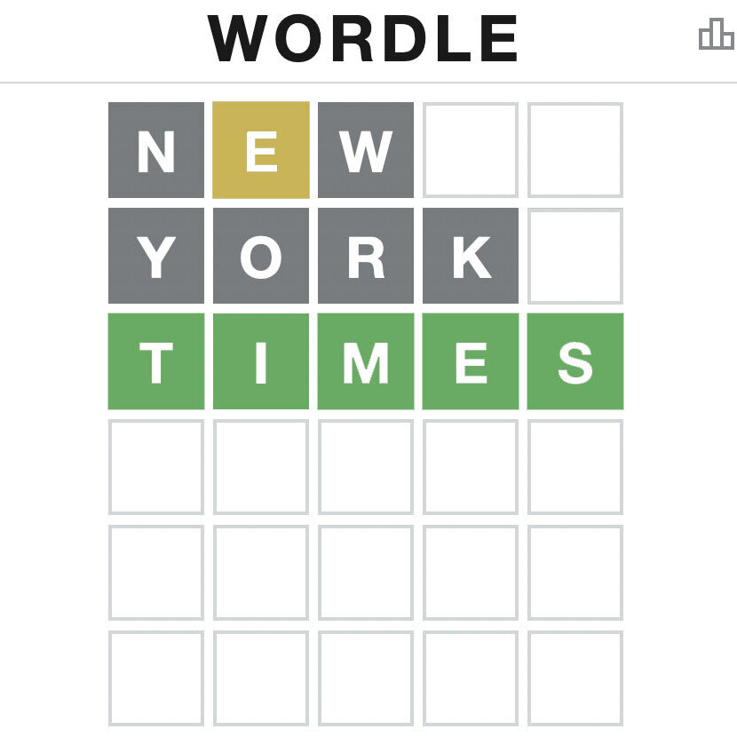

Worlde is a game which was released on the 16th May 2018 and was then purchased on January 31 2022 by the New York Times Company (parent company) for the sum of $1,000,000. Wordle is a web browser video game in which there is a random 5 letter word each day and you get 6 tries to get it. Although the video game becomes easier with the more guesses you make because letters in the right place in the word turn green whilst other letters in the word which aren’t in the correct place turn amber / yellow and then grey for characters which aren’t in the word itself. Wordle also has a database which stores all data for you, returning some minimal statistics.

One of my stakeholders (Monty Sherman - my brother) is a firm loyal customer to Wordle and has a streak of doing it every day for 230 days. However I soon found out that even my brother who is a loyal customer to this puzzle got bored of it and therefore stopped doing it each day. This gave me the goal of making my word guessing game more interesting and interactive which would in turn result in a larger lifespan compared to its competitors - such as wordle.

Stakeholder pros and cons:

| Pros: | Cons: |
| --- | --- |
| * Nice / effective mechanics (Monty + Stuart) * Easy to understand (Monty) * Intuitive (Stuart) * UI is simple and easily understandable (Monty + Stuart) * Dull design allows for the user to focus more on guessing the word compared to other features (Stuart) * Statistics are a good motivator to continue playing and make sense (Monty + Stuart) * Statistics are limited - Doesn’t overwhelm the user (Monty + Stuart) * Inviting to new players (Monty + Stuart) * One a day is good - Wordle’s USP (Monty + Stuart) * No advertisements (Monty + Stuart) * Easy to learn (Monty + Stuart) | * Minimal / Basic animations (Monty + Stuart) * Can be difficult depending on the user (Stuart) * Can be challenging / frustrating (Stuart) * Repetitive (Monty + Stuart) * Boring after a while (Monty) * Basic / boring / dull / muted design (Monty + Stuart) |

### Hangman:

Hangman is a puzzle in which you have to guess a word before you run out of guesses and the man is hung. It dates back to the 1890s and is known across the globe. It can involve as many people as you like with only 1 (or more if working together) person(s) creating a word for the rest of the group to guess. The words can be as long as the person creating the words wants and there can be as many words as the person wants. This shows that even with old puzzle games, people still use their own innovation to make the game more fun.

Overall even though the game has been around for 130 years (or so), the game / puzzle still has a popular fan base. However, I soon realised that even though the game is easily recognised and fun to play, the game is really simple and basic. This results in people becoming less interested in the game after playing it a few times, which I have proved by asking my stakeholders what they thought.

Stakeholder pros and cons:

| Pros: | Cons: |
| --- | --- |
| * Simple mechanics (Monty + Stuart) * Easy to understand (Monty + Stuart) * Made for children (Monty) * No computer devices involved - analogue game (Monty + Stuart) * Inviting to new players (Monty + Stuart) * Easy to learn (Monty + Stuart) | * Not difficult - Depends on the person creating the word (Stuart) * Fun for children (Monty + Stuart) * Repetitive (Monty + Stuart) * Boring after several games (Stuart) * Outdated (Monty + Stuart) |

### Pictoword:

Pictoword is a puzzle game where you are given 2 pictures and you have to put them together in order to solve the problem / guess the word. Pictoword was created by Kooapps and was released on 1st March 2013 for IOS and on May 31st 2013 for Android.

In Pictoword, there are 1000 levels to complete and in each level there is 1 word to guess. It became immediately apparent to me and my stakeholders that this puzzle game was limited to a certain number of levels. This severely decreases Pictoword’s life expectancy which is something I want to solve in my own project, by creating a puzzle programme which can be done indefinitely and therefore consumers won’t be limited to a certain number of words to guess.

However even though Pictoword has a limited number of levels, Pictoword differentiates itself from competitors (such as Wordle) by introducing different images to assist the user in guessing the word. Due to this unique selling point (USP), it shows that Pictoword innovates hints by introducing different pictures. Thus proving that I will need to be able to innovate hints in order to differentiate my puzzle game from the market.

Stakeholder pros and cons:

| Pros: | Cons: |
| --- | --- |
| * Mechanics are good / simple (Monty + Stuart) * Smooth animations (Monty) * Easy to understand / read (Monty + Stuart) * Intuitive (Stuart) * Perfect for children - Good educator / not very difficult (Monty + Stuart) * UI is good and intuitive - ignoring adverts (Monty + Stuart) * Hints are good when game gets difficult (Stuart) * Easy to learn (Monty + Stuart) * Inviting to new players (Monty + Stuart) | * Too easy for older people (14+ years of age), made for children (Monty + Stuart) * Advertisements take up 20% of the screen 100% of the time. Advertisements also interrupt the gameplay - Ruins the game (Monty + Stuart) * “Advertisements are more fun” (Monty) * Immensely boring (Monty + Stuart) * UI is ruined by adverts (Monty + Stuart) * Colours / design is childish - designed for children (Monty + Stuart) * Missing statistics - Would Have improved the life expectancy (Stuart) * Repetitive - Solved if more challenging (Stuart) * Outdated - lacks innovation (Stuart) * Hints are mostly pointless / too simple (Monty) * Words are American - Not good for educational purposes (Stuart) * Bad pointing system for hints - take a while to obtain (Monty) * Pictures are unclear / vague (Monty + Stuart) |

### Research overview:

Overall with all my stakeholder feedback and reviewing competitor puzzles, I will strive to create a fun yet challenging guess the word puzzle which can be played indefinitely (having a long life expectancy), and containing many innovative features to appeal to consumers (further increasing the life expectancy) such as an AI assistant as well as an improved database which allows for more in-depth statistics, such as what letter word you have guess the most times, % of games won, how long it took to guess the word or give any advice based on the statistics on how to get better at it. Thus allowing me to appeal to all consumers and keep them interested in solving the puzzle / playing the game.

## Requirements:

### Client Requirements:

#### Home Menu:

| User Requirement | Solves | Evidence | Justification | Success Criteria |
| --- | --- | --- | --- | --- |
| Play Button | Requirement to start the game / go to the next page. |  | This will bring them to a page which will allow the user to tailor certain settings of the game to their specific needs. | * Button will be clearly labelled using clear lettering. * Button will have a clear, **green** background. * Should take the user to the “Settings Menu” immediately. |
| Quit Button | Requirement to exit the game when finished. |  | This is required for users to exit the application. | * Button will be clearly labelled using clear white lettering. * Button will have a clear, **red** background. * Will end the programme. |
| Statistics Button | Used to display all statistics on one page. | Pg. 9 | This is used in order to take the user to a page which shows all statistics in full.  This is far more detailed compared to the small statistics display when playing the game. | * Button will be clearly labelled using clear white lettering. * Button will have a clear, **blue** background with a **black** border. * Should take the user to the “Statistics Menu” immediately. |
| —--Extra—-- | —------------ | —-------- | —---------------------------- | —---------------------------- |
| Login Page | Used in order to login in to different accounts - Will be connected to a database. |  | Each user will have their own different statistics, meaning users won’t have to share the same statistics when playing the game. | * Required to create an account tied to a database. * Username and Password required. * Passwords must be covered up (preventing shouldering). * Passwords must include at least 1 special character. |

#### Settings Menu:

| User Requirement | Solves | Evidence | Justification | Success Criteria |
| --- | --- | --- | --- | --- |
| Difficulty Button | Used in order to change the difficulty of the programme. | Pg. 3/4/5 | This is important because it means the user can challenge themselves if they want to. This ensures replayability. | * Button will be clearly labelled using clear lettering which will change colour from black to white depending on the background colour. * Button will have a clear background which will change **colour** depending on the difficulty chosen (it will range from green to purple). * The border colour will remain **black** regardless of the difficulty colour change. * The background colour should change when you select a different difficulty. |
| Difficulty Text box | Shows which each option entails.  E.g. “Easy” difficulty would have no word limit and can use all hints. | Pg. 3/4/5 | This is to simplify all of the technical details down into a single word (such as “easy”, “medium”, “hard”). This is effectively a glossary for each difficulty option, ensuring this programme can be easily used by anyone with ease. | * Must be easy to read. * Small and out of the way of the main programme. * Simple, clearly labelled and have a small border to give it the impression that it is a low priority text box. |
| Number of Characters selector | Allows you to choose how many letters you want the random word to be.  This can range from 3 letters to 7 letters (Depending on difficulty). |  | This gives the user freedom to play the game as they want. Due to the range of letters being 3-7, it allows the user to alter the difficulty as they please. | * The border will change **colour** depending on the difficulty chosen (it will range from green to purple). * The border colour will remain **black** regardless of the change in difficulty. |
| Continue Button | This is required in order to move on to the Game Page. |  | This will validate the settings asked for by the user and will then move the user onto the Game Page at which the user can start playing the game and guessing the word. | * Button will be clearly labelled using clear lettering. * Button will have a clear, **green** background. * Must go to the Game Page immediately after validating the settings. |
| Back Button | This is required in case the user wants to go back to the Home Menu to quit the game or check statistics. |  | This is used in order to go to the Home Menu. | * Must go back to the Play Game Menu immediately. * Button will be clearly labelled using clear lettering. * Button will have a clear, **black** border and **grey** background. |

#### Statistics Menu:

| User Requirement | Solve | Evidence | Justification | Success Criteria |
| --- | --- | --- | --- | --- |
| All statistics Text Box | Required to display all statistics. | Pg. 9 | This text box will fill the screen displaying all statistics which will range from “Total words guessed” to “Most words guessed for a 3 letter word”. | * Clear **black** border. * **Grey** background. * Simple and easy to read text. * Fill the screen. |
| Text Box -  First & Last 3 guesses | Displays statistics that relate to the previous game played specifically. |  | These 2 text boxes will be located next to the “All statistics text box” and is catered towards the previous game played. This text box will change drastically after each game has finished and will only affect the - Total guesses - statistic in the “All statistics text box”. | * Clear **black** border. * Simple and easy to read text. * Light **Grey** background to show it is a minor statistic. |
| Reset Statistics button | Required in order to reset all statistics to the default zero. |  | This is important in case the user wants to reset their data to the default statistics of 0. | * Button will be clearly labelled using clear lettering and white text. * Clear **black** border. * Button will have a clear, **red** background. |
| Back Button | Required in order to go back to the Home Menu / previous page. |  | This is used in order to go back to the Home Menu / previous page. | * Button will be clearly labelled using clear lettering. * Button will have a clear, **black** border. * Will take the user to the previous page immediately. * **Grey** background. |

#### Victory Page:

| User Requirement | Solve | Evidence | Justification | Success Criteria |
| --- | --- | --- | --- | --- |
| All statistics Text Box | Required to display all statistics. | Pg. 9 | This text box will fill the screen displaying all statistics which will range from “Total words guessed” to “Most words guessed for a 3 letter word”. | * Clear **black** border. * **Grey** background. * Simple and easy to read text. * Fill the screen. |
| Text Box -  First & Last 3 guesses | Displays statistics that relate to the previous game played specifically. |  | These 2 text boxes will be located next to the “All statistics text box” and is catered towards the previous game played. This text box will change drastically after each game has finished and will only affect the - Total guesses - statistic in the “All statistics text box”. | * Clear **black** border. * Simple and easy to read text. * Light **Grey** background to show it is a minor statistic. |
| Play Again button | This is used if the user wants to repeat the game with a different word. |  | This button will reload the previous game with the same settings but with a different word.  Hints will also be reset along with any consequences (word limit). | * Button will be clearly labelled using clear white lettering. * Button will have a clear, **green** background with a clear **black** border. * Should take the user to the “Game Page” immediately. |
| Home Menu button | Required in order to return to the home screen. |  | If the user wants to exit the game or change difficulty, the user will have to go to the Home Menu first. | * Must go back to the Home Menu immediately. * Button will be clearly labelled using clear lettering. * Button will have a clear, **black** border. * **Grey** background. |

#### Play Game Menu:

| User Requirement | Solve | Evidence | Justification | Success Criteria |
| --- | --- | --- | --- | --- |
| Play Game Button | Required in order to start the game. |  | Final confirmation button which is used in order to take the user to the “Game Page”. | * Button will be clearly labelled using clear white lettering. * Button will have a clear, **green** background with a clear **black** border. * Should take the user to the “Game Page” immediately. |
| Settings Button | Used in order to go to the “Settings Menu” to alter settings before playing the game. |  | This is used in order to alter settings so the user has a choice as to how they wish to play. | * Button will be clearly labelled using clear white lettering. * Button will have a clear, **blue** background with a clear **black** border. * Should take the user to the “Settings Menu” immediately. |
| Back Button | Required in order to go back to the Home Menu / previous page. |  | This is used in order to go back to the Home Menu / previous page. | * Button will be clearly labelled using clear lettering. * Button will have a clear, **black** border. * Will take the user to the previous page immediately. * **Grey** background. |

#### Game Page:

| User Requirement | Solve | Evidence | Justification | Success Criteria |
| --- | --- | --- | --- | --- |
| Word limit (guesses) Text Box | Required in order to show how many guesses the user has. | Pg. 3 | Will change depending on the amount of hints used and the difficulty. For example, the “easy” difficulty would have unlimited guesses whereas the “Impossible” difficulty would have a limited number of guesses.  As more hints are used, the word limit will go from “unlimited” to a certain number. | * Must be easy to read. * It will be located in the corner. * Clearly labelled and have a large border to give it the impression that it is a high priority text box. |
| Word input box | Required in order to enter words. |  | Needed in order to enter / guess words. | * Required to enter a word. * No special characters / numbers are allowed. * Will not accept words less / more than the selector character limit. |
| Number of characters Text Box | Required to show how many letters there are in the word. |  | This is used in order to remind the user how many characters there are in the mystery word. | * Covered by a completely white (or different background colour) text box to hide the number of characters. * Must be easy to read. * Simple, clearly labelled and have a small border. * This will be revealed if the user asks for it using a hint. |
| Small statistics display (Text Box) | Shows a small number of statistics in the corner of the screen. | Pg. 9 | This is used in order to show basic statistics whilst playing the game.  Some statistics shown would be:   * Words guessed * Hints used * Lowest amount of guesses | * Small and out of the way of the main programme. * Simple, clearly labelled and have a small border to give it the impression that it is a low priority text box. * Mundane colours (black or grey) to ensure the display is seen as “low priority”. |
| Hidden mystery word (Text Box) | Used to hide the mystery word and will be revealed when the word is guessed. |  | The word is covered up and will be revealed when the word is guessed. | * Covered by a completely white (or different background colour) text box to hide the word. * Must be completely hidden to the user. |
| Hint input box (drop down selector) | Required to choose a hint you want. |  | This is important because the user can select any hint they like to assist them with guessing the word. | * Must be easy to read / understand / use. * Clearly labelled and have a small **black** border to allow the user to focus on which hint to use. |
| Hint output Text Box | Required to display any text needed when a certain hint is asked for. |  | After a hint has been asked for, a text box is needed to display any text necessary. For example, if the hint - “Reveal the first character” is selected, the text box will display the first character. | * Must be easy to read / understand. * Simple and clearly labelled. * Will have a large border to give it the impression that it is a high priority text box. |
| AI Input / Output boxes | Required in order to ask AI questions and receive answers. | Pg. 3/4/5/9 | The input box will allow the user to enter a question or command and the AI will validate and process the input and give an answer via the output box. | * No special characters / numbers are allowed. * Will process the input and give an answer as quickly as possible. |
| Difficulty display (Text Box) | Displays which difficulty the user has chosen. | Pg. 3/4/5 | Displayed at the bottom of the screen. | * Small and out of the way of the main programme. * Simple, clearly labelled and have a border which will change **colour** depending on the difficulty chosen (E.g. **Green** for “Easy” difficulty). |
| Difficulty glossary (Text Box) | Shows which each option entails.  E.g. “Easy” difficulty would have no word limit and can use all hints. | Pg. 10 | This is to simplify all of the technical details down into a single word (such as “easy”, “medium”, “hard”). This is effectively a glossary for each difficulty option, ensuring this programme can be easily used by anyone with ease. | * Must be easy to read. * Small and out of the way of the main programme. * Simple, clearly labelled and have a small border to give it the impression that it is a low priority text box. |
| Home Menu button | Required in order to return to the home screen. |  | If the user wants to exit the game or change difficulty, the user will have to go to the Home Menu first. | * Must go back to the Home Menu immediately. * Button will be clearly labelled using clear lettering. * Button will have a clear, **black** border. * **Grey** background. |
| Enter buttons for each input box | Required in order to submit / validate inputs. |  | These buttons can be pressed via the mouse or the ‘enter’ key on your keyboard. | * Can be clicked via the mouse or via the “enter” key on the keyboard * Button will be clearly labelled using clear lettering. * Button will have a clear, **black** border. |
| —--Extra—-- | —----------- | —-------- | —------------------------------- | —-------------------------- |
| Reset word button | Required for the user to change the word. |  | This will create a new word and reset all hints, word limits, AI outputs. It will not change the difficulty. | * Will bring up an alert box which will ask the user if they are sure they want to reset the word. * Button will be clearly labelled using clear lettering. * Button will have a clear, **red** background. * **Black** border. |
| Full statistics button | Required in order to take the user to the Statistics Menu. | Pg. 9 | This is used in case the user wants to view other statistics which may not be on the small statistics display. The “Back button” on the Statistics Menu would take the user back to the Game Page. | * Must go to the Statistics Menu immediately. * Button will be clearly labelled using clear lettering. * Button will have a clear, **black** border and be located near the small statistics display. |

### Hardware / Software Requirements:

My programme will be created in Visual Studio 2022 using C#. Due to this, my programme will be able to be run via an executable file or via Visual Studio 2022 if desired. The user will also have to connect to Supabase if they want the database to work, this would require an internet connection if you want to use the database over the cloud. However, if you don’t have access to an internet connection, there is an option to run the database locally on your machine. Even though there are many statistics being calculated at any given time, most devices should be able to run this programme with ease. Due to the programme being very simple in visual and mechanical terms, the hardware requirements should be fairly low. Although, enough storage space is required in order to cater for the files / libraries with all of the words being held as well as the base programme (plus the database if used locally).

I am testing this programme on a device with 6 cores, 8GB of RAM and a processor with a base speed of 2.38GHz. Therefore these will be the base requirements for the programme to run perfectly.

Connecting a database to your programme:

Supabase (2023) Connecting to your database. Available at: <https://supabase.com/docs/guides/database/connecting-to-postgres> (Accessed: 21 September 2023)

### Limitations:

Due to me creating the programme in Visual Studio 2022 using the Windows Forms Application (coded in C#), some quality of life features (such as smooth transitions between pages) will have to be discarded or postponed to the end of the project if I have any spare time. For now, quality of life features will have to be substituted by simpler alternatives (then replaced later on). For example, smooth transitions between pages will have to be substituted by changing pages instantly.

Some features such as alert boxes or small pop up displays will have to be substituted for whole pages at the beginning stage of the programme. This is another quality of life improvement which may be implemented at the end of the project if I have any time left over.

### Prototype 1:

In the first prototype I will aim to create all pages apart from the extra login page with the correct features (buttons, text boxes etc) and add links to each page, allowing for simple, easy traversal between pages. I will also add libraries / files containing all words with 3, 4, 5 and 6 characters in the programme, allowing me to find random words with different characters across the English language / dictionary. Additionally, I will implement as much code as I can until I run out of time / implement all code.

### Prototype 2:

In the second prototype, I will prioritise implementing all code required if I missed anything from the first prototype. After this I will aim to link a database (used to store all statistics) to the programme. To do this, I will use Supabase to easily control and manage the database externally to ensure all data is saved correctly and there are no errors. I will then connect Supabase to my programme on Windows Forms Application. As well as connecting a database to my programme, I will also implement all of the code required for the database used (all in SQL). This will include a lot of pulling, pushing and processing data on both ends (WFA and Supabase). After this, it allows me to process and add the statistics to the Statistics Menu as well as the Small Statistics Display on the main game page.

### Prototype 3:

In the third prototype I will aim to ensure all hints work properly as intended as well as tidying up all code to make sure it is as efficient as possible whilst taking up minimal storage space. If I have any time left over towards the end of my project, I will use this time effectively to fulfil any of the extra requirements I stated earlier.

# Design:

## Overview of the Structure:

In the hierarchy chart below, my Guess The Word programme has been broken down into 5 important menus (Home Menu, Statistics Menu, Play Game, Game Page and Settings Menu), which all lead on to vital key features that are required in order for the programme to function as intended. When the user loads up the Guess The Word programme, they should see a login page and be able to login to their own account which will hold their own statistics (if I have enough time at the end of the project to do so).

After this the user will be sent to the Home Menu which will hold essential options for the user to choose, this ranges from quitting the game to viewing all statistics to actually playing the programme.

Due to this decomposition hierarchy chart, I can easily tell what needs to be added to each WFA page, for example on the Game Page, there will be sections for hints, inputting the word, a section for AI as well as text boxes which will hold information for statistics and other useful information such as a word count and difficulty.

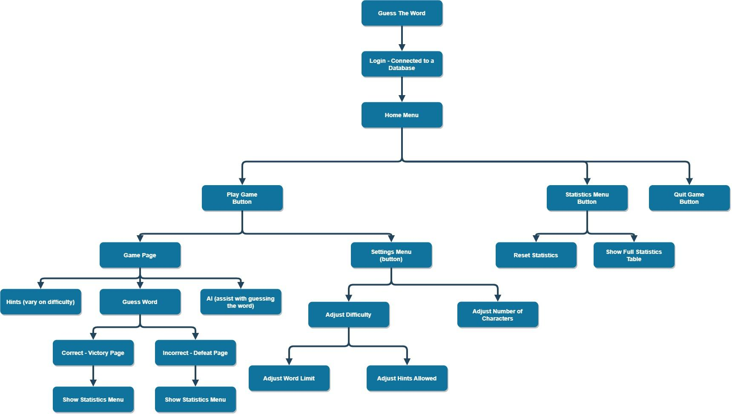

## UI Design:

### Home Menu:

Explanation:

This menu is the starting menu at which the user will be taken to when they first load up the programme. It will hold the **Title** at the top of the screen and there will be 3 buttons which will be colour coded. These buttons will be used in order to view statistics, play and quit the game.

* The **green** button will be the **Play** button and will take the user to the **Play Game Menu**. The button is coloured this way because its psychological symbol means that it portrays tranquillity and peace, comforting the user to play the game.
* The **blue** statistics button however will take the user to the **Statistics Menu** and is coloured this way in order to differentiate itself from the other options (**green** and **red)**, this will ensure that the user can easily identify each button and know what they do.
* The **red** button will exit the programme if clicked. It is **red** to warn you that you are going to exit the programme.
* Furthermore, when the user hovers over each button, the button will turn a darker colour (**green, blue, red**) to show that the user is hovering over the selected button.

### Play Game Menu:

Explanation:

This menu is the menu at which the user is taken to when they click the **Play** button on the **Home Menu**. If the user clicks the **Play Game** button, the settings will default to **Normal** settings (regular difficulty), thus altering the settings is not compulsory - this benefits the user because it allows them to start guessing the word quicker if they don’t want to tinker with any settings.

* This page contains a **back** button which is colour coded **grey** which would take the user back to the **Home Menu**. It is coloured this way in order to show its insignificance compared to the other two buttons on the page.
* The **green** button will be the **Play Game** button and will take the user to the **Game Page**, at which the user will be able to start the game. The button is coloured this way because its psychological symbol means that it portrays tranquillity and peace, comforting the user to play the game.
* The **blue** settings button however will take the user to the **Settings Menu** at which the user will alter the settings of the game. This button is coloured this way in order to differentiate itself from the **Play Game** button.
* Furthermore, when the user hovers over each button, the button will turn a darker colour (**green, blue, grey**) to show that the user is hovering over the selected button.

### Statistics Menu:



Explanation:

This menu holds all of the statistics which will be gathered when playing the game. It holds the first and last 3 guesses (which will be easily visible due to the bigger font size) as well as all of the other statistics (total wins and total hints used for example).

* This page contains a **back** button which is colour coded **grey** which would take the user back to the **Home Menu**. This button will have a large font size making it easily visible to the user, ensuring the games’ simple aesthetic and understandability.
* This page also contains a **Reset Statistics** button which is **red**. This button will reset all of the saved statistics to 0 and wipe the whole database. Due to the button being **red** it shows that this is a one time thing and cannot be reversed.
* Furthermore, when the user hovers over each button, the button will turn a darker colour (**red, grey**) to show that the user is hovering over the selected button.

### Game Page:

Explanation:

This page is the main game page where the user will be trying to guess the word and spending the most time in the programme. This page will hold a multitude of essential information such as hints, word limits, difficulty, potential AI, statistics and a vital input box. This page holds the most features and can be daunting to the user, because of this, the majority of features are coloured in a shade of grey which removes the daunting nature of the page compared to if everything was colours and “in your face”. The word and number of characters will be on the page but hidden with a textbox with no border and completely white (or other **Game Page** background colour) background colour. Both of which will be removed in the end when the word is guessed. The number of characters and word limits however will be revealed if the hint regarding the number of characters and word limit used.

* The **quit** button will take the user to the **Victory page**, resulting in a defeat. It is **red** to warn you that you are going to exit the programme.
* In the top right corner there is a **Word Limit** textbox, this will be automatically set to unlimited (depending on the difficulty) at the start of the game, and will change to a fixed number (which would decrease as the user guesses words) after a certain number of hints have been used.
* This page contains a **Main Menu** button which is colour coded **grey** which would take the user back to the **Home Menu**.
* The **grey enter** button is used in order to enter user inputs and validate guesses.
* The **Difficulty Display** will be a text box which will have a different border / background colour based on the difficulty chosen (for example the border / background colour will be **green** if the difficulty level is “Easy”).
* There is a **Small Statistics Display** in the top left corner of the page. This is the biggest feature on the page and will display the main statistics in the game.
* The input box is where the user will enter their guesses.
* The small **Hints** display will contain a white background which will have its hints covered until the user asks for a hint - clicks the **Reveal Hint** button - which will display the selected hint based on the **Hint number** button which you can click to change the hint number you want as well as a random number option. This button will act as a wheel - meaning you can click it and it will cycle through all of the options, which will be colour coded based on the difficulty selected. For example, if the **easy** difficulty was chosen, the border and background of the **Hint number** button will change depending on how useful the hint is.
* The transparent **Notes** text box will be used in order to inform the user of any mistakes made, such as inputting an incorrect value in the input box.
* The AI input and output boxes will be an **extra** feature that I will aim to complete and research if I have any time left over after I have finished my project. The aim is to be able to ask the AI questions about the word to act as another useful hint tool.
* The full statistics table will be an **extra** feature which will take the user to the **Statistics Menu**.

### Settings Menu:

Explanation:

This page is used to alter the settings of the game. The user will be able to select the difficulty level they want to play as well as selecting how many characters there are in the word (with a random option available). This page ultimately gives the user freedom on what they want to play, which will remove the repetitive nature of the programme.

* This page contains a **back** button which is colour coded **grey** which would take the user back to the **Play Game Menu**.
* The **green** button is the **Continue** button, which will take the user to the **Game Page**, at which the user will be able to start the game.
* There is a **Difficulty text box** which will display all of the difficulty levels available and what they entail.
* There is a **difficulty level selector** which will be used to choose the desired difficulty level.
* There is a **total letters selector** which will be used to choose the amount of characters in the random word the user has to guess.

### Victory Page:

Explanation:

This page will be displayed at the end of the game - either when the user guesses the word correctly, runs out of guesses or quits the game. This page includes a small statistics text box which will display most / all statistics. The hidden word is also displayed regardless of if the user has guessed the word or not. Finally there are the first and last 3 guesses from the game you just played.

* This page contains a **Main Menu** button which is colour coded **grey** which would take the user back to the **Home Menu**.
* The **green** button is the **Play Again** button, which will take the user to the settings menu, allowing for the user to choose their desired settings and play the game again.
* There is a **Statistics Display** on the left side of the page. This is the biggest feature on the page and will display most / all statistics of the game.
* There will be a small text box above the **First 3 guesses** text box which will display the hidden word.
* Additionally, there are 2 similar text boxes - **First 3 guesses** and **Last 3 guesses**. These will be used to display the first and last 3 guesses of the game the user just played. If the user guesses the word correctly within the first 2 tries, the null guesses will be blank.

### Login Page: **Extra**

### Explanation:

When creating a username and password, the user will be asked to enter their age. This is to ensure that no swear / inappropriate words will be used for younger ages. However these words will be included for older users (aged 17+) to ensure all words are available to the user. However, if the user doesn’t want the chance for these words to be added, there will be an option to disable them.

The button which would disable swear words will change colour depending on the result. If the user wants to disable inappropriate words, then the user will have to click the button until the button turns **red** and the button is labelled with “Disabled”. However, if the user wanted to include these words for an overall increased potential words used, then the button will have to be set to a **green** colour with the button being labelled with “Enabled”.

## Breakdown of the Structure:

### Player class:

This class will relate to the player and will be based on the decisions that the player makes. This class will inherit all of the methods and attributes from the Database class which inherits all of the methods and attributes from the Game class. Overall the Player class will have access to almost all attributes and methods in the programme.

### Game class:

The Game class will be used to process most of the game’s core mechanics. This class does not inherit any class because it is the parent / superclass for the other classes.

### Settings class:

The Setting class is the smallest class which inherits the Game class. This is because the difficulty affects the amount of hints and guesses in the programme.

### Database class:

The database class inherits the Game class and is only used to manipulate data which is stored in a database. The database used will be on a website called Supabase and will store all of the data required

### Hint class:

This class is only used to operate the hints. I decided to separate the hints from the Game class because of how big the hints are and how they are implemented. If these hints were included within the Game class, then the Game class would be too big and would be difficult to understand for any programmer that wishes to review / update my programme.

## 

## 

## Database:

**Player** (PlayerID, TotalGuesses, TotalWins, PercentageGamesWon, MostSuccessfulLetterWord, TotalHints, LowestNumberOfGuesses, LowestNumberOfSynonyms, TotalChallengesWon, WordsGuessedInFirstGuess, WordsGuessedInSecondGuess, WordsGuessedInThirdGuess)

| Player |
| --- |
| PlayerID  TotalGuesses  TotalWins  PercentageGamesWon  MostSuccessfulLetterWord  TotalHints  LowestNumberOfGuesses  LowestNumberOfSynonyms  TotalChallengesWon  WordsGuessedInFirstGuess  WordsGuessedInSecondGuess  WordsGuessedInThirdGuess |

## Algorithms:

GenerateRandomWord():

This function is used to generate a random word from a file containing all of the 3/4/5 letter words in the English dictionary.

GetHint(HintNumber):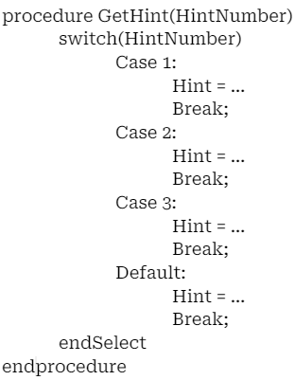

This procedure is used to select the correct hint based on the HintNumber parameter given. The hint chosen will then be activated.

UpdateWinOrLoss():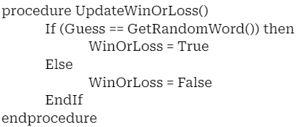

This procedure is used to change the state of the WinOrLoss attribute. This procedure is then used to determine if the user has won the game or not, if the user has won the game, the user will be taken to the Victory Page.

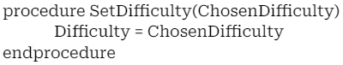

SetDifficulty(ChosenDifficulty):

This procedure updates the difficulty depending on the option chosen in the Settings Menu.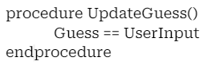

UpdateGuess():

This procedure is tied to the enter button on the Game page, this procedure will update the guess to be equal to the input guessed.

## Usability Features:

In order to ensure that all users will be able to play the game (regardless of experience), I have labelled the buttons clearly as well as included labels to show you what each selector does on the Settings Menu. This ensures the user knows what they are selecting after they have selected a value (since the selector only shows a number, it can be easy to misunderstand what it is for). On top of this, I have created a mouse-over (hover) event which is where buttons change background and text colour when you hover your mouse over the selected buttons, which makes it easier to read for the user. Other usability features I have implemented are message boxes (alert boxes) and labels to tell the user important information related to the game (mainly when guessing the word). Above all, I have made use of a minimalistic approach which won’t overwhelm new users when learning the game's mechanics and structure. The title labels at the top of each page are simplified to one or a few words which reduces the complexity of the game and the user doesn’t have to learn anything to understand what each page is and what it does (the names should be self-explanatory). Overall with the simplistic design of the game as well as the easy mechanics the user should receive an easy, smooth experience the whole time when playing the game.

## Test Data:

### Home Menu:

| Development stage | Feature being tested | Data Input | Expected Output |
| --- | --- | --- | --- |
| Prototype 1 | Play button | Mouse click | User is taken to the Play Game Menu |
| Mouse hover | Background colour turns to a darker shade of green |
| Prototype 1 | Statistics button | Mouse click | User is taken to the Statistics Menu |
| Mouse hover | Background colour turns a darker shade of blue |
| Prototype 1 | Quit Game button | Mouse click | The user exits the programme (programme ends) |
| Mouse hover | Background colour turns a darker shade of red |
| Prototype 1 | Guess the Word - title | N/A | Should be constantly visible |

### Play Game Menu:

| Development stage | Feature being tested | Data Input | Expected Output |
| --- | --- | --- | --- |
| Prototype 1 | Play Game button | Mouse click | User is taken to the Game Page where the difficulty is automatically set to “Medium” and the word length is set to “5” |
| Mouse hover | Background colour turns to a darker shade of green |
| Prototype 1 | Settings Menu button | Mouse click | User is taken to the Settings Menu where they can edit the preferences for the game |
| Mouse hover | Background colour turns to a darker shade of blue |
| Prototype 1 | Back button | Mouse click | The user is taken back to the previous page (Home Menu) |
| Mouse hover | Background colour turns to a darker shade of grey |
| Prototype 1 | Guess the Word - title | N/A | Should be constantly visible |

### Settings Menu:

| Development stage | Feature being tested | Data Input | Expected Output |
| --- | --- | --- | --- |
| Prototype 1 | Continue button | Mouse click | Takes the user to the Game Page and the selected “Total Letters” and “Difficulty” drop-down selector answers will be assigned to the correct variables for later processing |
| Mouse hover | Background colour turns to a darker shade of green |
| Prototype 1 | Back button | Mouse click | Takes the user to the previous page (Play Game Menu) |
| Mouse hover | Background colour turns to a darker shade of grey |
| Prototype 1 | Total Letters drop-down selector | Mouse click (selecting option) | The selected option should be assigned to the relative variable for later processing (after the continue button has been clicked) |
| Prototype 1 | Difficulty drop-down selector | Mouse click (selecting option) | The selected option should be assigned to the relative variable for later processing (after the continue button has been clicked) |
| Prototype 1 | Settings title | N/A | Should be constantly visible |
| Prototype 1 | Difficulty label | N/A | Should be constantly visible (it is the overview for the different difficulties) |

### Game Page:

| Development stage | Feature being tested | Data Input | Expected Output |
| --- | --- | --- | --- |
| Prototype 1 | Continue button | Mouse click | Should only be visible once the user has guessed the word correctly. When clicked, the user should be taken to the Victory Page |
| Mouse hover | Background colour turns to a darker shade of green |
| Prototype 1 | Quit button | Mouse click | The user exits the programme (programme ends) |
| Mouse hover | Background colour turns to a darker shade of red |
| Prototype 1 | Main Menu button | Mouse click | Takes the user to the Main Menu |
| Mouse hover | Background colour turns to a darker shade of grey |
| Prototype 1 | Enter button | Mouse click | The guess from the input box will be compared to the hidden random word. If the user has guessed correctly then the random word and continue button will appear. However if the user hasn’t guessed correctly then an incorrect message should appear. If the user has entered an invalid input, then an alert box will appear informing them of the issue. |
| Mouse hover | Background colour turns to a darker shade of grey |
| Prototype 1 | Reveal Hint button | Mouse click | A hint will be revealed depending on the value from the Hint Number selector |
| Mouse hover | Background colour turns to a darker shade of grey |
| Prototype 1 | Hint Number selector | Mouse click (selecting option) | The selected option should be assigned to the relative variable (selected hint) for later processing (after the Reveal Hint button has been clicked) |
| Prototype 1 | Word limit label | N/A | Should be constantly visible and update how many guesses the user has left every time the user enters a guess |
| Prototype 1 | Random Word label | N/A | Should be hidden until the word is guessed correctly |
| Prototype 1 | Guess the Word - Title | N/A | Should be constantly visible |
| Prototype 1 | Hints | N/A | Should be hidden until the Reveal button is clicked with the corresponding Hint number from the Hint No. Selector |
| Prototype 1 | Input box | Entering guesses | Should show what you are typing and should delete the guess when you click the Enter button |
| Prototype 1 | Difficulty display | N/A | Should be constantly visible and display the correct, current difficulty selected |
| Prototype 2 | Statistics display | TBD | TBD |

### Victory Page:

| Development stage | Feature being tested | Data Input | Expected Output |
| --- | --- | --- | --- |
| Prototype 1 | Play Again button | Mouse click | Takes the user to the Game Page with the same settings and a new random word |
| Mouse hover | Background colour turns to a darker shade of green |
| Prototype 1 | Main Menu button | Mouse click | Takes the user to the Main Menu |
| Mouse hover | Background colour turns to a darker shade of grey |
| Prototype 1 | First Three Guesses label | N/A | Should be constantly visible and display the user’s first three guesses |
| Prototype 1 | Last Three Guesses label | N/A | Should be constantly visible and display the user’s last three guesses |
| Prototype 1 | Victory! Or Defeat. label | N/A | Should be constantly visible and will display the corresponding text depending on if the user won or lost the game |
| Prototype 2 | All Statistics Display | TBD | TBD |

# Implementation - Prototype 1:

## Instantiation:

This short 19 lines of code is essential to the whole programme. This is where all classes are instantiated and referenced to. In order to reference each class from every page, a global scope is needed when instantiating objects, which is done by the public static command. However, due to the global scope, I will need to take extra care in updating the values of each object as they can be edited and changed easily.

## Home Menu:

This is the first page when you first open / play the game. The design is minimalistic and the buttons only do one thing (mainly taking the user to other pages).

For usability purposes, each background colour of the button turns a darker shade of itself when you hover your mouse over it and the black text turns to white text, which is done on every page, throughout the entire programme.

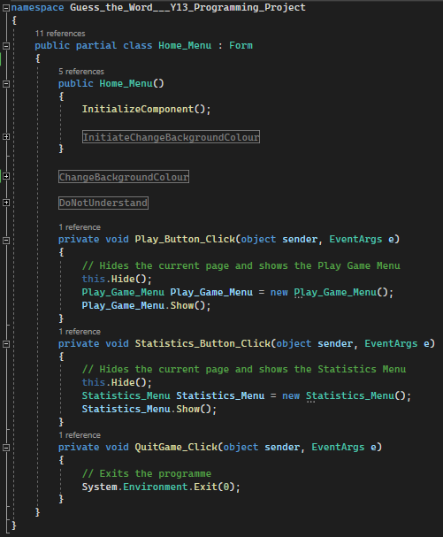

Each button (excluding the Quit Game button) holds the code to hide the current page and display the new page, giving the impression that the user is switching pages effortlessly. The Quit Game button only holds the data to end the programme, which works perfectly.

The code within the #Regions hold the code to change the properties of each button so the background and text colours change, which is one of the usability features I have added. These Regions work hand in hand by the ChangeBackgroundColour region holding the methods for when you hover your mouse over each button whilst the other 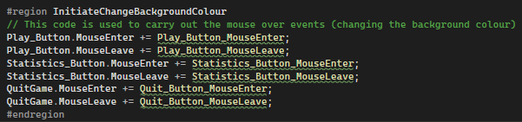

InitateChangeBackgroundColour is used to activate the methods when the user holds their mouse over each button.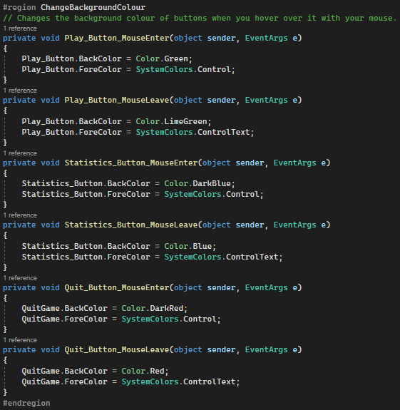

I am using Regions to organise my code and make it easily readable so anyone can pick up my programme and easily find out what each region / method does, along with all the comments in my code.

## Play Game Menu:

This page is where the user is taken to when the user clicks the “Play” button on the Main Menu. It hasn’t changed from its original design and everything works as intended. Each button has the same usability features as the Main Menu page. I have named the usability regions (which hold all of the necessary code) the same as in the Main Menu page, this is to make it easier for the programmer to read and understand if anyone else was to pick up my programme and develop it. Another reason why I have named it the same as in other pages is because of the scope. Each page is individual and has a local scope, meaning you cannot access any local variables (unless you specifically specify variables and call them). Overall meaning I can name each region the same thing without affecting code on other pages.

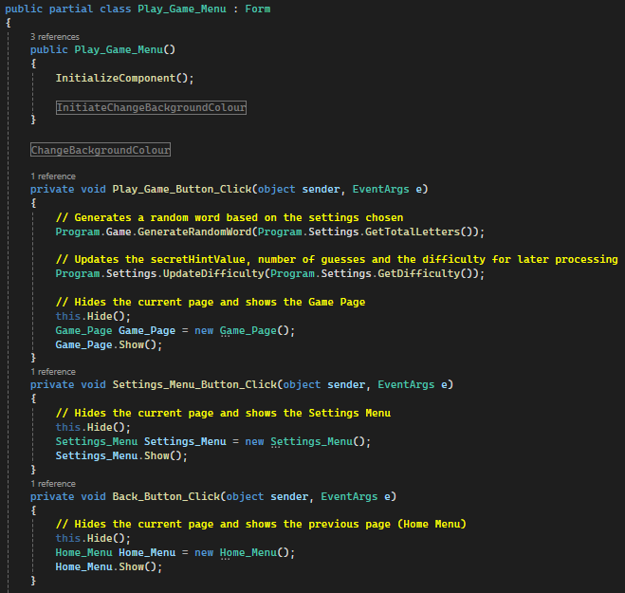

This is the code relating to the Play Game Menu. It is simple as it only holds the code for 3 buttons. Each button takes the user to a different page and only does one thing, apart from the “Play Game” button. The “Play Game” button takes the user to the Game Page but also creates a random word based on the settings either chosen by the user, or the default settings. This random word will then be stored in a variable called “RandomWord” in the Game class and can then be accessed from anywhere throughout the programme.

## Settings Menu:

This menu is accessed via the Play Game Menu by the ‘Settings’ button. This menu is complete and has all the features required to play the game. The original design remains the same (excluding the background colour and border) and each button has the same usability features as the Main Menu. I have named the usability regions the same as in the Main Menu page, this is to make it easier for the programmer to read and understand if anyone else was to pick up my programme and develop it (only due to local scope). Each feature on this page is self explanatory and is easy for new users to understand. The visuals of this page (such as the textboxes having background colours and borders) will be updated in the 3rd prototype once the programme has been fully implemented and optimised.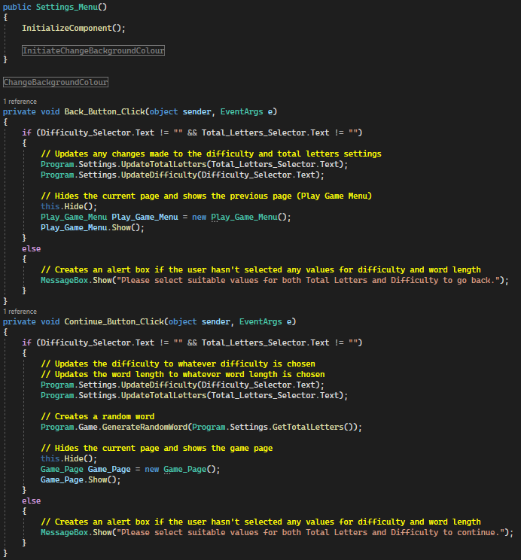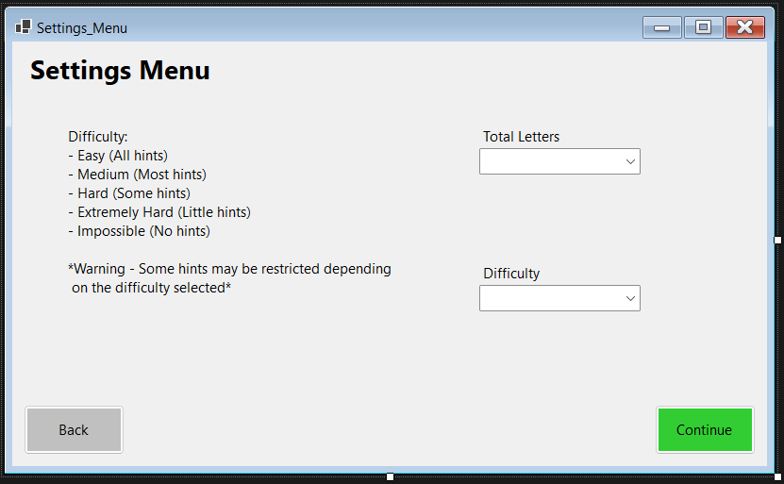

This code to the right corresponds to the Settings Menu. This page is very minimal - only holding the code for two buttons (as well as other usability code). The IF statements are necessary if the user has not selected anything in one or both selectors. However this doesn’t account for special characters being input in the selector manually. This error will be fixed in the 2nd / 3rd prototype when optimising / ensuring the game works as intended without any loopholes.

## Victory Page:

This page has been altered slightly from the original design, the changes include the text boxes being transparent as well as the titles being combined with each text box. The only main difference however is the Quit button next to the Main Menu button. This is so users are able to quit and close down the game after winning / losing.

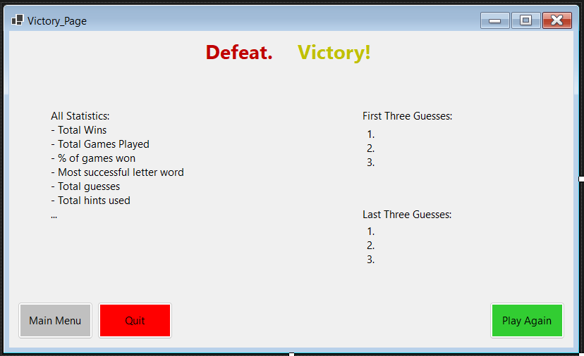

This page continues the trend of having all usability options every other page has with the same region names. Currently, the ‘All Statistics’ display isn’t functional due to no database being active. This display will be active and updated when the statistics get recorded and will be done in the 2nd prototype. However, the visuals of this page (such as the textboxes having background colours and borders) will be updated in the 3rd prototype once the programme has been fully implemented and optimised.

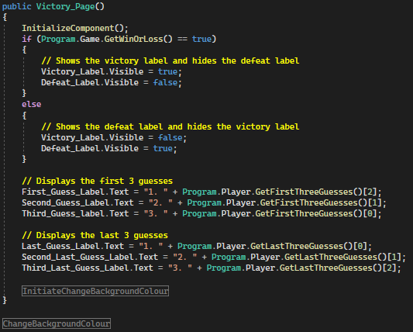

This code is run when the Victory Page is created and shown. The IF statement is used to display the correct label which displays the ‘Win’ or ‘Lose’ title at the top of the screen. The following code updates the First and Last three guesses to its corresponding values. Along with the important usability code.

This is the rest of the code for the Victory Page. It is extremely simple and easy to read. The code: Program.Player.ResetGuesses(); is used to reset the guesses recorded so the values for the First and Last three guesses will be accurate when the user plays the game again.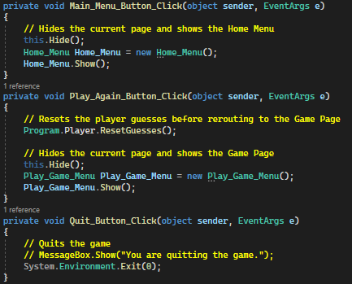

## Game Page:

This page is the main game page which the user is likely to spend the majority of their time on since this is where most of the game mechanics come into place.

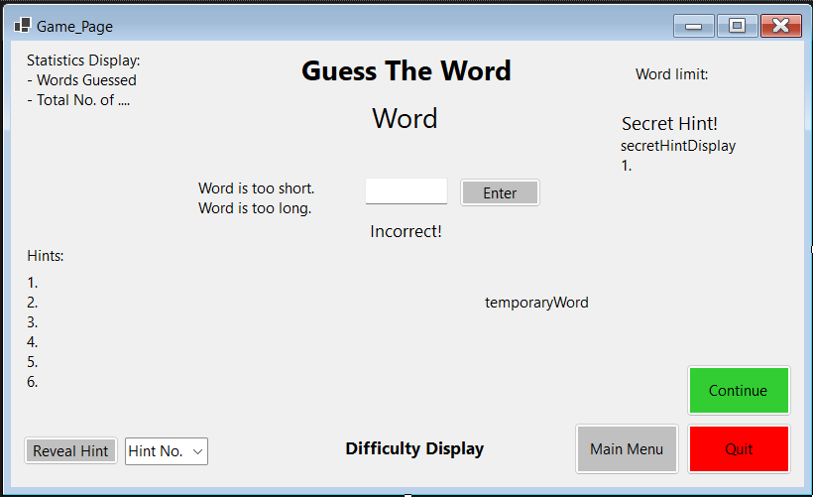

This page differs from its original design. The features missing from the original design are: Full stats button, AI input and output, Notes and number of characters displayed.

### Removed features:

The notes and number of characters displayed have been permanently removed from the programme since they’re purposes have been shown in simpler ways. For example the ‘notes’ box was going to be used for showing and declaring errors, the use for notes isn’t required anymore since I have added the ‘Incorrect!’ error display directly under the input box instead. On top of this, the ‘Word is too short/long’ errors are displayed to the left of the input box. All errors are hidden and appear (for a specific time - 3 seconds - before disappearing) when the user enters an incorrect input, resulting in the corresponding error being shown. Due to the user picking the number of characters they want to play with, the number of characters displayed became redundant. However, I moved it to be a hint in case the user selected the ‘random’ option when selecting the number of characters they like.

### Additional features:

I added a ‘continue’ button to the page which would replace the ‘quit’ button (It is above the quit button to avoid current confusion - only one button will be visible and functional at any given time) when the user either clicks the quit button or guesses the word correctly. I figured a continue button would be useful since the user would previously get taken directly to the Victory Page instantly. When testing the programme I found that when I entered the word correctly, I would struggle remembering what I input (after loads of guesses), therefore I decided to display the hidden word in the ‘Word’ label below the title on the Game Page and added a continue button for when the user is happy to go to the victory page.

The ‘temporaryValue’ label is a developer testing tool which displays the hidden word. It will not be accessible to any users and is purely used to test out the programme.

Finally, the ‘Secret Hint’ is a new hint I created which only reveals itself to the user when the user enters a certain number of unsuccessful guesses. The more the user guesses (unsuccessfully), the more secret hints get revealed. The secret hint only shows 1 character of the hidden word at a time. This secret hint can only be activated by guessing a certain number of times and is available to all difficulties. The secret hint also scales with each difficulty - more guesses are required for a higher difficulty. This hint also works for all words no matter the number of characters. However, I wish to improve this feature in the 2nd / 3rd prototype by making the secret hint optional (new setting), giving more freedom to the user.

Overall the majority of the Game Page has stayed the same with all features working as intended (excluding the statistics display). The statistics display is incomplete and will be dependent on the database and the updating / storing of statistics. This will be completed in the 2nd prototype where I will implement a database and thus be able to create all statistics tables effectively. The visuals of this page (such as the textboxes having background colours and borders) will be updated in the 3rd prototype once the programme has been fully implemented and optimised.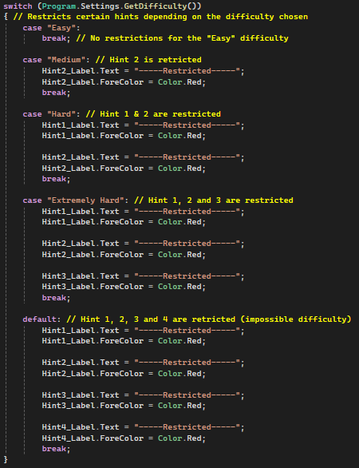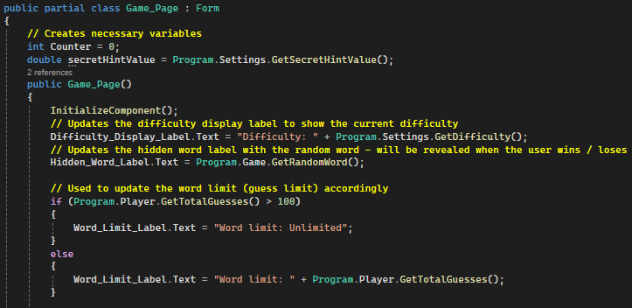

This code is what is run when the page is created. Firstly, the Difficulty display is updated with the current difficulty selected and the hidden word is updated (for when the user quits the game or guesses the word correctly).

The IF statement is used to update the guess limit. Since the guess limit changes depending on the difficulty, an IF statement is needed.

The switch statement used corresponds to which hints will be restricted or not depending on the difficulty. For example, the first and second hint will be restricted if the ‘Medium’ difficulty is selected. Finally the usability options are held at the end.

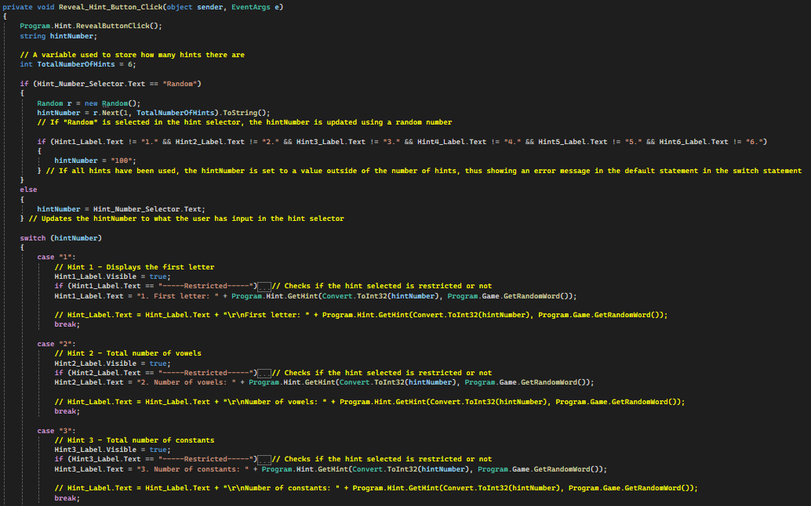

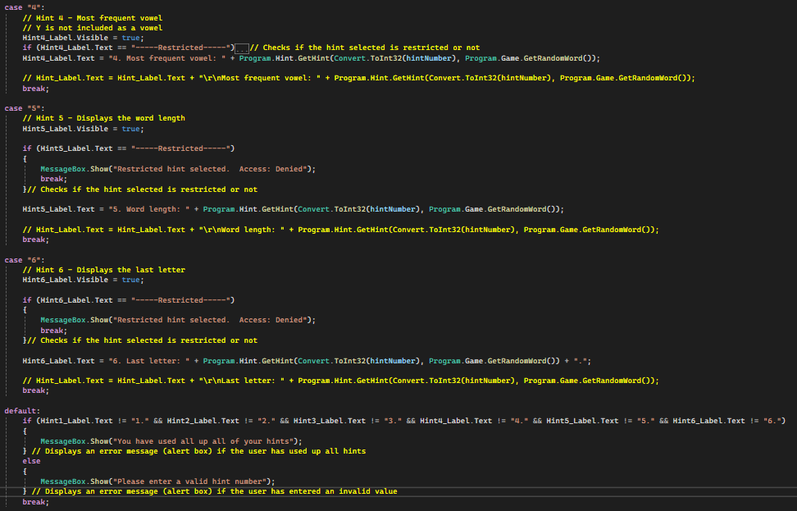

The Program.Hint.RevealButtonClick() is used to count how many times the button has been clicked. After this there is a nested IF statement which is used if the hint selector is set to ‘Random’. A random value is assigned to the hintNumber variable which is used in the switch statement after the IF statement. The nested IF statement is used to check if all hints have been used, if so then the hintNumber is set to 100, which isn’t a case in the switch statement, therefore running the code in the default case which will display the corresponding message depending if the hint entered is a valid number or all hints have been used. However, if all the conditions are right, then the hintNumber will just be updated with whatever number the user has entered. Each case in the switch statement corresponds to a specific hint, held within the hint class. When each case is run, the corresponding hint is made visible to the user and an IF statement is run to check if the hint is restricted (**as seen in case 6 - the IF statement is open**) and breaks the switch statement if the hint is restricted. Finally, if the hint is not restricted, then the hint label text is updated with the required hint information. The reason hintNumber is created as a string is to display the error message on the switch statement if the user enters an invalid value in the hint selector (which cannot be done if the variable is an integer since the user can enter any type of character - integer would only work for numbers).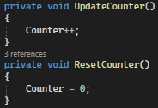

The following code corresponds to the number of times the user has entered a guess. The ResetCounter() method is used three times within the programme: Quit button, Continue button and the Main Menu button. This method is self explanatory and just resets the counter when the user changes pages. This ensures that the counter is reset before replaying the game. The UpdateCounter() method however is used to increment the counter and is called when the user clicks the ‘Enter’ button. The ‘Counter’ corresponds to the RevealLetters() method which is the method used to process and display the secret hint.

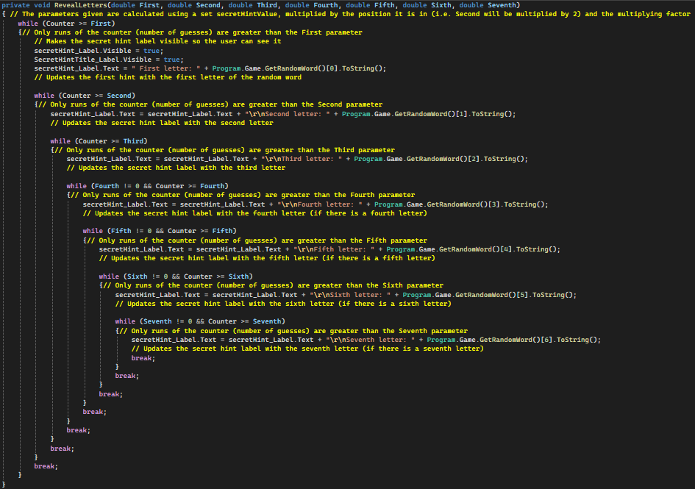

The RevealLetters() method works by firstly making the corresponding labels visible to the user, after this the counter is checked and the corresponding label is updated with the correct letter. I used while loops instead of IF statements to increase simplicity and reduce the size of the method. If the requirements aren’t met for the next while loop, the current while loop is broken to stop the method from continuously running aimlessly.

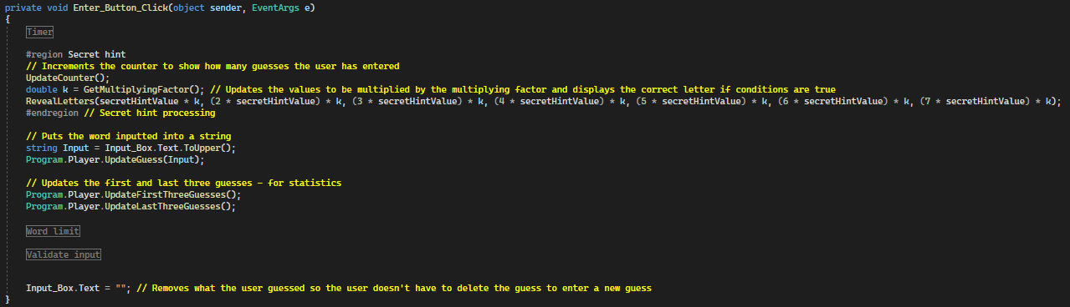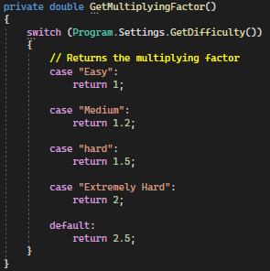

The UpdateCounter() and RevealLetters() methods are called when the ‘Enter’ button is clicked, which can be seen in the ‘Secret hint’ region. Due to the nature of the secret hint being to increase the likelihood of the user guessing the word correctly, the hint is purposefully made to take longer to achieve. In order to do this, I made another method - GetMultiplyingFactor() which returns a suitable integer depending on the difficulty selected.

The multiplying factor is represented by the variable k, which is how the secretHintValue gets updated. The parameters in the RevealLetters() method correspond to the number of characters and the parameters get updated with how many ‘guesses’ the user has to input to reveal the secret hint.

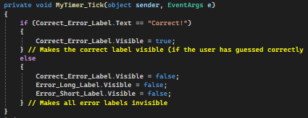

The MyTimer_Tick() method is used along with the ‘Timer’ region within the ‘Enter’ button. This method is used to display the corresponding error / correct / incorrect labels after the user has entered a guess. After displaying them, a timer starts which eventually hides the labels after a short period (3 seconds). The reason why I have implemented this is to limit the amount of information on the screen so the user doesn’t get overwhelmed. This is also beneficial because it increases urgency of the incorrect / correct / error labels.

This code below shows the Timer region and the code used to start the timer.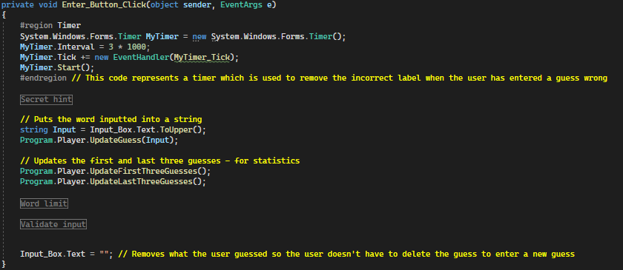

This image below shows the code for the Word Limit region. Firstly, the total guesses is decremented by 1 since the user has entered an input when this button is clicked and the code is run. The IF statement however is used to display the illusion of if the user has unlimited guesses or not. This region is simple and only relates to the word limit label.

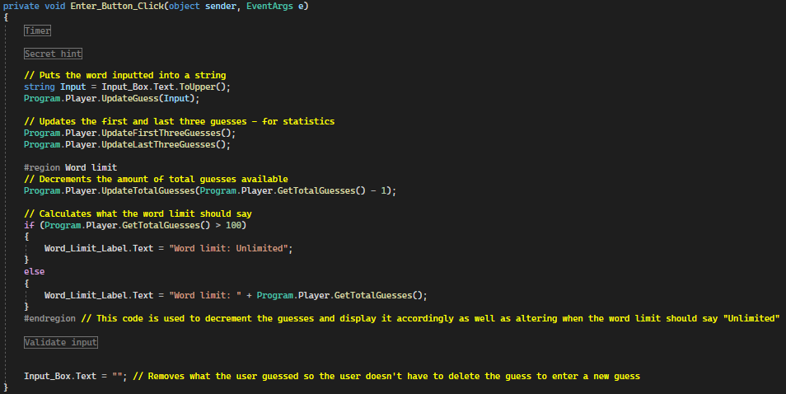

Finally, this image shows the Validate input region. Firstly, the value inputted is checked to see if it is the correct format (no special characters + the correct number of characters), which is done by calling a validating function in the Game class. After this the answer is checked to see if it is the same as the hidden word or if the user ran out of guesses, both of which will display the correct answers (by editing the text and text colour of the Correct_Error_Label as well as making any relevant features visible / invisible to the user).

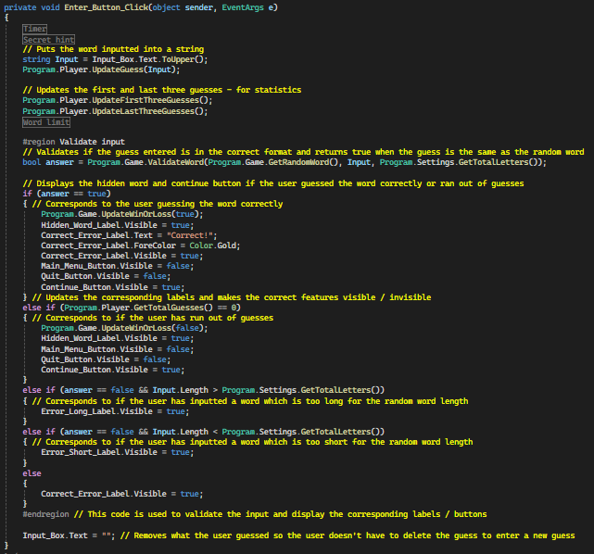

This region works with the Timer region by making the correct label visible based on the guess the user has inputted. For example, if the user entered a value which is too short, then the Error_Short_Label will be made visible, telling the user that the word they inputted is too short. The instant the error label is made visible the timer starts, which eventually calls the MyTimer_Tick() method when the timer is up, hiding the label.

Finally, the input typed into the input box is removed to give the illusion that the value has been processed.

Finally, these three methods relate to the Main Menu, Continue and Quit buttons. When each button is clicked, these procedures are run. The quit button is the only complex one which just makes the relevant buttons / labels visible or invisible as well as updating the Game class’ attribute of ‘WinOrLoss’ (a boolean variable which holds the data for which the user has won or lost the game) to false, meaning the user has lost the game.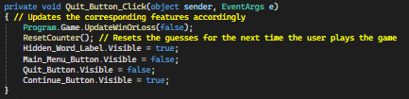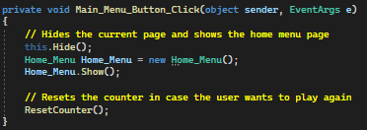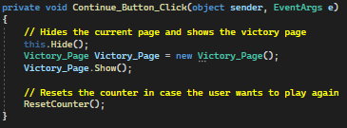

## Game class:

This class is required to hold essential information that needs to be accessed from every page, such as whether the user has won or not and the Random Word generated. This class is essential and is primarily used on the Game page.

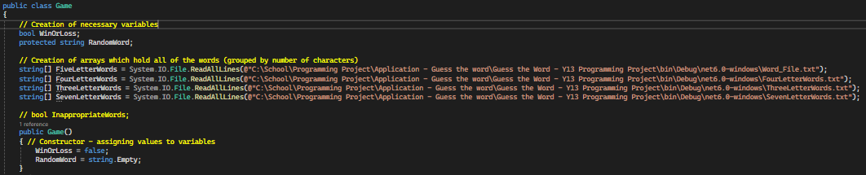

These are the attributes needed as well as the constructor for the class. A one-dimensional array is used to store the words of every letter in an external file, all of which are split up by number of characters. These arrays are used in the GenerateRandomWord() procedure which uses a simple random word generator to select a random word from the corresponding array at which the user has chosen.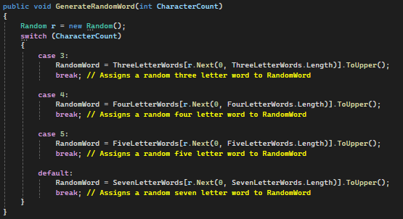

The procedure simply updates the RandomWord attribute with the selected random word which can then be accessed easily.

These methods are used as a gateway to access each attribute from any page with the simple line of code of; Program.Game.**Method()**.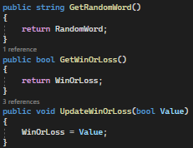

This is the most complex function within the Game class, it is used to validate the guess to make sure the guess inputted has no special characters in it (the nested for loop) as well as if the guess inputted has the same number of characters as the hidden word. If the user’s input is the same as the hidden word, the function returns ‘true’, otherwise the function will return ‘false’. The returned value is then used in further processing on the game page in the ‘Enter_Button_Click()’ method.

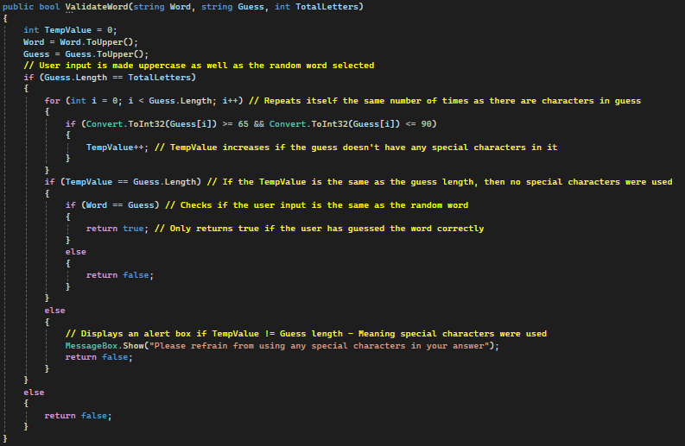

## Hint class:

This class is used purely for hints. It is only used on the Game Page and holds all of the data necessary to display hints correctly. No constructor is needed.

Most methods are simple and are only used once in the programme as of the first prototype, this class will be updated in the 2nd prototype with the implementation of a database.

Hints used as of the first prototype:

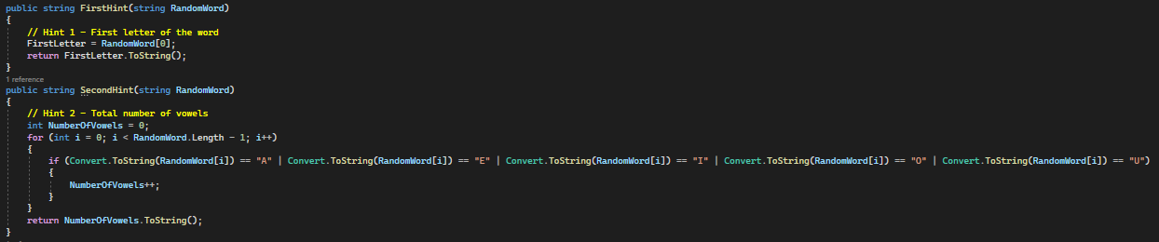



These hints are simple and will be optimised in the 3rd prototype.

Finally, the GetHint() method is used to return the specified hint wanted to the Game page, which can then be used to display the hint on its specified label.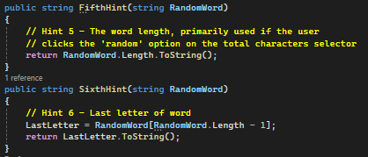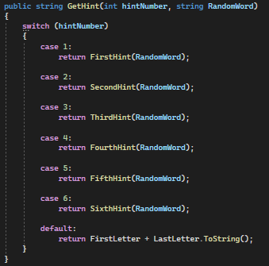

The two screenshots below show the code for the fourth hint

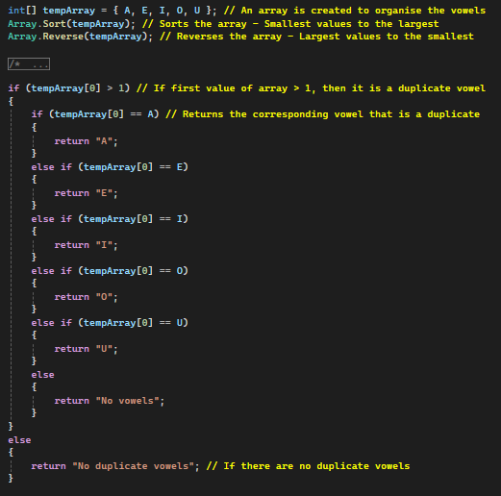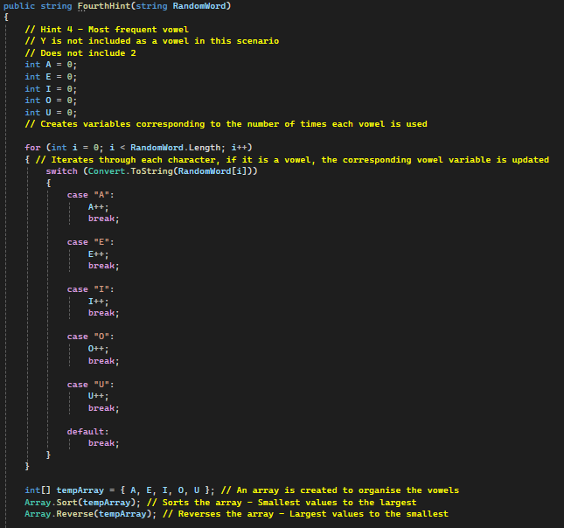

## Database class:

This class will be developed in the 2nd prototype and inherits the game class. It holds the current expected statistics which are going to be implemented, however it is currently unused.

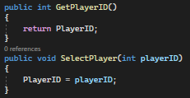

The only current methods are going to be used for a login page which will be implemented in the third prototype if I have any space time.

## Player class:

This class inherits the database class (for later use with a login page - extra feature which may be implemented in the third prototype) which inherits the game class. It holds the necessary information relating to the guesses the user inputs - including the current guess statistics.

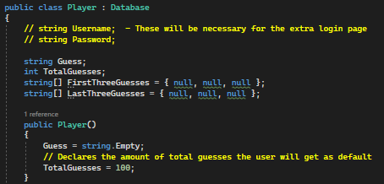

The image to the left shows the attributes used as well as the constructor.

TotalGuesses corresponds to the amount of default guesses the user is allowed, however this changes depending on what difficulty the user chooses.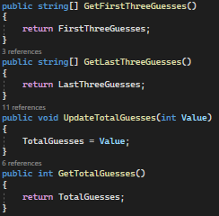

The rest of these methods are self explanatory, most of which act as a gateway for all pages to access and update the attributes. The first and last three guesses correspond to the statistics on the victory page.

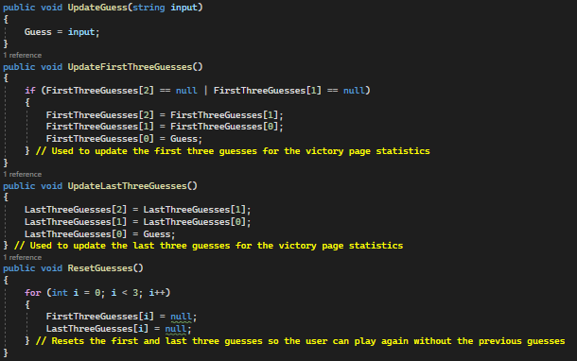

## Settings Class:

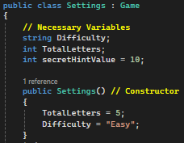

The settings class inherits the game class and is used primarily on the settings page.

This image shows the attributes and the constructor. The constructor is used to set the default settings for if the user wants to get into the game quickly and clicks the ‘play game’ button without altering the settings. The secretHintValue attribute is used for the secret hint on the game page. The higher the value, the longer it takes for the secret hint to be activated.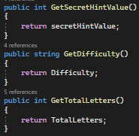

These are the usual methods used as a gateway for every page to access the values easily.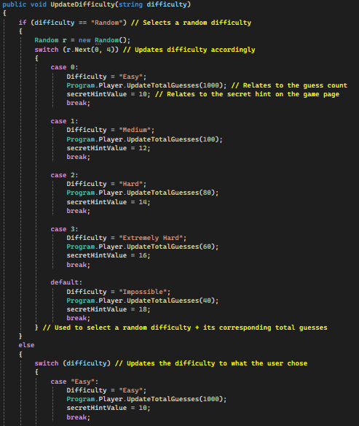

The UpdateDifficulty() procedure is the longest method due to the nested selection statements (IF and Switch statements). This method is used to update the difficulty depending on if the user selected it or if the user wanted it to be random. On top of this, the secretHintValue and total guesses are updated accordingly, to increase the difficulty. Overall this improves the complexity of the programme whilst scaling the difficulty appropriately.

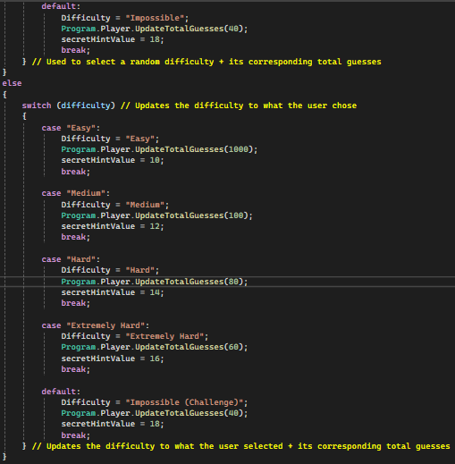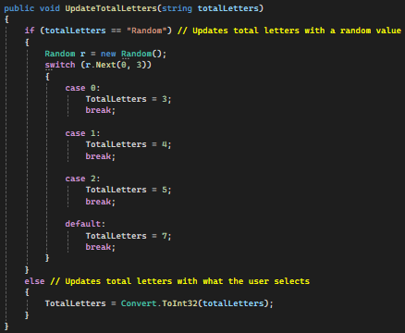

Finally, this procedure is used to update the character count of the word the user wants to guess. The same with the difficulty, the user is able to select ‘random’ which selects a random number of total letters. However the user is still able to select a specific total number of characters that they wish to guess.

## Errors:

### Victory Page Label Error:

On the Victory_Page window I needed to show the correct label and to hide the other label corresponding to if the user won the game or not. I originally managed to do this via panels (which hide each label). For this to work however I need to hide and show these panels which was the biggest obstacle to overcome. I succeeded and solved this issue with the code: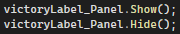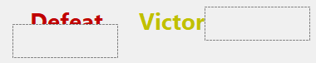

This worked and proved to be effective. However, whilst looking through the properties of each panel and label, I discovered that there is a property called “Visible”. This made each panel obsolete since I can set each label’s visible property to true or false as required, which solved my issues within a single line, which is overall more efficient - as seen below.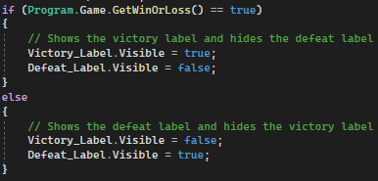

### Displaying the hidden word error:

On the Game_Page you are able to input guesses. Once you guess the word correctly, you are sent to the Victory Page immediately, which shows you your statistics and if you want to play again. Here, the error arises where you are unable to see the hidden word unless you guess it correctly (and remember your last). To solve this issue, I created a new button called “Continue” and set its visibility to false, meaning the user cannot see the button and cannot click it. This button then appears once you have guessed the word correctly or ran out of guesses. Whilst this button appears, the quit button disappears, and the continue button is moved in its place. This solves the issue because the hidden word is visible when the continue button appears, allowing the user to see the hidden word.

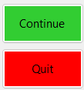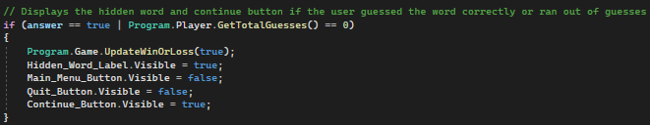

### Selecting default settings / updating them:

On the Play Game Menu there is a button which takes the user to the Game Page and sets default settings as a result. However, the problem arises when the user selects their settings and goes back to the Play Game Menu to click “Play Game” instead of clicking “Continue” on the Settings Menu. When the user clicks the “Play Game” button, the difficulty is automatically set to “Easy” and the total letters is automatically set to “5”, as seen in the code below:

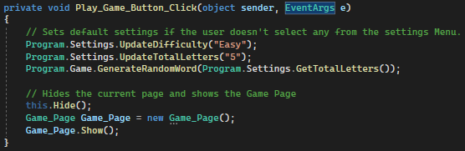

To fix this, I made use of the UpdateTotalLetters() and UpdateDifficulty() procedures in the Settings class. By using these procedures, I was able to call them when the user clicks the “Back” button (as well as the “Continue” button) on the Settings Menu Page, thus updating any changes made to the settings.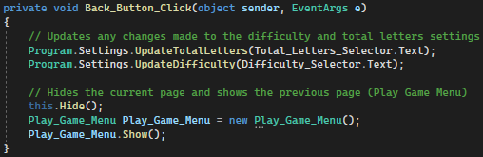

Furthermore, I changed the default values of the TotalLetters and Difficulty (in the Settings class) to “5” and “Easy”, this means that if the user clicks the “Play Game” button on the Play Game Menu, the default settings will be used, and if the user has changed the settings, they will be used. This can be seen in the constructor of the Settings class. On top of this, I removed code from the “Play Game” button, which was updating the settings to its default value, which isn’t required anymore. 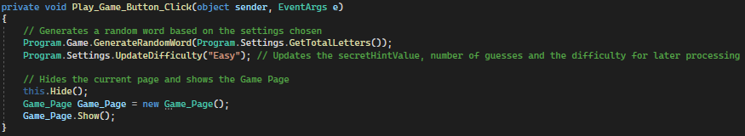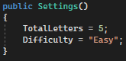

### Secret hint display:

The secret hint on the Game Page works by displaying each individual letter of the hidden word one at a time depending on how many guesses the user has. The minimum number of guesses the user has to guess before a letter appears is dependent on an algorithm (multiplying a certain number by a certain multiplying factor). Originally I made 7 values which would all be multiplied by the same multiplying factor: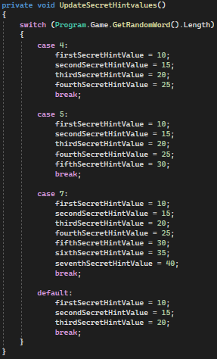

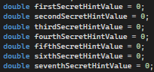

However this seemed inefficient due to multiple variables being created and ultimately only used once to figure out if the user is due a secret hint or not.

In order to make this more efficient I removed all 7 variables (thus allowing me to remove the UpdateSecretHintValues() procedure- reducing file size) and replaced them with a single variable which would be used as a staple guess count for the user. This will work by the variable (named **secretHintValue**) being passed as a parameter to the RevealLetters() procedure which is used to check and display the secret hint. The RevealLetters() procedure required 7 parameters to function, to solve this issue I simply passed the same **secretHintValue** in 7 times, each time multiplying by n (starting from 1 and incrementally increasing by 1). Overall solving this problem, making my programme more efficient.

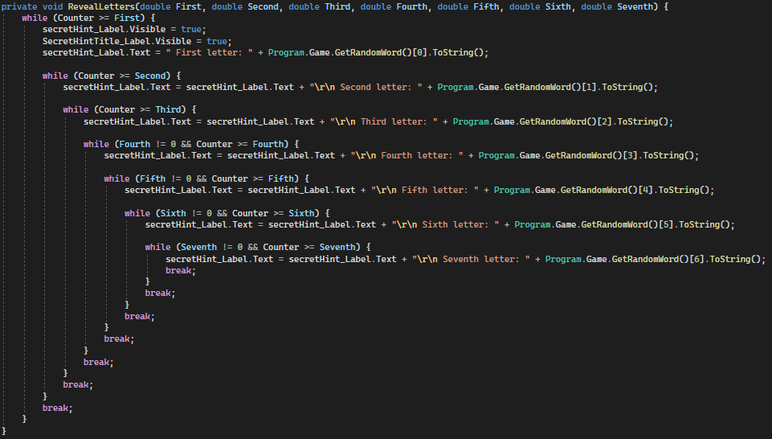

This code above shows how each value is compared to the counter (which is the check) and then displays / updates the secretHintLabel accordingly.

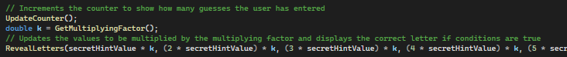

This line of code is held within the “Enter_Button_Click()” procedure. UpdateCounter() updates the amount of guesses the user has entered. The local variable k corresponds to the function GetMultiplyingFactor() which returns the multiplying factor and updates the secretHintValue. Finally, the RevealLetters() procedure displays the corresponding letters based on the counter (which relates to how many guesses the user has entered).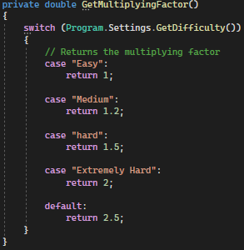

This code to the right corresponds to the GetMultiplyingFactor() function.

### Game Page:

In order to display each hint I originally created several different labels, each corresponding to a specific hint. This was beneficial since I was able to easily alter the properties of each hint individually (as well as coding them individually). However, whilst implementing the difficulties (and their corresponding hint allocation) I figured out that there will be gaps within the hints when they are all displayed. Determined to fix this, I tried to display all of the hints within the same label. After implementing half of this, I realised that it was extremely long winded and inefficient compared to the original labels used as the number of operations used to display a hint was fairly minimal due to the switch statement used. After keeping the original code, there were 2 ways I could try to improve the programme; create a recursive procedure to display all of the hints on one label or change the text within each restricted hint to tell the user.

For this prototype, I decided to go for the simpler option of telling the user which hints are restricted depending on the difficulty selected and left the potential recursive algorithm for later prototypes to improve efficiency within my code.

## Post Prototype Test Data:

| Feature Being Tested | How it will be tested / Data Input | Expected Output | Actual Output | Result - Further Action Needed? |
| --- | --- | --- | --- | --- |
| Back button processing on the Settings Menu. | Inputting values (none, one or both as well as values which aren’t in the selector list) in the Difficulty and Total Letters selector before clicking the back button. | If one or no values are inputted, the user should get an alert box asking them to input suitable values into the two selectors. | Both cases function as intended. The alert box appears and the values are saved for later use. | Partial success.  Further action needs to be taken to ensure that values which are not in each selector list cannot be inputted. This will be fixed in the third prototype since users are most likely going to choose the values within the drop down selector due to convenience. Making this issue low-priority. |
| If both values are inputted, the values selected will be saved and the user can go back to the Play Game Menu. | However, if the user inputs values which aren’t values in each selector list. The Difficulty is automatically set to Impossible, and the Total Letters is automatically set to 7 (due to these settings being held within the default case in each corresponding switch statement). |
| If the Difficulty Display label on the Game Page functions properly. | This will be tested by selecting all difficulties on the Settings Menu which will update the label on the Game Page startup. | Each difficulty should be shown clearly and must be easy to read. | All difficulties except the Impossible difficulty is shown clearly and is readable. The Impossible difficulty however overlaps the Main Menu button due to the extreme length of the label. | Partial Success.  In order to fix this problem, I will edit the location of the display accordingly so it will always remain in the bottom middle regardless of the length of the label. Furthermore, I will remove the “(Challenge)” from the text to shorten the label. |
| Traversal through every page. | This will be done by clicking all the corresponding buttons (along with meeting all requirements for the traversal code to run) on all pages. | Each button should take the user to the correct, designated page immediately without fail. | All buttons work perfectly, going to the correct page immediately without fail. | Complete success.  No further action needed. |
| If the error labels show correctly + show the correct error. | There are 3 error labels: If the word is too long, short and if the word inputted is not the same as the random word chosen. | If the word is too short the “Too short” error will appear briefly before disappearing. | All error labels appear and disappear in appropriate times and when they should appear / disappear. | Complete success.  No further action needed. |
|
| If the word is too long the “Too long” error will appear briefly before disappearing. |
| In order to test these, I will input a word that is too short and long compared to the random word, as well as input a random word which isn’t the same as the random word. |
| If the word is incorrect, the “Incorrect” error will appear briefly before disappearing. |
|
| If all hints work as intended. | I will use the Hint Number selector to choose every hint individually, then I will reset the game and select the “Random” option and test to see if all hints are revealed. | Each hint should be revealed and remain visible. Each hint number should only reveal the corresponding hint. The “Random” hint option should be able to reveal all hints on a random basis.  Any restricted hints should remain restricted and invisible. All hints should be accurate and correspond to the random word. | Almost all hints are completely accurate and correspond to the random word (not a previous word generated). On top of this, each hint value reveals the correct hint. | Partial Success.  In order to make this hint system efficient, I will need to fix the Random option selecting already revealed hints, after this I will have to fix the fourth hint to make sure it gives accurate results if there are two vowels with the same number of duplicates. |
| If any hints are restricted, the hint should remain restricted and remain hidden. | However, if there are two vowels with the same number of duplicates, only one vowel will be displayed in the hint, which is only partially accurate. |
| Finally, all hints should be accurate. | The random option on the selector sometimes doesn’t work since a random hint that has already been revealed can also be selected. Overall the random option doesn’t reveal every hint in an efficient manner. |
| If the First and Last three guesses (from the previous game played) on the Statistics Menu are updated as the page loads. | I will play a game and enter three values, after that I will go to the Home Menu and navigate to the Statistics Menu, this will then show if the values update or not. | If the user hasn’t played any games, a message will show saying the user has no data. If the user has played a game, it should display the First and Last three guesses. | Labels aren’t updated with any statistics or updated with any error message saying the user has no data. | Failure.  The further action needed is each label being updated with the “No Data” message if the user has no data. After this the First and Last three guesses will be stored in variables in the Statistics / Database class which will be used to update each label accordingly. |

# Implementation - Prototype 2:

## Database:

Due to this programme being made using WinForms in Visual Studio 2022, connecting an external database proved to be difficult since databases are usually connected to Visual Studio Code, an alternative IDE (integrated development environment) instead of Visual Studio 2022. Therefore, I found it difficult to connect my project to Supabase (an online application used to manage and query data), which was my original idea. Instead, I decided to just use a simple text file to store data values, which proved to be effective and an efficient way to store the users statistics. However, if the programme grows anymore or is uploaded online, then a more sophisticated database will be required to store the data of different users, as well as a login page, which will be used to input a username and password which will then pull the necessary data referring to the corresponding table, holding all statistics. This will be made possible with an advanced database using SQL which will be connected to the programme. In advance of any growth / if anyone was to pick up my project, I have included a PlayerID value in each text file, which acts as a primary key - allowing for multiple text files to be used and easy conversion to a database.

## Database class:

### Text Files:

This class is purely used to control all of the statistics in the programme. I have done this via the use of a text file to store any values. I am currently using 2 text files to store all of the data. One text file is used to display the statistics accordingly, making it readable to humans, acting as a proxy for the statistics. The other text file holds several integers, which are the statistics that are stored, these values don’t mean anything on their own without any context, which is why there is another text file containing all of the information relating to them. Thus the two text files are used simultaneously to deliver and store all statistics. The proxy text file is named Database.txt and is only used 4 times within the programme, mainly to figure out the length of the array, which is used to display the correct data. This is necessary because there are data values which shouldn’t be shown as they are used in the processing of other statistics. Overall not all lines need to be shown, for example, the last 5 lines are used to calculate the Most Successful Letter word statistics. The other text file is named Data.txt, which holds all of the data used to process the statistics. This file holds several lines of integers (17), which are all used in processing. The Database.txt file is also used to reference what statistics relate to what data within the Data.txt file, which is an extremely useful developer tool, especially when more statistics get added.

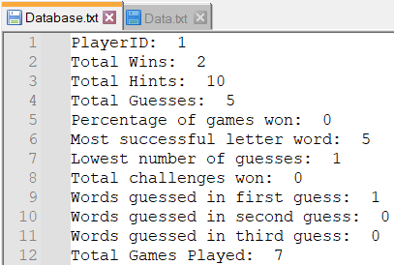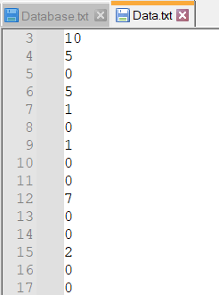

### Class Code:

Firstly, in order to process any data, the data needs to be read from the file and stored in an array. Which can be seen in the following code:



Due to me using WinForms and different classes, I need methods which return any necessary data in order for each page and class to communicate with each other.

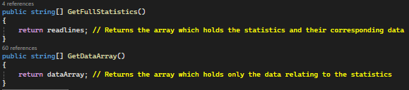

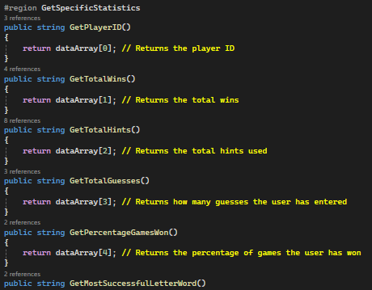

This code corresponds to the region GetSpecificStatistics. These methods return the specific statistics data via the index in the array which holds all of the data from Data.txt - named dataArray. These methods are essential because it allows for the developer to reference each specific statistic and process them accordingly, rather than using the GetDataArray() method found on the previous page and trying to remember each specific index of each statistic. Overall this makes each individual statistic easier to access. Not all methods have been shown since all of them are the same, excluding the method name and the index of the dataArray returned.

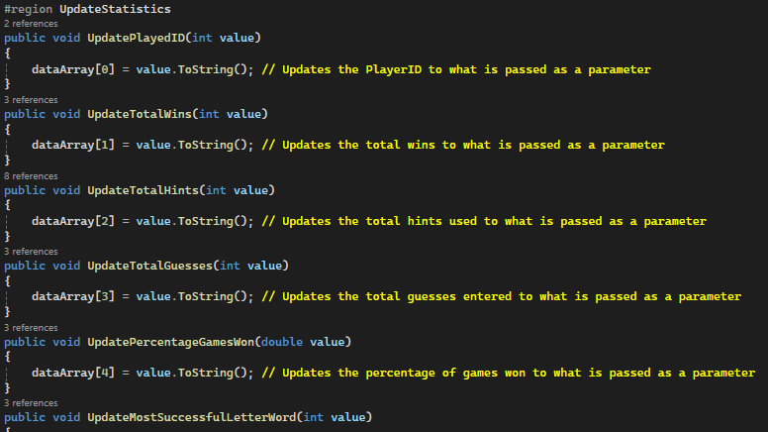

This code however is used in conjunction with the getter functions. This region - UpdateStatistics - is used to update any statistics. These procedures only use the dataArray (which uses the data from Data.txt) because if the values had anything other than integers, it would complicate the programme and wouldn’t be efficient, since only the integers are used in processing. Therefore this region only holds procedures which update integers - all of which are integers in the form of strings because the dataArray only holds the string version of the file when Data.txt is read. Not all methods have been shown since all of them are the same, excluding the method name and the index of the dataArray used.

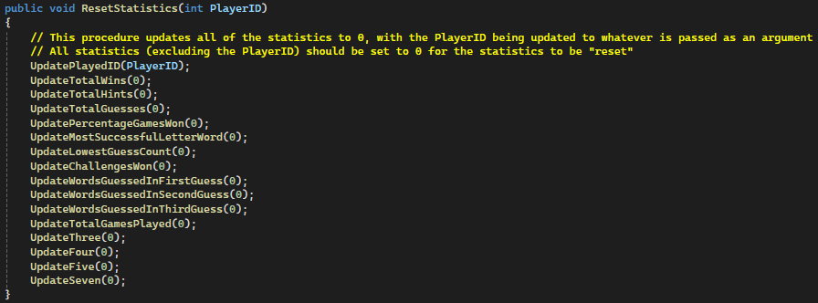

This procedure is used to reset all statistics (excluding the PlayerID). This is only used once and is used on the statistics page (which has been fully implemented in this prototype) when the “Reset Statistics” button is pressed. It resets all statistics by updating all values to “0”. However, the PlayerID will be updated to whatever argument is given. Currently, there is only 1 database (using 2 text files) so there is only one PlayerID, but as the programme grows, more databases will be required and more PlayerIDs will be needed, which is why it will reference which record needs resetting (using PlayerID as a primary key). Overall, this update will be done in the third prototype or in the future if someone develops it further (when more text files / a functioning database is implemented).

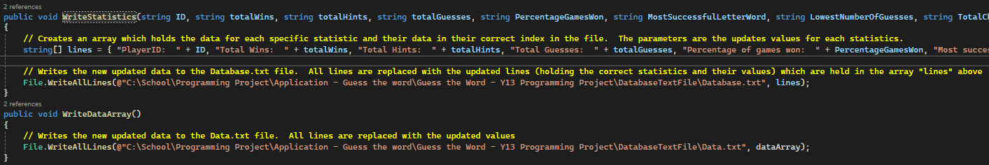

These two procedures are used to rewrite each file which is important for storing all of the updated data so the data is up to date and can be used when the programme gets used next. These procedures are both used twice, which are on each quit button in the programme - Home Menu and the Victory Menu. Due to the dataArray being updated directly, dataArray can just be put in the File.WriteAllLines() command (in the WriteDataArray() procedure) which will update the Data.txt file correctly by rewriting each line with the same updated data. The WriteStatistics() procedure however, needs the data from dataArray to be passed as parameters individually to ensure the data is saved correctly in the Database.txt file. Since the Database.txt file has text on each line, the text needs to be rewritten when the File.WriteAllLines() command is used, thus resulting in a string array called “lines” being used, holding all of the correct text on each line.

This is the rest of the code from WriteStatistics(). It is done in 3 images due to its size.

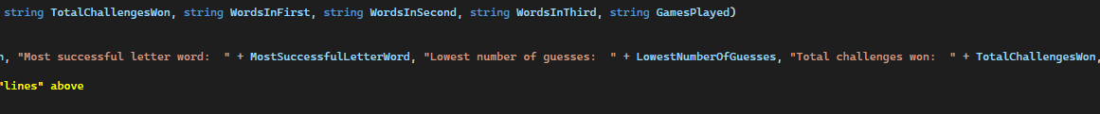



Finally, the last region holds the necessary functions and procedures to process and update the data for the Most Successful Letter Word statistic.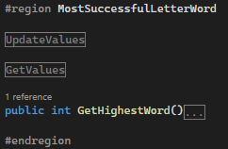

This region holds 2 more regions as well as the function used to return the number of characters word which the user has guessed the most. The GetHighestWord() function is called on the Victory Page when it is loaded, updating the Most Successful Letter Word, which is then shown in the statistics on the victory page and written to file later.

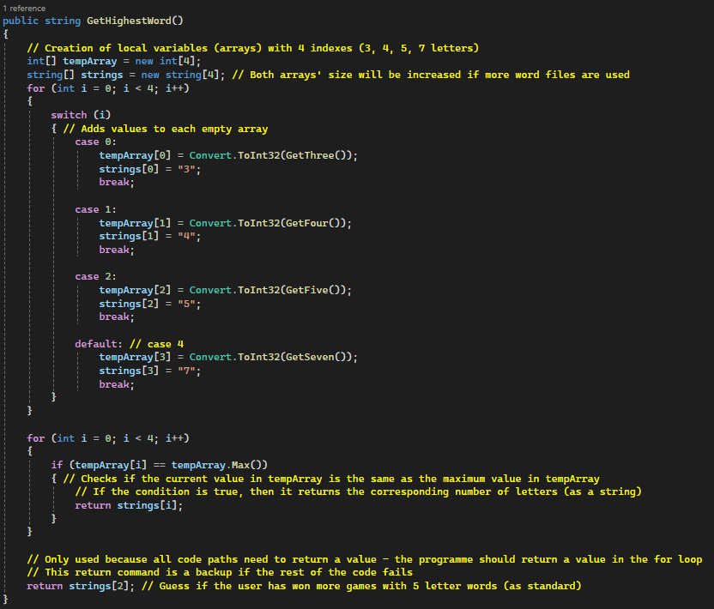

This function uses the last 5 values in the Data.txt file. Each value corresponds to a number of characters (for example, the value on the 13th line in the Data.txt file represents the number of times the user has guessed a 3 letter word correctly. With the 14th line representing a 4 letter word and the 15th representing a 5 letter word etc). Each value is updated when the user guesses a word correctly, after this all 5 values are compared with each other and the highest value is returned, which is the Most Successful Letter Word.

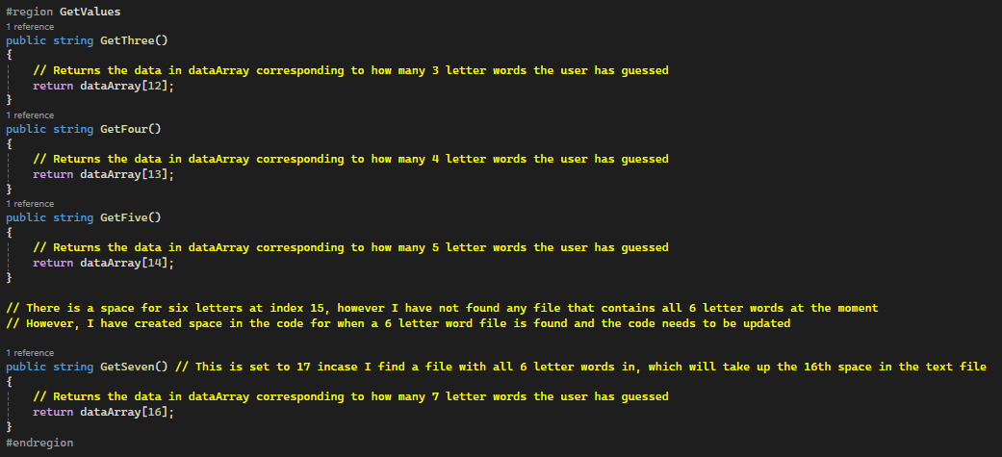

This region is held within the MostSuccessfulLetterWord region. It is used to get the values in the dataArray which correspond to how many times the user has guessed a 3, 4, 5 or 7 letter word. With GetThree() holding the 3 letter value and the GetFour() value holding the 4 letter value etc. The six letter word function is missing because there isn’t a 6 letter word option since there is no file with all of the 6 letter words in the programme at this current time.

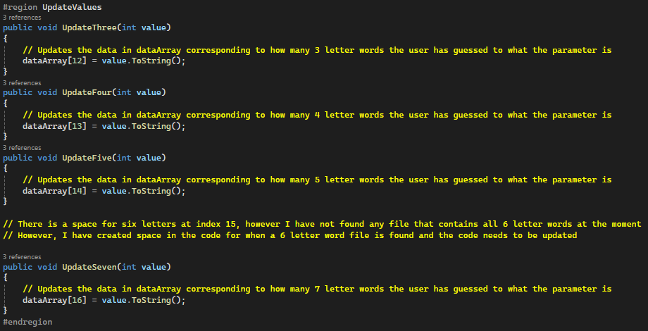

This region is also held within the MostSuccessfulLetterWord region and holds the code for the procedures used to update the last 5 values in the Data.txt file (excluding the second to last line as that is reserved for the 6 letter word, which currently doesn’t exist). These procedures are called if the user guesses the word correctly when the user clicks the enter button on the Game Page.

## Statistics Menu:

This menu has been fully implemented in this prototype. Its design and layout hasn’t changed from the original design and all buttons and labels work as intended. This page is also fitted with the same usability features as the rest of the pages (background of buttons and button text changing when you hover your mouse over it).

There are three labels; All Statistics, First Three Guesses and Last Three Guesses. The First and Last three guesses use the same code as the same labels from the Victory Page. However, the Victory Page uses 3 hidden labels to display the three guesses, this differs from the Statistics Menu code because all of the guesses are displayed using a single label. This is done with the following code: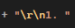

The \r\n command basically works the same as a Console.WriteLine command, it finishes the line and goes down a line, allowing for text to be input in the label below whatever is currently in the label. Overall 3 lines can now be turned into 1, making the code a lot easier to read and understand for everyone.

This is the full code that updates the First and Last three guesses labels using the Player class (which holds the data).

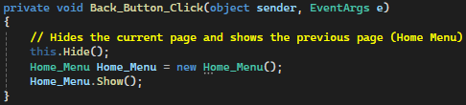

This code corresponds to the back button and if you click it. It simply returns the user to the previous page (Home Menu).

When you click the Reset Statistics button, an alert box with an input box appears. This is to warn the user that they are about to reset all of their statistics, the user can only reset their statistics if they go through further confirmation by inputting the correct option which is shown in the alert box.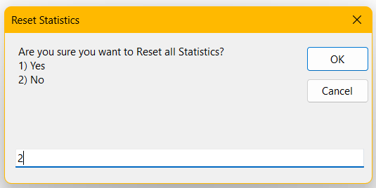

This is the alert box shown, it is titled “Reset Statistics”, representing the topic of the current situation. It also has a question, followed by two options, at which the user can input and click “OK” to validate it, or “Cancel” to close the alert box and do nothing - Not reset any statistics.

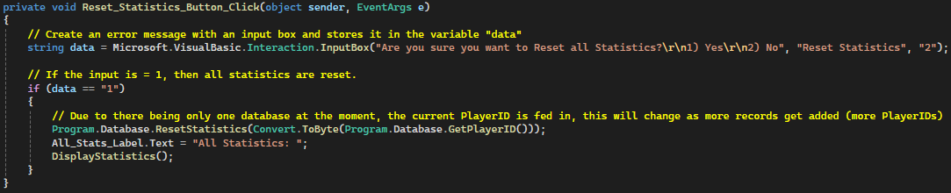

This is the code for the Reset Statistics button when it is clicked. The alert box with an input box is created with the command - Microsoft.VisualBasic.Interaction.InputBox(). The selection statement however is used to reset the statistics if the conditions are right, which it does so by changing all of the statistics to 0, and then renaming the statistics label, removing any incorrect / obsolete values. Finally, the reset statistics are then displayed again using the DisplayStatistics() procedure.

This procedure can be seen on the following page. It uses a simple for loop (which is run as many times as there are a number of statistics) which repeats a switch statement, which updates the statistics label line by line, adding any statistic which is missing. This procedure is called when the statistics are reset, and when the page is loaded, same with the first and last three guesses being loaded on the page startup.

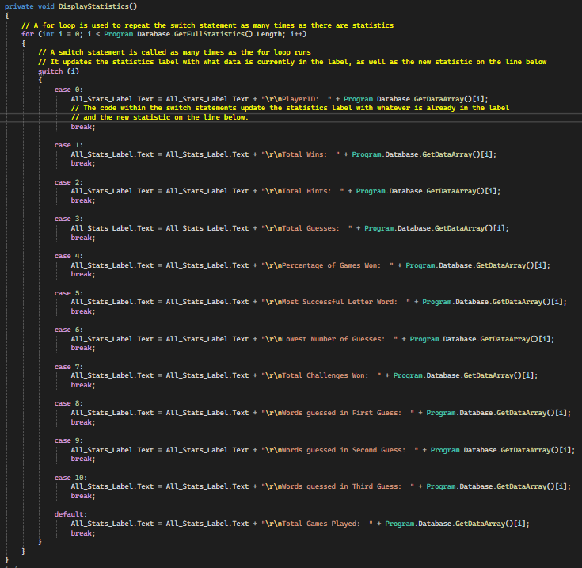

## Game Page (Updates):

One of the features I missed in the first prototype (because of the lack of a database with statistics) was the full statistics button / miniature statistics display on the Game Page. I have created this in the second prototype and it hasn’t differed from the original feature design.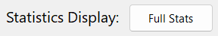Although, one way this differs from the original design is the arrangement of the buttons and the lack of textbox border & background. This display makes use of only 1 label, which is made possible with the “\r\n” command which can be used to go down a line in labels (essentially the whole function of an “enter” button). This can be seen in the following screenshot, which is used to update the statistics display with the limited statistics when the Game Page is loaded.

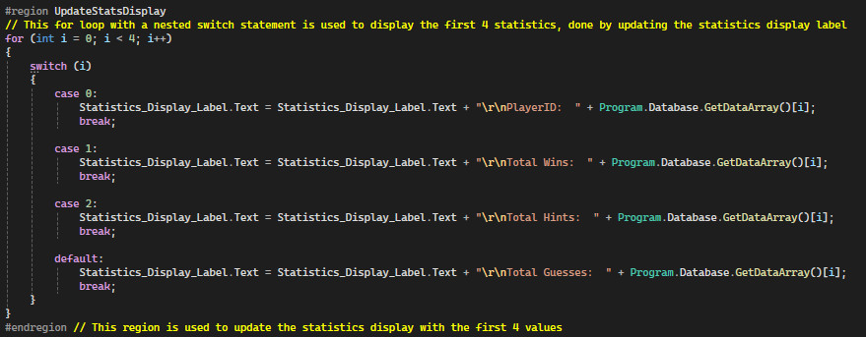

This code is run only once and represents the 4 statistics that need to be displayed at all times.

I added a Full Stats button which displays all statistics when clicked (updates the Statistics Display label with the other, specific + relevant statistics). This button’s text / name changes when you click it to the opposing value. For example, if the text is “Full Stats”, then the opposing value would be “Hide Stats” and vice versa. This is done with similar code to the initial UpdateStatsDisplay region when the Game Page starts up (seen above):

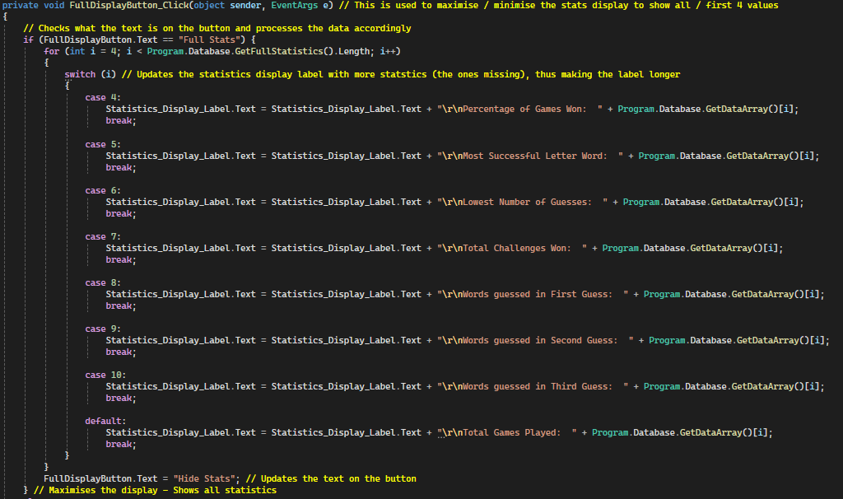

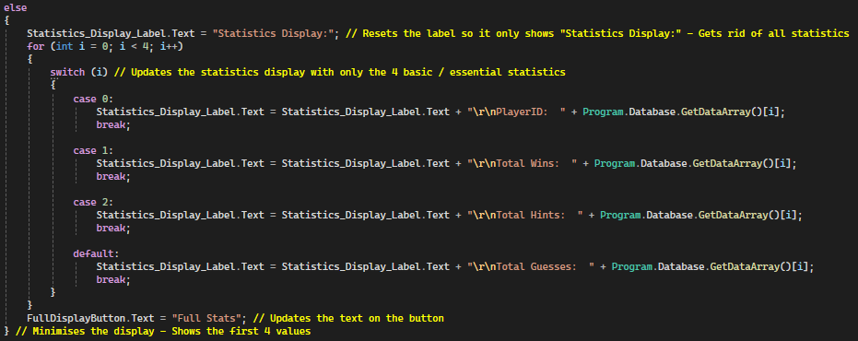

Similar code can be found in the Enter Button Click procedure which is purely used to update / refresh the statistics so they are constantly up-to-date. This ensures that the data is accurate. This works by updating the whole statistics display label with the data held in the database class (which would be the most up-to-date and accurate data).

In order to make use of the database (text files) effectively, I needed to update the relevant statistics when required. The majority of this is seen on the Game Page (with the rest being on the Statistics and Victory pages).



This code is held within the region Statistics, which holds the region UpdateStatsDisplay - Which holds the code to update the mini stats display on the Game Page startup. Due to this, this code is run on the Game Page startup. This code is run on startup because the user has technically started a new game when the Game Page loads.

The rest of the statistics updated on the Game Page are held within the Enter Button Click event handler:

Firstly, the total number of guesses is updated as soon as the user clicks the enter button.



The following code is held within the region - Statistics.

Secondly, the LowestGuessCount is updated. This statistics corresponds to the lowest number of guesses that the user has used in order to guess the word. It uses an IF statement and is only updated if the number of guesses is lower than the record (with the use of the count variable) or the number of guesses record is held at 0, which is for when the user resets their statistics.

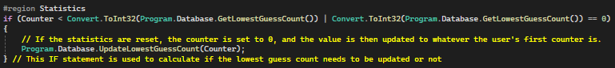



Due to this code being held within the positive condition, the user has guessed the word correctly, therefore this code is essential for keeping track of how many games the user has won.

After this, an IF statement is run to see if the user has guessed a word correctly on the “Impossible” difficulty level (or in other words, the “Challenge” option).

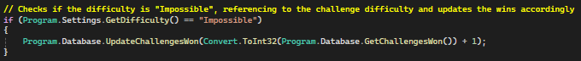

Following this, the words guessed in the first, second or third guess, are incremented like the rest of the statistics.

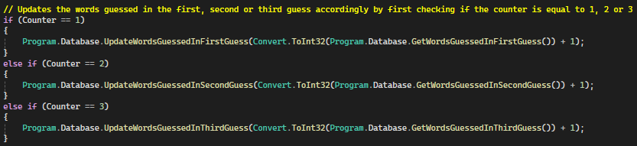

Finally, the last statistics being updated correspond to the values at the end of the Data.txt files. These numbers are used to calculate the Most Successful Letter Word statistic, which is calculated on the Victory Page.

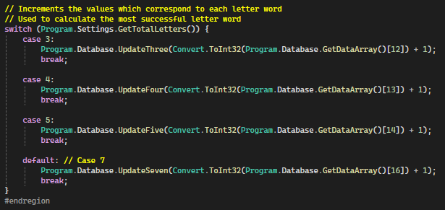

Other changes I have made are with the error labels, the incorrect label remains the same, however, the two Word is too long / short labels have been combined into one label named “Error Length Label”. Thus simplifying and reducing the complexity of my programme.

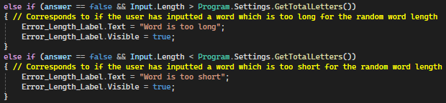

Finally, the last change I have made to the Game Page is the Reveal Hint Button Click event handler. Even though the event handler worked before, it was inefficient and if you selected the “Random” option (within the hint number selector), then a random hint would be selected, regardless of if it has been revealed or if the hint was restricted or not. Overall the original code was prone to errors. However, the new code makes use of recursion and calls itself when a repeated hint is selected (a hint that is already revealed or is restricted). On top of this, this function is only recursive if the user selects the “Random” option in the hint number selector. If the user selects a hint normally, then the procedure works as it did normally, and an error message is shown if the selected hint is restricted.

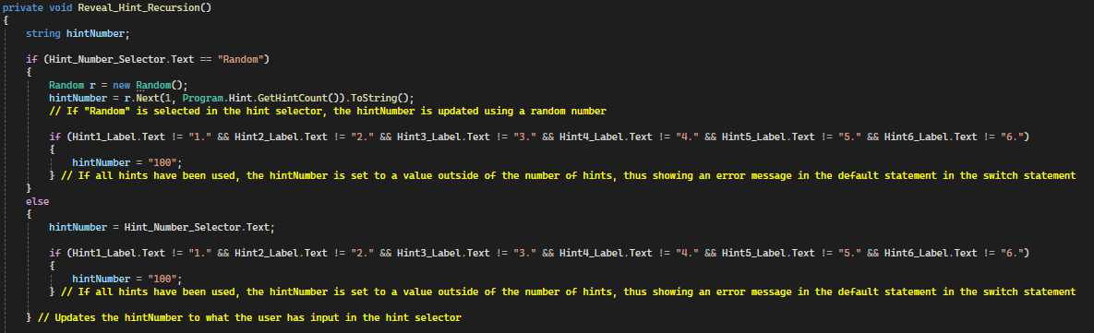

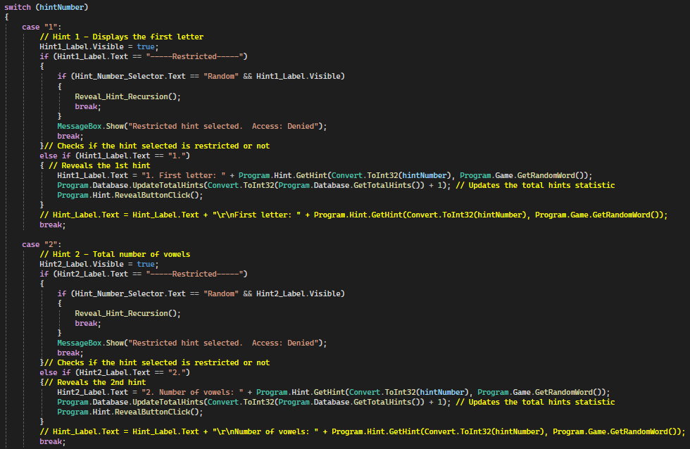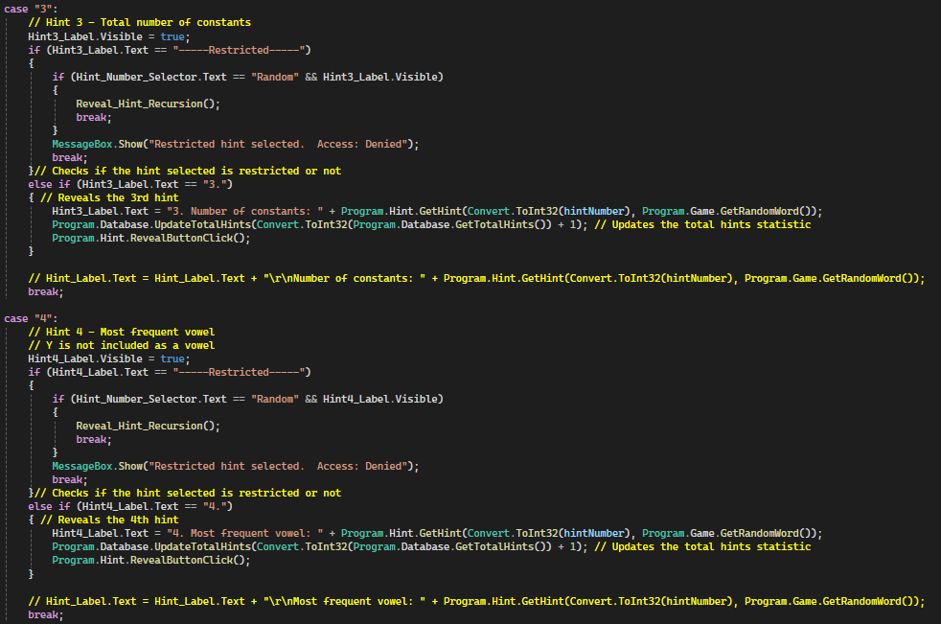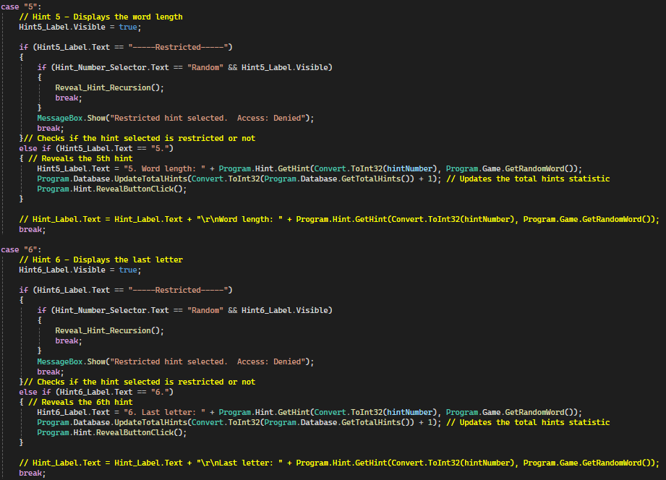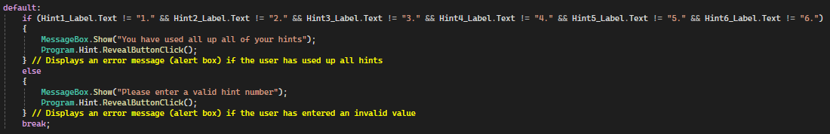

When each hint is revealed, the corresponding Total Hints statistic is updated, thus keeping all statistics up-to-date.

## Victory Page (Showing Statistics):

Due to the statistics being implemented, I was able to make the All Statistics label functional. This is done by updating the All Statistics label with all statistics, which has been made possible with the “\r\n” command. This code is held within the procedure DisplayStatistics(), which is called on startup. Its code is similar to the Refresh stats code in the Game Page Enter Button Click event handler since the same For loop and switch statement method is used. This is shown below: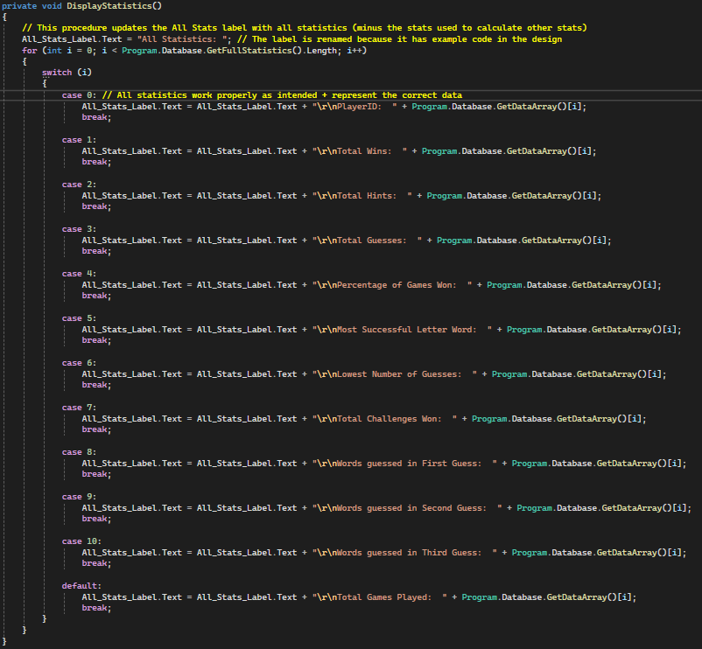

This code only displays the first 12 lines of data in Data.txt because the next 5 lines are used to calculate the value for the Most Successful Letter Word statistic, which is calculated on the Victory Page startup.

The Most Successful Letter Word is updated on startup with the following code:

It takes in the value from the GetHighestWord() function which returns the highest value from the last 5 lines of data from Data.txt which corresponds to a specific number - such as line 17 corresponding to 7 letters.

As for the other statistics calculated on startup, the Percentage of Games Won statistic is calculated. This is done using the calculation (Total Wins / Total Games Played) x 100. Which can be seen in the code below.



## Quit Buttons (Writing all text to file):

In order to store the user’s statistics, I needed to store this data in a database. I ended up using two text files to hold the statistics, one is mainly used for developer purposes. In order to use these text files effectively, I needed to write all of the updated statistics to the files so I can access them when the user opens and uses the programme. This can be seen twice in the programme, on both Quit buttons. The Quit button is the best place to write the updated statistics to each file, since it is the only way to quit the programme (excluding the Close button at the top right) and all statistics should be updated and stored when you quit the programme to avoid any mistakes / values being updated by accident.

This is the updated version of the Quit button on the Victory Page, it is exactly the same as the code from the Home Menu and makes use of the WriteStatistics and the WriteDataArray procedures from the Database class. The WriteStatistics procedure takes in all statistics as parameters, which are all called from the GetStatistics region from the Database class. Overall, the WriteStatistics procedure rewrites all of the lines from the Database.txt file with the updated statistics and the WriteDataArray procedure rewrites all of the lines from the Data.txt file with the relevant updated statistics.

## Errors:

### Most Successful Letter Word Error:

One error I found is a logical error when calculating the Most Successful Letter Word statistic. It is held within the GetHighestWord() function. The error is that if there are 2 indexes with the exact same integer (duplicates), then only one index will be returned.

The logical error is found within the IF statement in the second For loop, which is that if there are two max values in the tempArray, then only one will be placed first using the .Max() command. This means that only one value is returned with a potential 2 options needing to be returned instead. This is a minor error, however, since 2 values are technically the Most Successful Letter Word, then both need to be returned for the data to be accurate. I have yet to figure out this error and will pursue it in the third / final prototype.

### Fourth Hint Error:

Another similar error is with the fourth hint, where any duplicate vowels are returned. This error is similar to the previous Most Successful Letter Word error because if there are multiple duplicates, then only one is returned. Like the previous error, I have yet to figure out how to fix this bug and will pursue it in the third prototype.

### Percentage of Wins Statistic Error:

Another logical error found is with the Percentage of Games Won statistic. The value should be calculated with the formula: (Wins / Total Games Played) x 100, which is seen below:



However, this statistic only seems to work for 1 turn before being set to 0 and not changing. The procedure UpdatePercentageGamesWon() is only called twice in the programme, when the statistics are reset and when the statistic needs to be updated on the Victory Page. Therefore I figured that the statistic wasn’t being updated accidentally. However, I did manage to fix the issue, due to the Percentage Change possibly including decimals, I had to change all of the int values to double to ensure that decimals can be included.



This is proven in this code where the parameter - value - has the double data type instead of int. Although this remained double before the error occurred, the fix to this issue was with the Update functions parameters in the Victory Page, as seen below:



Due to the fact that the parameters needed to be passed as integers to be calculated, I used the Convert.ToInt32() command. This caused different data types to be mixed, which is the logical error. To fix this I changed the Convert command to Convert.ToDouble(), which fixed the issue.

### Post Percentage of Wins Statistic Error:

However, even though the logical error was fixed, the string saved is extremely long and specific, which users may not be interested in. Therefore I decided to change store the string saved to two decimal places, which would fit nicely along the other statistics as well as being accurate. In order to do this, I used the Math.Round(string, number of decimal places) command which takes in a string and calculates the new value depending on the number of decimal places given.

Original code:



Updated code: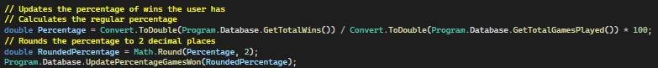

Using the Math.Round() command was a more efficient way to find a value to 2 decimal places (which rounds as well), not only does it decrease the amount of potential lines of code, it also reduces the complexity and can be easily understood by any programmers that decide to update this programme in the future.

### Special Characters Input Error:

In the Game class, a logical error was found which was that an alert box telling the user not to use any special characters was only shown if the user entered all special characters in their guess. The code for the function ValidateWord() is shown below:

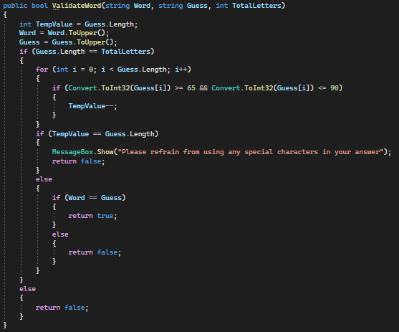

This code represents the nested selection and iteration commands used to calculate if the user entered any special characters or guessed the word correctly.

To fix this error, I changed the TempValue to 0 and incremented it each time a special character was found. After this, I made it so the user’s guess was only checked to see if it was correct if the TempValue was at 0, therefore no special characters could give the correct answer. If special characters were inputted however (any amount), then the else code would run, which would be the alert box. This fixed the issue and now the guessing system works perfectly. The correct code is show below:



## Post Prototype Test Data:

| Feature Being Tested | How it will be tested / Data Input | Expected Output | Actual Output | Result - Further Action Needed? |
| --- | --- | --- | --- | --- |
| Full Stats button & Statistics display on the Game Page. | Clicking the Full Stats button twice (a full cycle) and updating the statistics by inputting guesses and revealing hints. | The statistics on the stats display should be updated every time a hint is revealed and a guess is inputted & entered. | The Full Stats button works as intended, maximising and minimising the stats display. | Partial success.  Further action is needed, the stats display needs to be refreshed every time the hint button is clicked. This is an easy fix which can be done by copying the RefreshStatistics region from the Enter Button Click event handler and pasting it at the end of the Reveal Hint Button Click event handler. |
|
| Inputting a guess and clicking the enter buttons updates the total guesses on the stats display as intended. |
| The Full Stats button should expand the stats display to show all statistics and if clicked again should minimise the stats display to show only 4 statistics. |
| However, if any hints are revealed, the stats display is only updated when the user clicks the enter button. |
|
| If the secret hint updates the Total Hints statistic & if the secret hints work as intended. | All difficulties & number of characters will be selected and the enter button will be clicked several times until all secret hint values are displayed. The Total Hints statistic will be checked after each secret hint is revealed. | All difficulties should be able to show all of the secret hints. The number of characters selected shouldn’t make a difference. | Each time a secret hint letter is revealed, the Total Hints aren’t updated. | Failure.  Future development:  The guess limit for each difficulty needs to be adjusted, as well as the multiplying factor which determines how many guesses need to be inputted before a secret hint character is revealed.  The Total Hints statistic should also be incremented by 1 every time a character is revealed. All of this will be completed in the third prototype. |
|
| On top of this, the programme crashes if all secret hint characters are displayed and the user continues to click the enter button. |
| When each secret hint is revealed, the Total Hints should be updated accordingly. |
| Furthermore, not all secret hint characters are revealed if the difficulty is higher than “Medium”. This is because each difficulty after the “Medium” difficulty has too little of a guess limit, thus the user runs out of guesses before all secret hint characters can be revealed. |
|
| Is each text file updated properly? | This will be tested by updating several statistics via the Game Page and the Statistics Menu. After this, each Quit button will be clicked (Home Menu & Victory Page) and each file will be checked to see if the statistics are stored properly. | Statistics should be stored correctly with no errors. Each value should correspond to the correct statistic also. | Statistics are stored correctly and the data corresponds to the correct statistics. | Complete Success.  No further action required. |
| The last 5 lines of the Data.txt file are also updated correctly, even though they aren’t displayed at any time. |
| Does the reset button work as intended? | The reset button will be clicked on the Statistics Menu. When it is clicked, an alert box should appear with an input box and 2 options, both options wi | An alert box should appear with 2 options, when the “No” option is entered, no statistics should be erased. However if the “Yes” option is entered, then all statistics should be reset to 0. | Alert box functions correctly, and the statistics are only reset to 0 when the “Yes” option is entered. | Complete Success.  No further action required. |
| Are the first and last three guesses correct on the Statistics Menu? | A game will be played, four guesses will be inputted with the fourth guess being the correct word. After this the Statistics Menu should be updated with the correct values. | The first three guesses will be stored and displayed on the FirstThreeGuesses label. | The values stored are correct on the Victory Page and are the same on the Statistics Menu. | Complete Success.  No further action required. |
| The last three guesses will be stored and displayed on the LastThreeGuesses label. |
| Do all the statistics get updated properly when the Enter Button is clicked on the Game Page? | Random guesses will be inputted (including the random word). These guesses will include some errors. Finally, the enter button is clicked and the mini Stats display will be updated accordingly. | When the hidden word is inputted, the Total Guesses and Total Wins should be incremented by 1. | All statistics are incremented by 1 when the correct conditions are met. | Complete Success.  No further action required. |
| Total Guesses should be incremented by 1 when the guess is incorrect, when the guess is too long / short and when the guess contains special characters. |
| If the recursive Reveal Hint procedure works as intended. | Firstly, all 6 hints will be requested individually to see if they are revealed correctly and quickly.  Secondly, the “Random” option will be selected and all hints should be revealed sequentially with every click of the Reveal Hint Button. | The hint should be revealed if the hint is not restricted and when specifically asked for. | When specific hints are requested, they are given (excluding restricted hints). | Partial Success.  Further action is needed to ensure that when a hint is revealed, it cannot be selected and the recursive procedure is run again. |
| When the “Random” hint is selected, the procedure should repeat itself until an unrestricted, hidden hint is selected. If all hints are revealed / restricted, then an alert box displaying an error should appear. | When the “Random” option is selected, all unused hints are revealed. However, sometimes hints are revealed which are already revealed, resulting in the user having to click the button more to reveal all hints. |

## Prototype 3 plans:

For the final prototype for this project, I will try to update all of the visuals from the original design where possible. This will include the colour of buttons, textbox background and borders and text font. Overall making the programme visually appealing and less boring.

Currently the programme only runs on a smaller window, since each label / button is set in a fixed place and doesn’t scale / move when the user maximises the page. This is a small issue which can be fixed quickly using the Anchor property on each feature on every page. This may also be a hindrance for users as they may have a preferred way of having the game open, therefore I think this is an important change that needs to be made swiftly, to cater to user’s needs.

When each hint is revealed, the Total Hints statistic is updated accordingly, however the Total Hints statistic isn’t updated when the hidden, secret hint is revealed. Therefore I will ensure that all hints update the relevant statistics in the third prototype.

# Implementation - Prototype 3:

## Optimisation:

One thing I wanted to ensure I did in the third prototype is to remove any unnecessary code and to alter my procedures and functions so they are more efficient and don’t waste any memory.

### Selectors:

Some changes I have made as a result of this involve reducing complex checks of user inputs and removing the user’s ability to input any values in unnecessary selectors. For example, instead of adding code to display errors and check what the user has inputted in the Total Letters and Difficulty selectors within the Settings Menu, I have made it so the user cannot input any values in the first place, overall reducing the complexity of the programme and the total lines of unnecessary code. This can be seen below:



This allowed me to remove the else part of the following selection statement (in the following screenshot), reducing the complexity of the procedure.

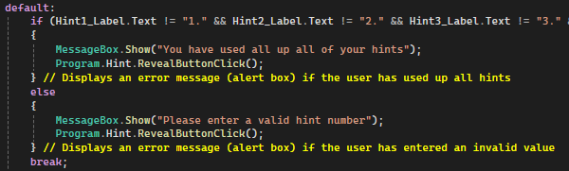

### Redundant code:

Another change I have made is held within the Game Page relating to each hint. When each hint is called, the hint is checked to see if it is restricted and if the user has selected the “Random” option in the hint number selector using nested selection. Within this code, all labels corresponding to each hint are set as visible and the nested selection statement is only run when the label is visible. I realised that this code was not needed at all since each label is never changed to be invisible and the selection statement wouldn’t be affected by the excess code. This can be seen in the code below:

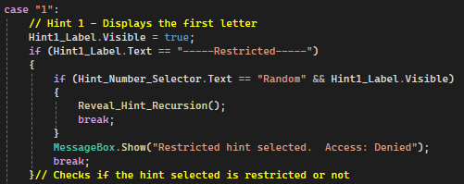

Which then changes to:

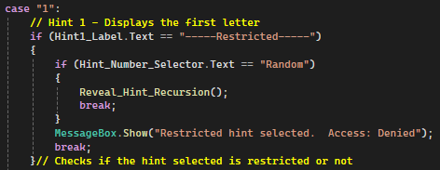

Overall this reduces the total number of lines and makes the programme easier to read for any programmers that would want to pick my project up in the future.

### Combining labels:

In order to reduce the total number of lines, and make it easier for any programmer to pick up, I decided to combine labels which I haven’t combined yet. An example of this is on the Victory Page, where the first and last three guesses were all on separate labels (differing from the exact same first and last three letters being displayed on one label on the statistics menu). This process combined 8 labels into 2 different labels (three guesses and a title label x2). The change can be seen below.

Old code:

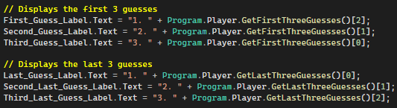

New code:

## Visuals:

One update I wanted to do in the third prototype was to update the UI on every page to make it easier to read, more appealing to play and make it look like the original design as much as possible. To do this I simply needed to add a border around every label (excluding titles) and fill in the background colour. This resulted in me using the following two properties;

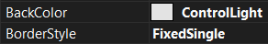

The BackColor property allowed me to change the background colour to a light grey (same as in the design) and the BorderStyle added a black border around the label. This was used on every label (excluding titles) across the programme and makes the programme look more visually appealing.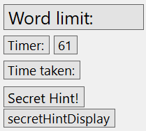

To the right is an example of labels with these properties.

Furthermore, for buttons the FlatStyle is set to ‘Flat’, resulting in the button being given a flat appearance, looking less 3D.



## Hints:

Firstly, I removed unnecessary code from the Game Page. This code is held within the Reveal_Hint_Recursion() procedure which is used to display / reveal each hint individually. The code that has been removed consists of commands which made each label visible when the appropriate case is called, which can be seen below;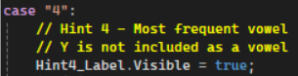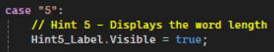

These lines of code are obsolete since each label is visible as default and doesn’t get changed at any time during processing, therefore it makes no difference whatsoever apart from taking up extra lines of code.

On top of this, in the following selection statement one of the conditions is if the label is visible or not, which is always true and is also therefore not needed. This can be seen below;****

Overall the Hint1_Label.Visible = true; command is not necessary along with the Hint1_Label.Visible condition within the IF statement and got removed. The new code is shown below and is now a lot easier to read for anyone reading the code.



### Reveal secret hint:

One problem with the secret hint is that it crashed the game when the user guessed so many times that the next letter would try and be revealed, even if there all letters have been revealed (e.g. the 6th letter of the word would try and be revealed when the user is guessing a 5 letter word). To solve this problem, I removed the while loop and replaced it with an IF statement. This removes any unnecessary looping and saves space. After this I made it so each selection statement can only be called once, which made it so no IF statement would be accidentally run because they all use the same counter as the condition to determine if they should be run or not.

The code is shown below. The procedure works by the first 3 conditions only working if the counter is high enough (dependent on the multiplying factor and the secret hint value calculated when the procedure is run) and if the corresponding global boolean variables are false (which they are automatically set to on startup and seen to the right).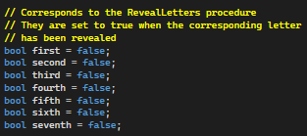

When each letter is revealed, the corresponding boolean variable is set to true so it cannot be run again, thus the next relevant condition can be run. This is essential since if the counter is high enough for the second letter to be revealed, the first letter would be revealed because the condition is placed before the second letter condition and it is true. Therefore there is another condition which is used to control if the letter has been revealed or not.

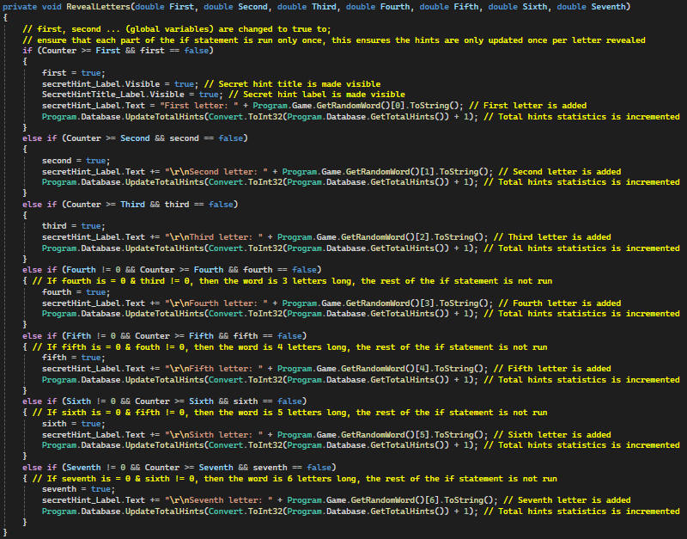

After the third letter, the number of characters the random word has is checked. This is done by the arguments given being set to 0 if that number character doesn’t exist (e.g. the ‘Sixth’ (and seventh) parameter would be set to 0 if the random word has 5 characters, and the ‘Fourth’ (and all of the above) will be set to 0 if there are only 3 characters in the random word). Thus there is another condition which is used to determine if each else if statement should be run or not. Overall this is a big improvement compared to the previous while loop which tried to reveal letters that the random word didn’t have.

Due to each if statement being run only once, I am able to update the total hints statistic correctly, allowing for more accurate results & statistics.

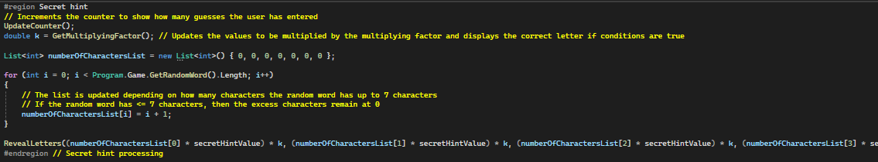

This is where the RevealLetters procedure is called. The arguments have been optimised so the secret hint values are more realistic so more characters can be shown (all characters should be shown in lower difficulties and less should be revealed in the higher difficulties).

### Reveal hint:

One issue in the second prototype is that the Reveal Hint button would only work sometimes, at other times it would reveal a hint that has already been revealed. In order to fix this I altered the Reveal_Hint_Recursion() procedure by adding a check that checks if each hint has been revealed or not, if the random hint chosen has been revealed, then the random hint value is changed to another random value, and then this process is repeated until a hint has been chosen that has not been revealed. Before these checks, another check is put in place to see if all hints have been revealed, if so then the random hint value is made ‘100’ which is out of bounds of the following switch statement, triggering the ‘default’ case which displays alert boxes telling the user that all hints have been used.



This is the global list used in order for the check (that checks if each hint has been revealed or not) to work. Each index corresponds to a hint (e.g. Index 0 represents the first hint) and if the index is set to 0, then the hint isn’t revealed and can be revealed.

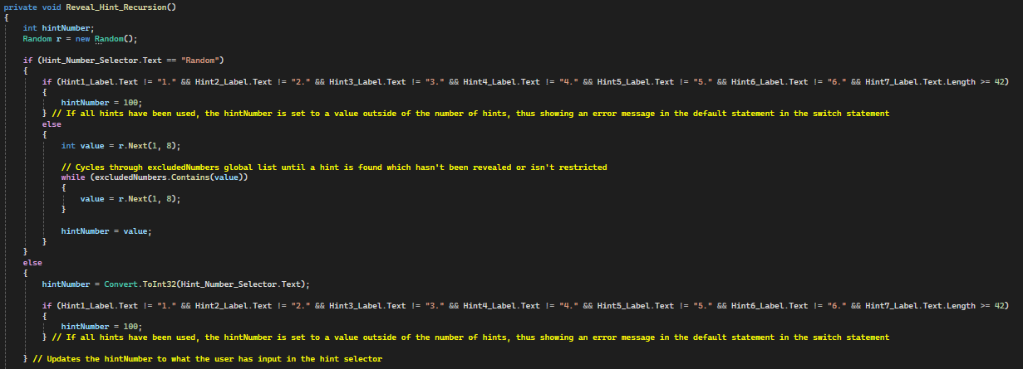

This is the updated code for the start of the Reveal_Hint_Recursion() procedure. It differs from the old code by the checks being in place in the form of a while loop, which checks if the random value chosen is held within the global list ‘excludedNumbers’. This works by if a specific hint is revealed (or is restricted), then the index of that hint in ‘excludedNumbers’ will be updated with the number hint it is (e.g. if the first hint is revealed, then the excludedNumbers[0] (0 is the index that represents the first hint) will be updated with the value ‘1’ (because it is the first hint). Another example is if the fourth hint is revealed, then the excludedNumbers[3] (3 is the index that represents the fourth hint) will be updated with the value ‘4’). Overall when the random hint value is chosen, then the value is checked with what values are in excludedNumbers in the while condition (e.g. if 4 is held within the 3rd index, then if the random value is equal to 4, then the condition is true and the while loop is run again, selecting a new random number). Each index is updated with the corresponding hint when the hint is revealed, as seen in the code below.

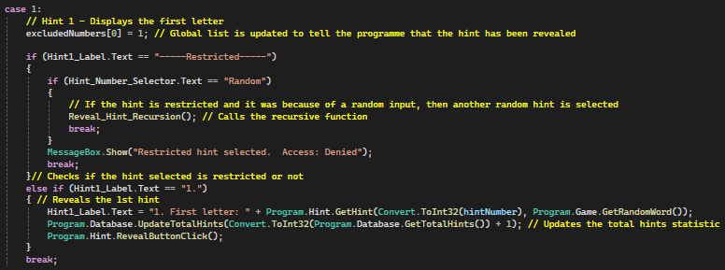

This is repeated for all cases.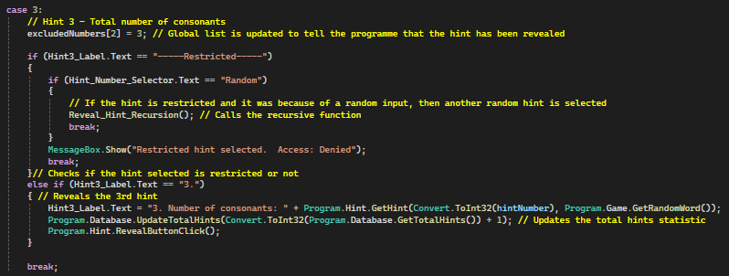

All cases are the same except the seventh case, which can be run 6 times (for reasons stated earlier) before being classified as ‘revealed’.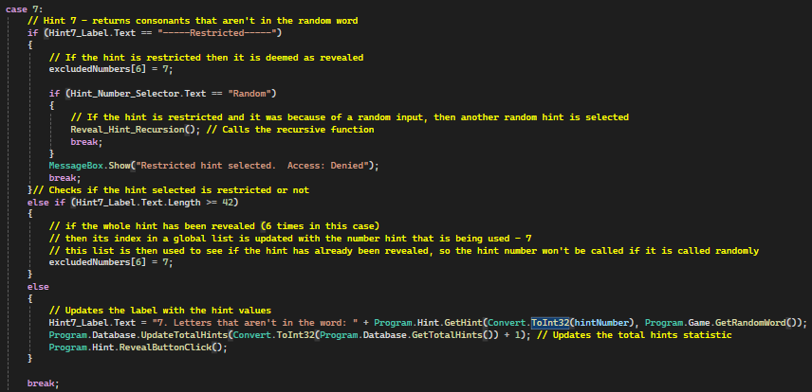

### New hints:

#### Hint 7:

For the third prototype, I thought that the number of hints combined with the quality of each hint was inadequate, therefore I decided to create a new hint (the seventh hint). This hint displays random consonants which aren’t in the word. Due to the number of letters in the random word and the total number of letters in the English alphabet, I decided to make it so this hint can be called several times (6 at the moment, this may change in the future if I allow it so the user can choose how many times it is run). This means that the user can get a total of 6 random consonants which aren’t in the word, which makes the game a lot easier for the user.

In order to create this, I had to use a global variable to temporarily store the consonants which are held in a string form (e.g. ABCDEF). This is beneficial because it means I can check if any random consonants are selected twice, allowing me to select a new random consonant instead. Fortunately this programme is small and the global variable cannot be altered by accident since it is only used for the 7th hint and the global variable is named properly (SeventhHintValues), therefore a global variable can be used. However, if this programme was to be picked up by someone and expanded, then I will need to find a way to use local variables instead for better practice.

This hint uses 3 functions to work effectively. The code for the 7th hint is shown below;

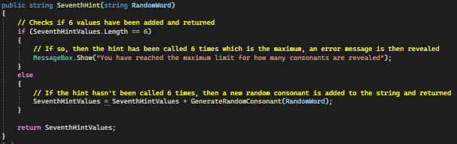

The function above is what is called when the user selects the 7th hint or the 7th hint is randomly chosen. Firstly, a check is made to see if the hint has been revealed 6 times, if so an alert box is shown and no more consonants are added to the global string - SeventhHintValues.

The function below is what is called to select a random consonant, a random value is chosen from an array filled with every consonant in the English alphabet. After this 2 checks are made; if the random consonant is in the random word (e.g. the random consonant is in the random word which is what we are trying to avoid) and if the random consonant is in the SeventhHintValues global string (e.g. the random consonant has already been selected and revealed). If either one of these checks is false, then a new random consonant is chosen.

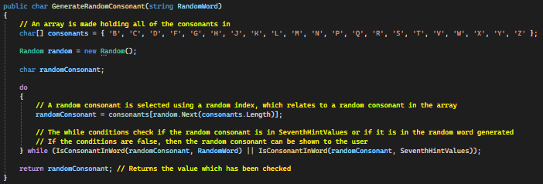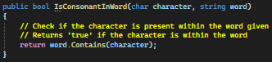

The function to the left is the function used to check if the random consonant is held within the word given (random word or SeventhHintValues - global string).

Finally, the seventh hint is called in the Game Page Reveal_Hint_Recursion() procedure which can be seen below:

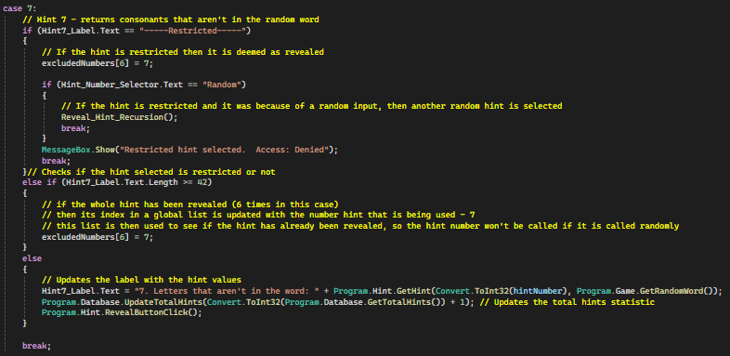

It is the same for every other case (hint) except the hint is only deemed as ‘revealed’ once it has been revealed 6 times (because of previously stated reasons).

One issue with using a global variable is that if the user wants to play the game again, then the global variable needs to be reset otherwise the user will get false information from the previous game. This is made possible by the procedure - ResetSeventhHintValues(), which makes the string empty so no false data is stored.

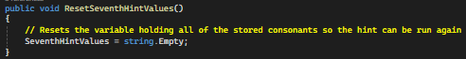

This procedure is called when the user leaves the Game Page; Continue button, Quit button, Main Menu button.

#### Hint 8:

This new hint gives the user a chance to reveal a character in the random word as well as where it is placed (in the middle of the word, i.e. the character selected cannot be the first or last character). The user has to pick a number between 1 and 6, if the user picks a number which is the same as a random number then the hint is revealed, if not the hint is restricted. This hint can only be tried once.

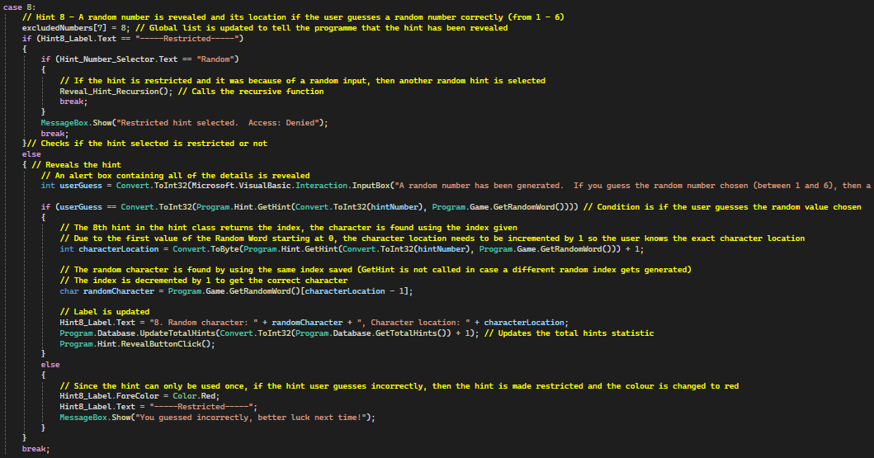

This case corresponds to the 8th hint and is held where all other hints are in the RevealHintRecursion procedure.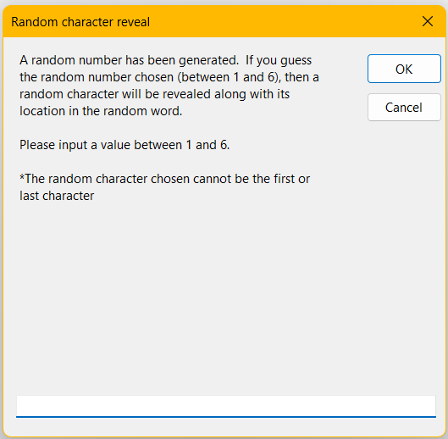

To the right is the alert box, this is what is shown to the user when the 8th case is run. It gives the user an input box to input a value, along with a description of the hint. Finally, a hint label is created which is where the 8th hint is revealed (8 is also added to the Reveal hint selector on the Game Page).

The code below refers to the 8th hint in the Hint class, it simply finds a random number which isn’t the first or last index.

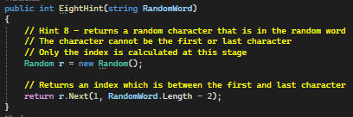

### Secret Hint:

Another feature I added was on the Play Game Menu, which is a button which enables / disables the secret hint. When the player clicks the button, the secret hint changes to the opposite value of what it currently is, for example if the secret hint was enabled, if the user clicked the button the secret hint would then be disabled.

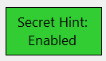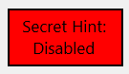These are the two different versions of the button. The button has the same usability options (changing colour when the user hovers their mouse over the button) as the rest of the buttons on the game.

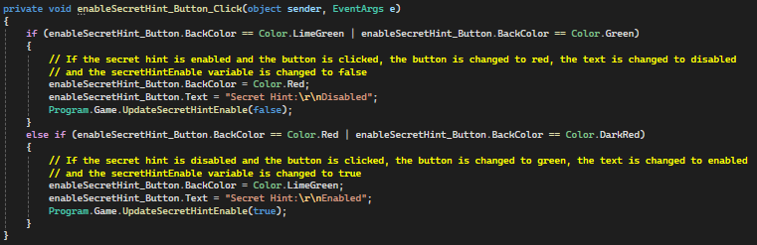

This code above corresponds to the ‘enableSecretHint’ button click event handler. It updates the background colour and text depending on the current background colour being used, this is how the button changes colour when clicked. On top of this, the Game class has a value called ‘secretHintEnable’ which tells the programme if the secret hint should be enabled or not. If the variable is true, then the secret hint should be enabled.

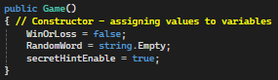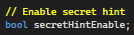

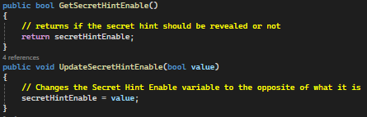

Due to this variable being held within the Game class, getters and setters are required in order for all other pages to communicate with the Game class to manipulate this value.

The ‘secretHintEnable’ variable is updated on the Play Game Menu startup (because it is the default), when the secret hint is disabled due to a rare hint consequence, in the ‘enableSecretHint’ button click event handler and finally this is used as a condition in an IF statement on the Game Page to check if the secret hint should be revealed or not.

### Hint Consequences:

One problem I found when revealing hints is that there is no consequence to using them. This meant that the user would most likely use all of them at the start of the game to make the game easier. To counter this I decided to add different hint consequences which randomly occur when the user reveals a hint. These include; Minus 5 guesses, Minus 10 seconds on timer, Word limit disabled (can’t see how many guesses you have left) and secret hint disabled.

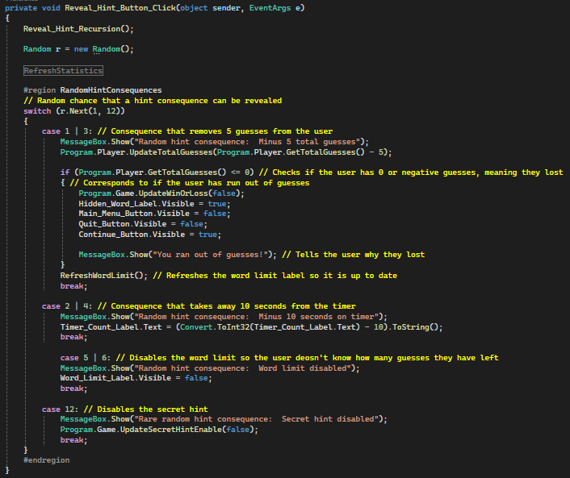

This code is held within the ‘Reveal button’ click event handler. A random number is generated and if it is the same as a value from a case then that consequence is run.

## Timer:

One problem I found with my programme is that it was extremely relaxed, especially with the ‘Impossible’ difficulty which is supposed to be challenging and intense. To solve this I added a timer to the programme, which counts down and makes the game more challenging as there is a time limit. I managed to integrate it in my programme by making the user lose the game when the timer reaches 0, giving the user more ways to lose the game, making some statistics such as the percentage of games won more valid.

In order for the timer to work, a few properties have to be alerted. These properties are altered when the Game Page is loaded and can be seen below.

These are essential for the timer to function properly.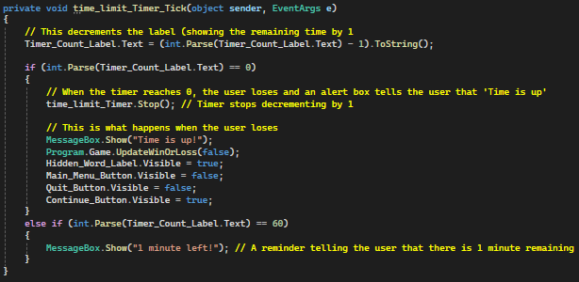

This is the procedure used as the EventHandler for each timer tick. Each tick is for 1 second and every second this procedure is run, it first decrements the label and then checks if the timer (label) has decremented to 0, at which the user would have lost and the appropriate operations are undertaken. On top of this, a reminder is put in place if there is only 1 minute remaining.

The timer must be stopped otherwise the timer will carry on decrementing forever, taking up memory. Due to the Game Page closing down if the user changes pages, if the timer is not stopped then the programme would break. Therefore I made it so when the timer reaches 0, the timer stops and when the user wants to leave the page, the timer stops (the timer is stopped when the Main Menu button & Quit buttons are pressed and when the user guesses the word correctly), avoiding any errors.

Furthermore, I utilised the timer by adding a ‘time taken’ feature. This works by a variable holding the total number of seconds the user is allowed, and taking away the time at which the user guesses the word, resulting in the time taken to guess the word. This feature is only used when the user guesses the word correctly and is hidden from the user until the user guesses the word correctly.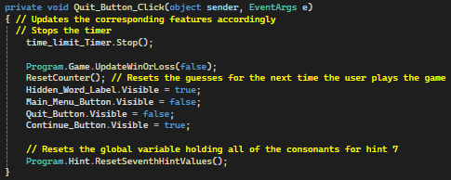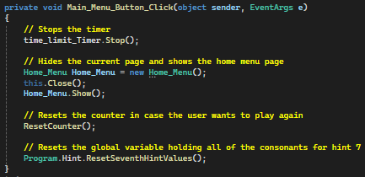

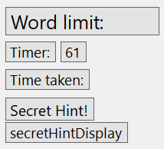

This is the UI used to show the timer. The ‘Timer:’ label is always visible and the label to the right is used to show how many seconds the user has until they fail.

The ‘Time taken:’ label is hidden from the user until they guess the word correctly, at which the label will appear along with the time taken for the user to guess the word.



This is held within the Validate input region in the Enter button click event handler. It simply makes the label visible and updates the text with the calculated time taken.

In order for the time taken to be calculated, the total time given to the user needs to be stored in a variable. This is stored when the Game Page loads at the same time the total time given is set, which is entirely dependent on the difficulty chosen.

The total times given range from 720 seconds (easy difficulty) to 300 seconds (impossible difficulty).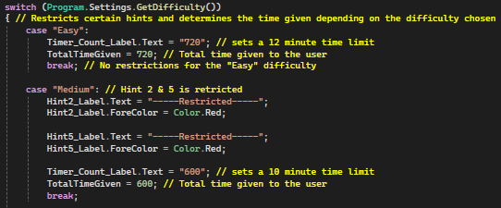

## Customise Page:

One thing wrong with my current programme is that there are limited ways of playing the game and that the game is only single player. To solve this I created a new page which holds new features - allowing the user to create their own Guess the word game for someone. This is a new couch co-op feature which allows the user to manipulate different variables, allowing them to create a game for someone as they plead. The variables that the user can manipulate are; Hints (restricting), Difficulty, Random Word, Total Guesses, Multiplying Factor, Number of times the seventh hint can be revealed and the amount of time the user has.

### Design:

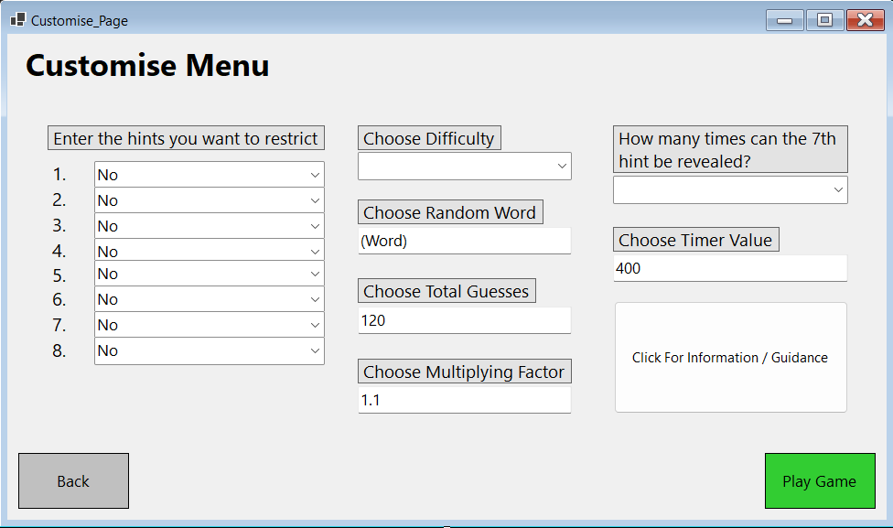

The design is the same as all other pages with the black border and grey background for all titles. The design is simple to read with all input boxes and selectors being clearly labelled so the user isn’t confused on what to input. On top of this, there is an information button which tells the user more information in detail about the page if the user needs it. Furthermore, this page uses the same usability features on the buttons as other pages.

### Customise Page Code:

#### Updated Play Game Menu:

This is similar to the message sent via an alert box when the Customise Page is loaded except this alert box goes into more detail. The following message is shown when the user clicks the Customise Game button on the Play Game Menu.

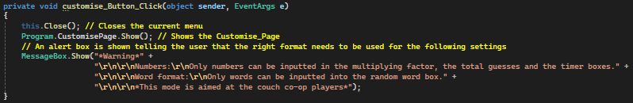

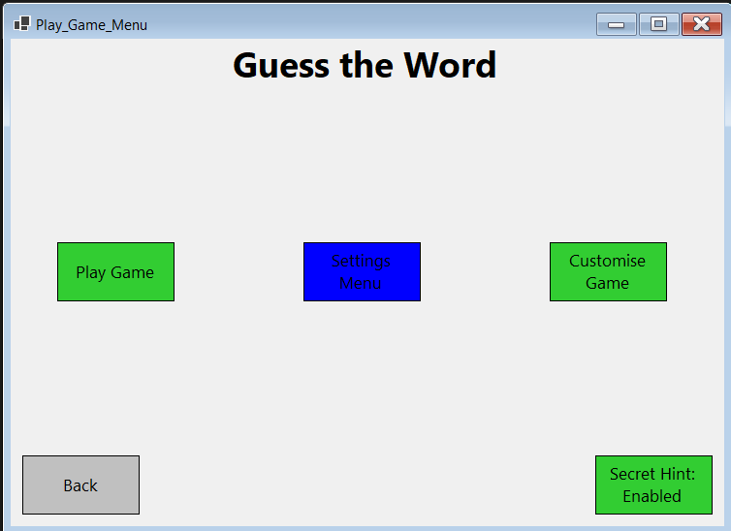

The user can access this feature by clicking the Customise Game button on the Play Game Menu.

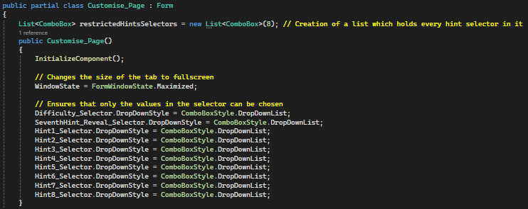

This is what is run on the Customise Page startup, the restrictedHintSelectors is a list which holds all of the ComboBox’s (Selectors) in. This is used later when checking which hints should be restricted or not. The code in the constructor simply makes the page fill the screen when the user loads the page and also stops any values from being inputted into the selectors.

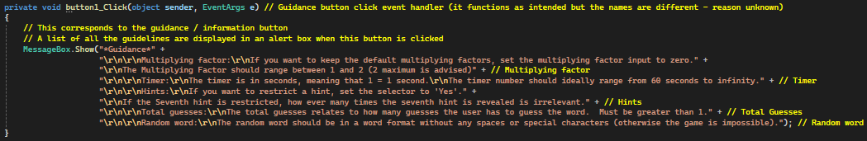

This code is what is used for the Guidance / Information button. It simply displays an alert box telling the user that all input boxes and selectors need to have a value and which input boxes require which data types.

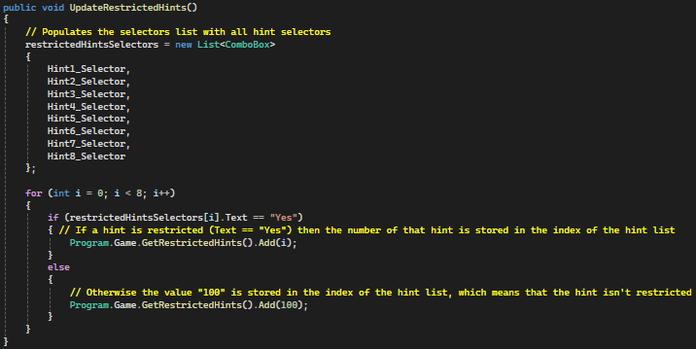

This is one of the procedures run when the Play Game button is clicked, it populates the list with all ComboBoxes (selectors). This means that I can reference each label with the list where each index references a ComboBox (for example index 0 will reference Hint1_Selector). After this another list in the Game class is updated with a number referencing which hint needs to be restricted, if the hint doesn’t need to be restricted then the value is placed as “100”.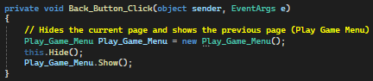

This is the standard code to traverse each page, the previous page is the Play Game Menu. This page is hidden instead of closed every time the user traverses past this page, this allows for the page’s settings to be saved when the user inputs values, allowing the user to easily manipulate the settings as they wish, making adjustments when necessary.

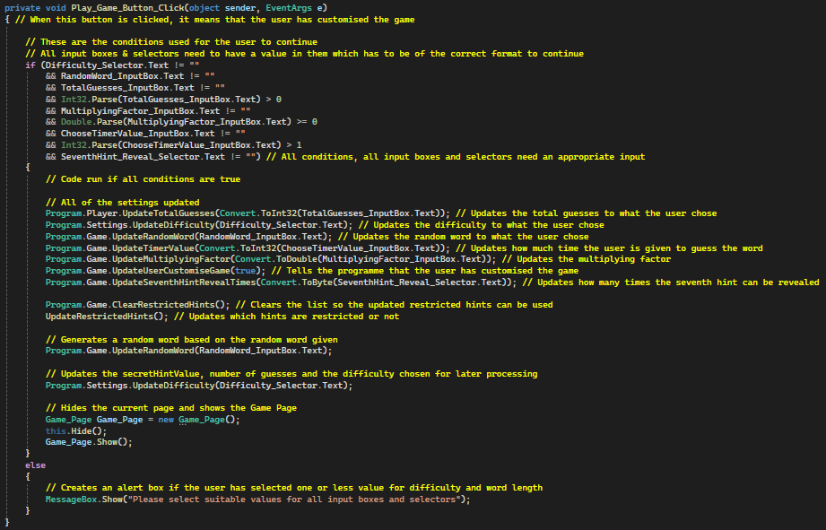

This is where the most processing is done. All settings from the Game class are updated here in preparation for the Game Page to be updated. This button must be clicked in order for the game to register that the user customised the game, otherwise the game will be processed as normal. The code is only run when the user inputs values in all input boxes and selectors (otherwise the else part of the IF statement is run), on top of this all inputs need to be of the correct format (otherwise the programme will crash). Which is done by each input box using the .Parse command as a condition, which converts a string to an integer as standard and returns an exception when the string cannot be changed into an integer format. The exception thrown is shown on the right.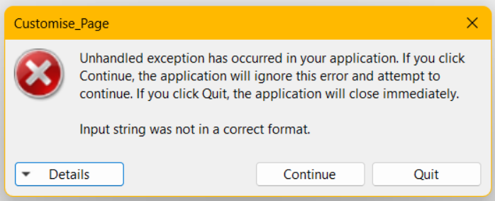

### Game Class:

In order to save necessary variables, I added more to the Game class, this allowed me to access necessary variables from anywhere in the programme, which allowed me to implement the Customise Page.

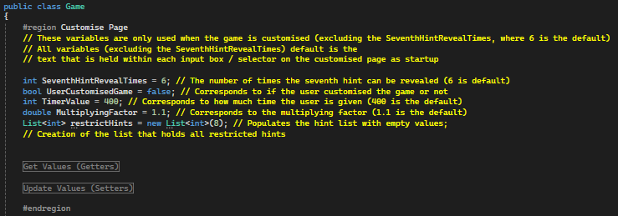

The region ‘Customise Page’ holds all subroutines and variables which are exclusively used when the user customises the game (excluding the SeventhHintRevealTimes where the default value 6 is fed into the hint class to ensure that the seventh hint can be revealed only 6 times). The restrictedHints variable is created with a total of 8 items when the class is created and is only populated with the restricted hints on the Customise Page. It is an empty list and values are added to the list on the Customise Page. On top of this, the list needs to be cleared before the hints are updated to ensure that the restricted hints are up to date and aren’t affected by the previous game. The procedure used is held within the ‘Update Values (Setters)’ region.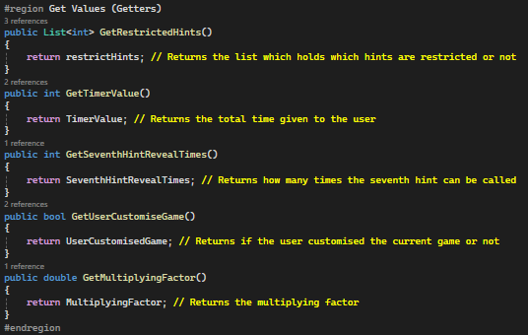

This is the code held within the ‘Get Values (Getters)’ region. It simply holds the functions necessary for other pages to get access to the variables used for the Customise Page held in the Game class.

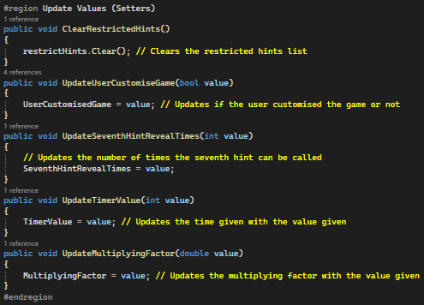

The ‘Update Values (Setters)’ region holds all of the procedures used to update all variables relating to the Customise Page in the Game class.

### Game Page (Updates):

In order for the Customised Game to function correctly, all settings chosen by the user in the Customise Page need to be updated (which is done when the user clicks the ‘Play Game’ button on the Customise Page) and the game needs to be updated, which is done on the Game Page startup (all code is held within the constructor).

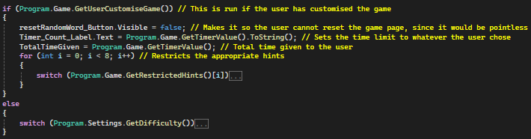

This is the IF statement held in the constructor. The condition used is if the user Customised the game or not, whether the user has Customised the game or not is denoted by the variable ‘UserCustomisedGame’ which is held within the Game class. If the user has customised the game, the variable is updated to ‘true’ and vice versa.

The switch statement on the following page restricts the hints based on the user's request.

The code below relates to the usual code that is run if the user did not customise the game. One difference between this new code and the previous code from the second prototype is that the total guesses are updated when the time is updated along with any restricted hints. This changed from the previous iteration where the total guesses were updated when the difficulty was chosen in the settings class. This meant that when the user chose the difficulty (alters the secret hint value) when customising the game the total guesses weren’t updated and were instead updated to what the user chose.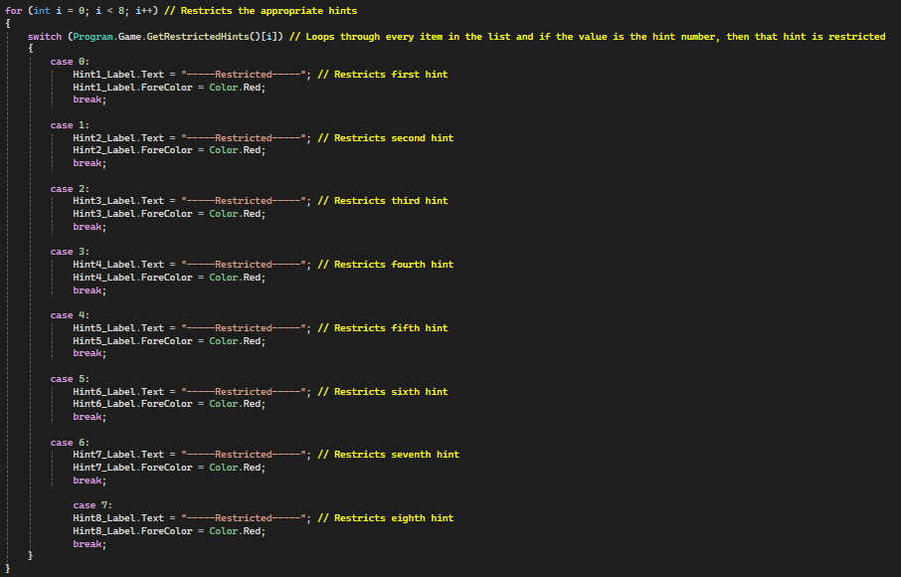

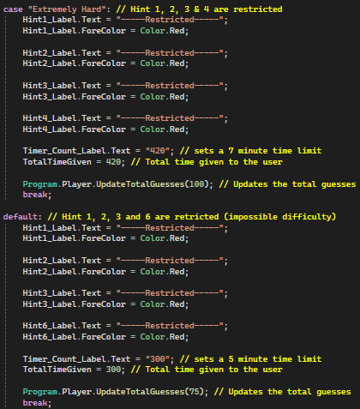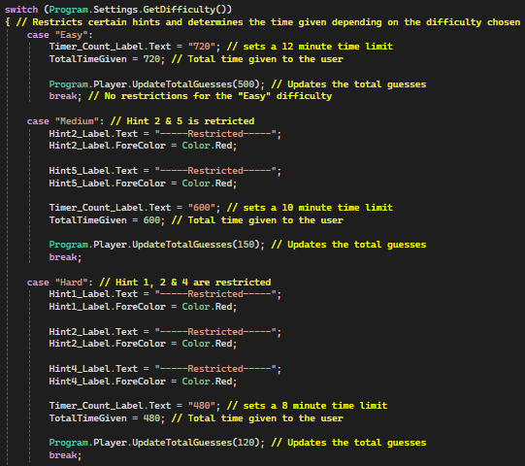

To ensure that the programme wouldn’t replay the same customised game again when the user clicked the ‘Play Game’ button (on the Play Game Menu not the Customise Page) I needed to update the variable which tells the programme if the user has customised the game or not. I decided to do this when the user left the Game Page, which is on the Quit button, Continue Button and the Main Menu button. The following code is in each button click event handler.



One feature I altered is the GetMultiplyingFactor() function. In order to make it so the multiplying factor wouldn’t update based on the difficulty, I added an IF statement with the condition of if the user customised the game, if so then the multiplying factor would be updated to what the user selected, if this condition isn’t true then the original code would be run.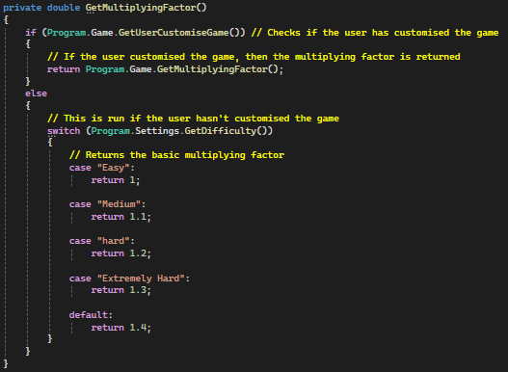

Another feature I altered is how the Secret Hint is used in the ‘Enter’ button click event handler.

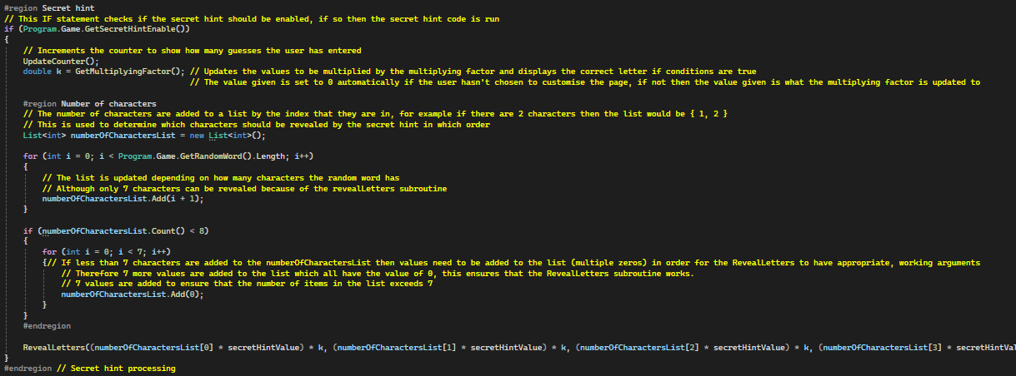

(The RevealLetters() procedure arguments just repeat themselves with the index incrementing by 1 each time until the 6th index)

The change is held within the ‘Number of characters’ region. The change is with the numberOfCharactersList, the list has changed from having 7 values / items (all with the value ‘0’) to being an empty list. The reason for this is that if the user customises the game and picks a word which is more than 7 characters, then the original for loop would break since the numberOfCharactersList only had 7 indexes. Therefore I changed it to an empty list at which values are added to the list instead (each item will have the character index, for example the first item will have a value of 1 and the second item will have an index of 2, which is i + 1 because the indexing for a list starts at 0). The only problem with this is that if the random word is less than 7 then the arguments fed into the RevealLetters procedure wouldn’t exist (i.e. if the random word is a 4 letter word, then the 5th index or character wouldn’t exist), causing the programme to crash. To fix this I added a nested for loop (within a IF statement with the condition of if the random word is less than 7 characters) which adds 7 items with the value of ‘0’ to the list to ensure that this list has excess indexes as a buffer zone.

### Hint class:

Finally the SeventhHint function has been altered slightly in the Hint class. Instead of the usual 6 used in the condition for the IF statement, this is replaced with the SeventhHintRevealTimes variable which is held within the Game class. Overall this allows the user to choose how many times the seventh hint can be revealed.

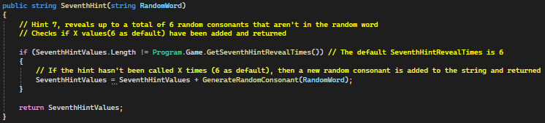

## Game Page (Updates):

### Reset Random Word:

One new feature I added in the third prototype is a reset random word button. This simply gives the user a quicker way to reset the word with the same settings.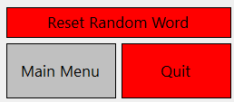

This button is placed directly above the main menu and quit buttons on the Game Page and is only visible when the user is playing the game (i.e. the user hasn’t lost or won the game).

Due to the feature being a button, the usual usability options are used (hovering over the button).

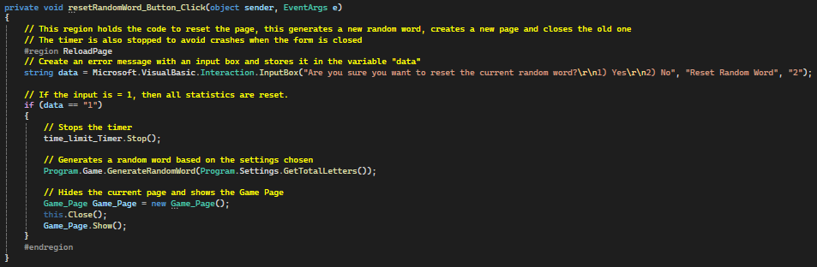

This code corresponds to the reset random word button. An alert box with an input box is used to get the user input and the game is only reset when the user enters ‘1’ into the input box.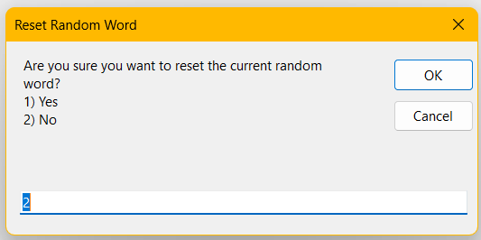

This is what is shown. If the user enters ‘1’ then the game page is reset, which generates a new random word.

This feature is not available if the user customised the game since there would be no point because this feature is primarily used to generate a new random word for the user to guess.

## Victory Page (Updates):

One problem I found with the Victory Page is that the Defeat. / Victory! labels were never in the same location which had to be the middle. To improve this I removed one label and updated the remaining label accordingly, changing the text and colour of the text depending on if the user won or lost the game.

This is the old code. Which changed to this new code.

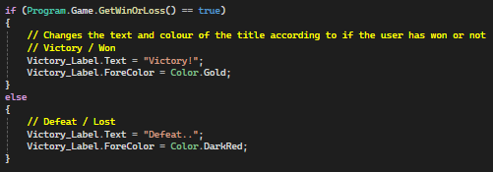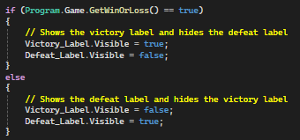

Furthermore, I added the Random Word to the victory page with a simple label above the first and last three guesses labels. 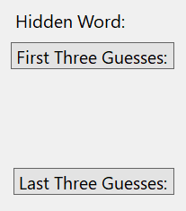

There is no benefit to this label. It simply reminds the user of the random word they had to guess.

## 

## Keybinds:

One thing I have been trying to do since the very beginning is adding keybinds to my programme, specifically allowing the user to click the ‘Enter’ key as a shortcut to clicking the Enter button. I have finally been able to implement it fully in the third prototype. Currently, there is only one keybind which is the ‘Enter’ key since I have found no use for any other keybinds. However, I will easily be able to add more keybinds if needed, allowing for effortless traversal between pages with the use of keys. The reason I wanted to add the ‘Enter’ keybind is because constantly moving the mouse back and forth to input a value and clicking the Enter button to validate the value was extremely tedious after a while, which is bound to happen when future players try and guess the word, especially on the harder difficulties. Overall this keybind allows for smoother gameplay, making the game more appealing to potential users.

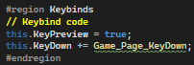

This is the code held in the Game Page constructor, KeyPreview enables keybinds meaning that key events can be used. The KeyDown command calls the Game_Page_KeyDown subroutine, which holds the following code;

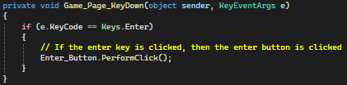

This is what is called when a key is pressed. After a key is pressed, an IF statement checks if the key is ‘enter’ or not, if so then the enter button is pressed.

However, the user cannot click enter and use up a go if they haven’t input anything in the text box, which is useful in case the user accidentally clicks the enter button and subsequently uses up a guess (which are critical in the impossible difficulty).

## New statistic - Streaks:

Another statistic I added was a streak statistic, where the streak depends on how many games you win in a row. This was inspired by Wordle’s one a day streak system. One way I differentiated this statistic was removing the one a day time limit, this allows for the user to create their longest streak in a single sitting. In order to do this, I had to add 2 more values to the Data.txt text file (and one value to Database.txt - Highest Win Streak: 1, although this is only used for developer purposes). The first value in Data.txt is the actual value saved as the highest win streak value (held in index 17 due to most successful word calculation indexes), the other value however is used as a temporary win streak value (held in index 18), which is incremented each time the user wins a game (and resets to 0 when the user loses) and is compared to the actual win streak to see the highest win streak has been broken and needs to be updated.

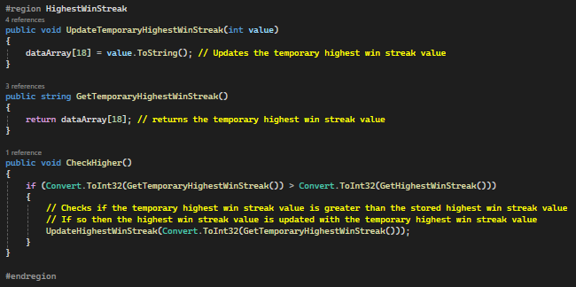

This code is found in the Database class, this is used in conjunction with the Highest Win Streak getters and setters:



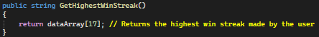

The main processing done to calculate this statistic is held in the Victory Page, where the temporary highest win streak is incremented or reset.

The following code is held in the constructor. If the user wins then the temporary highest win streak is incremented and that value is checked with the actual saved highest win streak, which is then updated if necessary.

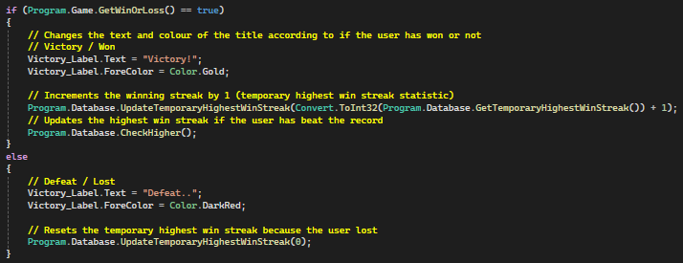

The only other times this statistic is used is when all statistic labels are updated, which are on the Statistics Menu, Victory Page and Game Page.

Finally, the value needs to be updated on the Data.txt file, at which the code remains the same. However, for the developer, the Database.txt file has been updated to hold the statistic. The changes made is that another parameter is added and consequently another item in the array. Overall this adds the following to the Database.txt file. 

## Errors:

### Reveal Hint Button Error:

The Reveal hint button didn’t work properly as intended all of the time, which resulted in nothing happening when the button was clicked (on the Game Page). However, the code has since been updated (stated earlier) and works perfectly. The old code is shown below;

Which differs from the new code;

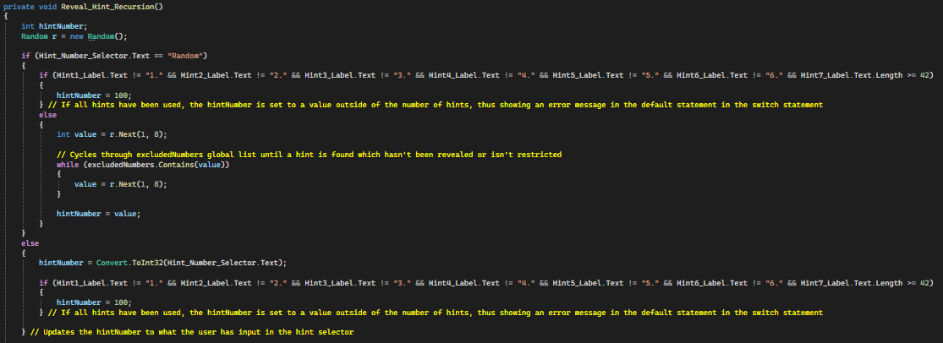

### Settings Menu Error:

In the Settings Menu, the user has to input values for both the Total Letters and the Difficulty Selector before proceeding to the next menu / play the game. However, it was possible for the user to input values of their own, which caused the programme to crash. In order to solve this error, I simply removed the user’s ability to input their own values into each selector, which can be seen by the 2 lines of code below:

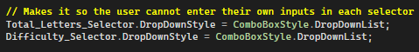

This code is held within the Settings Menu startup code and disallows the user to enter their own values. This works in combination with the error messages as the user has to input a value in both selectors to continue. Overall avoiding any crashes with user inputs.

The same code can be seen in the Game Page with the Hint selector.

### Multiplying Factor Error:

When testing the secret hints, I discovered that all letters were revealed only on low difficulties. This made it extremely difficult for users to guess the word correctly in higher difficulties due to the limited number of guesses. However, this did make the game more challenging. Although, I decided to make the game more forgiving by altering the total guesses, the multiplying factors and the secret hint value.

Below is the code for the original multiplying factors, total guesses and secret hint value:



As the difficulty increased, the multiplying factor increased at a faster rate, meaning that revealing any character took a large number of guesses. On top of the secret hint value increasing and only 40 total available guesses for the ‘impossible’ difficulty revealing any characters was virtually impossible and made the secret hint extremely obsolete and not helpful at all (contradicting the whole point of a hint). As a result of this, I altered the secret hint values and the multiplying factor to increase at a slower rate and gave the user more total available guesses for higher difficulties, seen below.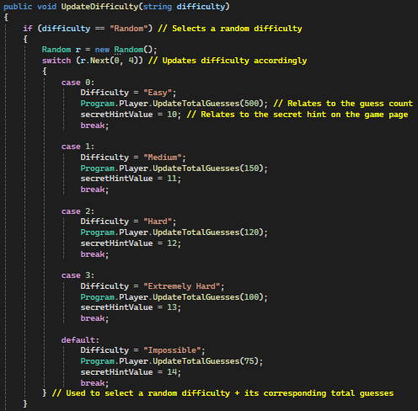

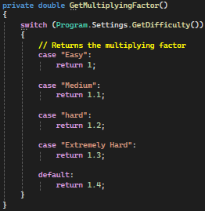

The multiplying factor now increases by 1 the higher the difficulty, along with the secret hint values. The total guesses have been made more realistic also. The problem still remains that not all letters from the secret hint are revealed in the higher difficulties, however, I am going to keep it this way to ensure the difficulty remains.

### Reveal Hint Button + Selector:

One problem I encountered when getting new users (who haven’t seen or played the programme before) to play my programme is that the programme crashes if the user clicks the Reveal Hint button and nothing is selected in the Hint number selector. This problem can only be activated if no hints are used on the Game Page startup, since when the user selects a hint, they cannot select nothing to make the problem appear. To solve this problem, I made the default text of the selector - “Random”, which removes the situation of the selector being blank and not corresponding to a specific hint.

This is the code used to change the default value, and thus removing the potential logical error.

## Post Prototype Test Data:

| Feature Being Tested | How it will be tested / Data Input | Expected Output | Actual Output | Result - Further Action Needed? |
| --- | --- | --- | --- | --- |
| If the reset random word button (on the Game Page) works as intended. | The button will be clicked and the values “1”, “2”, and other random values will be input. | If the value “1” is input the Game Page and random word should reset. | The Game Page and random word resets as intended | Complete success.  No further action required. |
| Fourth hint works as intended | A random word with 2 duplicate vowels (i.e. ee and ii making up eeii) will be made the random word and the fourth hint will be revealed | Both E and I should be returned (2 vowels) | Only one vowel is returned. This vowel is in alphabetical order, meaning that E is returned because it is before I. | Partial Success  Further action needs to be taken for the fourth hint to function as intended, returning two values if there are multiple duplicate vowels. |
| All values inputted into the Customise Menu are saved for the user to alter as they please. | Values will be inputted into all input boxes and selectors, after this a game will be played and I will traverse to the customise page where all inputs should be saved | All inputs should remain the same. | All inputs are the same | Complete Success.  No further action required. |
| Checking if data of the wrong data type can be input on the Customise Page and allowed to proceed. | String formatted data will be inputted into the integer input boxes (Total Guesses, Timer Value and Multiplying factor) | An exception should be thrown and the user will have to input a different value of the correct format to continue. | Game crashes and some exceptions thrown | Partial success.  Each value inputted needs to be checked that is it in the correct format and if not an error needs to be shown. |
| If the timer works as intended on the Game Page. | The timer value will be set to a minute to test if the reminder works and the user should lose the game if the timer reaches 0 (or less than 0 depending on the random hint consequences) | The reminder should be shown when the timer reaches 60 seconds. | Reminder is shown as 60 seconds and the user loses the game when the timer reaches 0. | Complete Success.  No further action required. |
| When the timer runs out the user should lose the game. |
| If all random hint consequences work as intended | The Reveal Hint button will be clicked multiple times until all consequences happen. | All consequences should work as intended and be clearly stated what they are. | All consequences work as intended and are clearly explained. | Complete Success.  No further action required. |

# Evaluation:

## Post Development Testing:

| Specification / Question | User experience | Result |
| --- | --- | --- |
| Timer on Game Page. | The timer is simple to understand for new players. However it is extremely simple and doesn’t convert the time to minutes, only the total number of seconds. | Partial Success. |
| Do the statistics make sense? | All statistics make sense and are a useful overview of how the player has performed. | Complete Success. |
| Keybinds / Automatically selecting the input box (user convenience) | When the user inputs a guess, the user can click the enter key which will process the guess. On top of this, the input box is still selected so the user can input guesses easily. | Complete Success. |
| Are the hints obvious? Is it clear how to reveal a hint using the button and selector? Do the restricted hints make sense? Is it obvious that the seventh hint can be revealed more than once? Are the hints useful? | Hints are only obvious when revealed.  Some hints are also obsolete and don’t work, such as the fourth hint (doesn’t work) and the fifth hint which shows the length of the word, which the player can work out from the error messages after inputting a value.  It also isn’t obvious that the seventh hint can be revealed multiple times and is only known if the player has previous experience with the game. Overall new players won’t know that they can reveal the 7th hint more than once.  However, the hints give useful information that is essential to guessing the random word (increases the chances of guessing the random word significantly) and the restricted hints are easily understood by new users. | Partial Success. |
| Does the customise page make sense? | When the Customise Page is shown, an alert box is shown telling the user essential information about what format each input box should have. After this, each selector / input box is labelled clearly and easily identifiable. However, the user will need some knowledge of what each hint is and what the multiplying factor does to affect the game, aside from this the Customise Page is easy to understand for new and existing players. | Partial - Complete Success. |
| Is revealing the hints easy / simple to understand? | The hints are clearly labelled and it is obvious where each hint is revealed. When hints are revealed they are easy to read and make sense. However, for new users, the reveal hint selector isn’t labelled clearly and it isn’t clear what the selector is used for. Therefore the user is likely to stick with using the default ‘Random’ hint selector option throughout the whole game.  Overall revealing hints are easy to do but revealing specific hints requires existing knowledge of how the reveal hint selector works. | Partial Success. |
| Does the settings menu make sense? | The settings menu clearly states which hints are restricted on each difficulty, all buttons are labelled clearly and each selector is easy to understand for new users. Therefore the Settings Menu is easily understood. | Complete Success. |
| Are all labels worded clearly and make sense? | All labels are worded clearly which allows for new players to understand what each button / selector / input box is for. | Complete Success. |
| Are the statistics displays useful? | They show a useful representation of how you are playing the game and are updated in real-time. | Complete Success. |
| Is it clear what the difference is between each difficulty? | The difficulties are explained briefly on the settings menu (only the hints are shown). This is simple to understand for new players, however, it doesn’t show how the multiplying factor (secret hint value) is changed between each difficulty or what the multiplying factor is. | Partial Success. |
| Do you know what to do on the Game Page? | It is clear that the user has to start guessing the word when the Game Page loads. The timer is also self-explanatory along with the word limit in the top right corner. Each button is also labelled clearly so new users know what each feature is and what it does. However, the only things the user may not know how it works or what to do is with the hint selector (since it isn’t labelled clearly and is automatically set to ‘Random’, which the ‘Reveal Hint’ button uses to operate) and that the ‘Full Stats’ button is a button that the user can click to reveal the full statistics table. Overall the majority of the Game Page is self-explanatory and all features can be used easily. | Partial - Complete Success. |

## Success Criteria:

| Success Criteria | | Essential Features | Evidence | Fully / Partially / Not met? |
| --- | --- | --- | --- | --- |
| 1 - Home Menu | |  |  |  |
|  | 1a | Play Button | Home Menu (Prototype 1) | Fully met |
|  | 1b | Statistics Button | Home Menu (Prototype 1) | Fully met |
|  | 1c | Quit Button | Home Menu (Prototype 1) | Fully met |
| 2 - Settings Menu | |  |  |  |
|  | 2a | Difficulty Button | Settings Menu (Prototype 1) | Partially Met |
|  | 2b | Difficulty Display | Settings Menu (Prototype 1) | Fully Met |
|  | 2c | Number of Characters Selector | Settings Menu (Prototype 1) | Fully Met |
|  | 2d | Continue Button | Settings Menu (Prototype 1) | Fully Met |
|  | 2e | Back Button | Settings Menu (Prototype 1) | Fully Met |
| 3 - Statistics Menu | |  |  |  |
|  | 3a | Statistics Display | Statistics Menu (Prototype 2) | Fully Met |
|  | 3b | First and Last Three Guesses Display | Statistics Menu (Prototype 2) | Fully Met |
|  | 3c | Reset Statistics Button | Statistics Menu (Prototype 2) | Fully Met |
|  | 3d | Back Button | Statistics Menu (Prototype 2) | Fully Met |
| 4 - Victory Page | |  |  |  |
|  | 4a | All Statistics Display | Victory Page (Prototype 2) | Fully Met |
|  | 4b | First and Last Three Guesses Display | Victory Page (Prototype 1) | Fully Met |
|  | 4c | Play Again Button | Victory Page (Prototype 1) | Fully Met |
|  | 4d | Home Menu Button | Victory Page (Prototype 1) | Fully Met |
| 5 - Play Game Menu | |  |  |  |
|  | 5a | Play Game Button | Play Game Menu (Prototype 1) | Fully Met |
|  | 5b | Settings Button | Play Game Menu (Prototype 1) | Fully Met |
|  | 5c | Back Button | Play Game Menu (Prototype 1) | Fully Met |
| 6 - Game Page | |  |  |  |
|  | 6a | Word Limit Display | Game Page (Prototype 1) | Fully Met |
|  | 6b | Word Input Box | Game Page (Prototype 1) | Fully Met |
|  | 6c | Number of Characters Display | N/A | Not met |
|  | 6d | Small Statistics Display | Game Page (Prototype 2) | Fully Met |
|  | 6e | Random Word Display (Hidden) | Game Page (Prototype 1) | Fully Met |
|  | 6f | Hint Selector | Game Page (Prototype 1) | Fully Met |
|  | 6g | Hint Output Display | Game Page (Prototype 1) | Fully Met |
|  | 6h | AI Input Box / Output Display | N/A | Not met |
|  | 6i | Difficulty Display | Game Page (Prototype 1) | Fully Met |
|  | 6j | Difficulty Glossary (Display) | N/A | Not met |
|  | 6k | Home Menu Button | Game Page (Prototype 1) | Fully Met |
|  | 6l | Enter Button (to reveal hint and input value) | Game Page (Prototype 1) | Fully Met |
| Success Criteria | | Additional Features |  | Fully / Partially / Not met? |
| 1 - Home Menu | |  |  |  |
|  | 1d | Login Page | N/A | Not met |
| 5 - Play Game Menu | |  |  |  |
|  | 5d | Customise Page | Customise Page (Play Game Menu - Prototype 3) | Fully Met |
| 6 - Game Page | |  |  |  |
|  | 6m | Reset Random Word Button | Reset Random Word (Prototype 3) | Fully Met |
|  | 6n | Full Statistics Button | Full Stats button (Prototype 2) | Fully Met |
|  | 6o | Quit Button | Game Page (Prototype 1) | Fully Met |
|  | 6p | Error Labels | Game Page (Prototype 1) | Fully Met |
|  | 6q | Continue Button | Game Page (Prototype 1) | Fully Met |
|  | 6r | Timer | Timer (Prototype 3) | Fully Met |
|  | 6s | Secret Hint Display | Secret Hint Display (Prototype 1) | Fully Met |

## Success Criteria Review:

### Essential Features:

| **1a.** The Play Button criteria was fully met and took the user directly to the Play Game Menu as intended.  **1b.** The Statistics Button criteria was fully met and takes the user directly to the Statistics Menu as intended.  **1c.** The Quit Button’s criteria was fully met and closed the application when clicked. |
| --- |
| **2a.** The Difficulty Button criteria was partially met since it was supposed to change when you click it (as well as changing the background colour). However, this changed to a drop down selector, where the user can pick the difficulty instead, which is more practical compared to the user having to click the button several times to find the difficulty wanted.  **2b.** The difficulty display criteria was fully met - a display is used to tell the user the difference between each difficulty.  **2c.** This selector criteria was fully met and works as intended.  **2d.** The continue button criteria was fully met and works as intended, traversing to the Game Page.  **2e.** The back button criteria was fully met and works as intended, traversing back to the Play Game Menu. |
| **3a.** The Statistics Display criteria was fully met. The only change is the number of statistics being displayed, at which the size of the display changes accordingly.  **3b.** The first and last three guesses displays have been split into 2 displays which are easier to read compared to both displays being combined. Aside from this small change, the criteria was fully met.  **3c.** The Reset Statistics Button design hasn’t changed and it functions as intended. The criteria was fully met.  **3d.** The back button criteria was fully met and works as intended, traversing back to the Home Menu. |
| **4a.** The Statistics Display is the same as the stats display on the Statistics Menu, which meets the criteria fully.  **4b.** The first and last three guesses displays are the same as the ones on the Statistics menu and meet the criteria fully..  **4c.** The Play Again button criteria was fully met, with the button being clearly labelled and easy to read.  **4d.** The Home Menu button criteria was fully met, with the button being clearly labelled and easy to read. Traversing to the Home Menu when clicked. |
| **5a.** The Play Game button criteria was fully met, with the button being clearly labelled, easy to read and always traverses to the Game Page when clicked.  **5b.** The Settings button criteria was fully met. The button when clicked traverses the user to the Settings Menu, which works efficiently.  **5c.** The back button criteria was fully met and works as intended, traversing back to the Home Menu. |
| **6a.** The Word Limit display criteria was fully met. The display remains in the top right corner and is easy to read and understand.  **6b.** The Input Box criteria was fully met. This box is easily recognisable and functions as intended.  **6c.** The number of characters display criteria has not been met. This is because the number of hints has instead been changed and made into a hint, resulting in no display showing how many characters the random word is.  **6d.** The small statistics display criteria has been fully met. It is clear what the display is and it is small enough to not distract the user in the top left corner.  **6e.** The hidden random word display criteria has been fully met. The random word is hidden until the user either loses or wins the game.  **6f.** The hint selector criteria has been fully met, it functions correctly as intended. However to the user who hasn’t seen it before, the selector isn’t as self explanatory as it seems.  **6g.** Hint output display criteria has been fully met. Each hint is revealed in the correct order and is clear what hint has been revealed or not to the user. Restricted hints are also easy to understand.  **6h.** The AI input box / output display criteria has not been met. There is no trace of AI in this project and there is no sort of AI input box / output display. This feature is for a potential future update.  **6i.** The difficulty display criteria has been fully met. It is clearly stated what the difficulty of the current game is.  **6j.** The difficulty glossary (telling the user the difference between all difficulties) criteria has not been met. This is because the difficulty glossary is shown on the Settings Menu instead.  **6k.** The Home Menu button criteria has been fully met. This button is clearly stated and easy to understand what the button does.  **6l.** The Enter button criterias have been fully met (reveal hints and validate input). Each button is clearly stated and it is obvious what each button does. The Enter button to validate the user’s input also has the keybind of the ‘enter’ key, which is convenient for the user. |

### Additional Features:

| **1d.** This additional feature has not been implemented due to the database being used being a text file which is stored locally and the criteria therefore has not been met. If the database was online then this page would be implemented easily, however, with a locally stored text file this is ineffective and not very useful in the programme's current state. |
| --- |
| **5d.** The Customise Page additional feature has been fully implemented and the criteria fully met. This is a new page which is accessed via a button on the Play Game Menu. The page contains selectors and input boxes to allow the user to change the following; Random Word, Restricted Hints, Difficulty, Total Guesses, Multiplying Factor, the amount of time given and the number of times the 7th hint can be revealed. This page also contains a Continue and Back button which operate exactly the same as other similar buttons on the Play Game Menu. |
| **6m.** This additional feature is held on the Game Page and has been fully met. This button resets the Game Page so the user can try and guess a new word. This feature however is not available if the user customises the game since it wouldn’t reset the word to be something random. Overall the success criteria has been fully met.  **6n.** This additional feature is a button which maximises the small statistics display on the Game Page once clicked (if clicked again the small statistics display minimises and vice versa). This feature has been fully implemented and its criteria has been fully met.  **6o.** A Quit button has been added to the Game Page. This button when clicked reveals the random word and allows the user to continue to the Victory Page (which shows defeat) instead of the original idea of just closing the programme. This button has been fully implemented and its success criteria has been fully met.  **6p.** One important additional feature that needed to be met was error labels / alert boxes. These are essential to tell the user where they are going wrong when guessing the word and have been implemented fully in the form of alert boxes and error labels (varies depends on the error needing to be shown, for example an error label is used when the user inputs a wrong word / inputs a word that is too long or short to match the number of characters the random word has and an alert box is shown when the user tries to reveal a hint that they have already revealed). Overall the criteria has been fully met.  **6q.** In order for the user to traverse to the victory page by themselves (after the hint has been revealed (i.e. the user lost) or the user has guessed the random word correctly) the user needs to click a button (this changed from the original idea of just taking the user to the victory page when they won / lost). I decided to do this to allow the user to review their performance by seeing how many hints they used, secret hint values etc. Overall this feature has been fully implemented and criteria fully met.  **6r.** In order to make the game more challenging, I added a timer as an additional feature. This timer acts as another way for the user to lose the game, making it more challenging. This timer has been fully implemented with its criteria being fully met.  **6s.** Finally, a secret hint display has been added. This gives the user extra help when the user has entered too many inputs, which helps the user guess the word by giving the user characters that are within the word. The criteria has been fully met as the display has been fully implemented. |

## Usability Testing:

In the [Usability Features](https://docs.google.com/document/d/1qKCtugvhIyju04Ytd6K2hWrSxxqetK2VQ6UxX9VcWII/edit#heading=h.qck6u84p2k07) section (held in the Design section), I outlined all usability features that were going to be implemented in my programme to help the user. These include: Clearly labelled buttons and selectors, hover events for buttons, clear titles, alert boxes for important information, a minimalistic design to ensure new users aren’t overwhelmed when they play for the first time and easy mechanics for the whole programme. Overall, all of these usability features have been fully met throughout the whole programme (although one exception is the Reveal Hint selector on the Game Page which isn’t labelled). All buttons have been clearly labelled and make sense (emphasised by stakeholder feedback below). On top of this, every button when you hover over it with your mouse changes the background and text colour to make it obvious to the user that they are hovering over that specific button. Alert boxes have also been used throughout the programme. They have been primarily used to tell the user what to do to avoid errors (for example telling the user to input values in all selectors before continuing to the Settings Menu) but they have also been used to guide the user and give them information on what some features are (for example on the Customise Page). Therefore all usability options stated in the [Usability Features](https://docs.google.com/document/d/1qKCtugvhIyju04Ytd6K2hWrSxxqetK2VQ6UxX9VcWII/edit#heading=h.qck6u84p2k07) section (held in the Design section) have been implemented fully.

## Stakeholder Feedback:

After I finished developing my programme I gave my stakeholders the programme to play. I also ensured that my stakeholders went in completely blind and had to figure out everything for themselves with the only goal of guessing the word correctly. This meant that I got useful feedback from ‘new’ players.

### Universal feedback:

The overall impression given was positive. Almost all labels and buttons could be easily read (as seen in the Usability Testing section) and made sense (except the ‘Full Stats’ button on the Game Page looked like a title and wasn’t obvious that it was a button. However, the feedback given showed that if the stakeholders had their statistics, they would be more invested). On top of this, the stakeholders liked most features, with features like the hints, secret hints and the timer being their overall favourites. However, one feature that was universally misunderstood is the ‘Reveal hint selector’. This is because it wasn’t obvious what it was or how it related to the ‘Reveal Hint’ button, overall both stakeholders decided to use the ‘Random’ button for every game. Other feedback relating to the programme for new users is that there should be a tutorial page / more tutorial options since both stakeholders (acting as new players) didn’t understand some features such as what the ‘Multiplying Factor’ on the ‘Customise Page’ actually does (it relates to how often a character should be revealed on the ‘Secret hint display’ on the Game Page) and how many times the seventh hint can be revealed. Although both stakeholders did say that they were able to pick up what each feature did as they became more experienced with the programme.

### Older generation:

Feedback given was positive, with the older generation stakeholder complimenting the game saying it was “easy to understand” and had “impressive features” which “made sense” and were “easy to use” (as seen in the Usability Testing section). On top of this, the older generation stakeholder felt challenged and enjoyed the overall difficulty and experience of the game. They ended the positivity saying they would “play again”.

However, on the other hand, the specific feedback given from the older generation is that they couldn’t remember what words they input and would prefer to have a display that showed them what words they have inputted. This could be done by implementing a similar system to Wordle in which letters are highlighted to show if the letter is in the word or not / any incorrect labels should be shown next to each word to show where they went wrong. Also, the odds of guessing the words are extremely low (possibly making the impossible difficulty pointless), therefore the hints are extremely useful and need to be more useful since there are some hints which tell the user what they may already know (e.g. one hint reveals the number of characters in the random word, which can be figured out by the ‘Word is too short / long error label’). Overall some hints should be altered to be more useful, especially when hint consequences are used. More feedback given is that when customising the game, a key should be given to the user telling them what each hint does. This is important because if the user is inexperienced with the game then they won’t know what each hint does and what number hint it is, therefore a key could be implemented and would be useful when customising the game. One final criticism is that the ‘Random word’ on the Customise Page is misleading. This is because the user is going to input a specific word which isn’t ‘random’ therefore the label should be worded differently to avoid confusion.

### Younger Generation:

One feature that the younger generation stakeholders wanted to see developed is the ‘First and last three guesses’ displays. Due to these displays receiving extremely positive feedback along with the statistics, they should be extended by adding more than 3 first and last guesses and adding more statistics.

However, the main feedback given about this project is that it gets boring quickly compared to competitors such as Wordle. To fix this, some of the features from the future development section (further on) could be implemented, specifically the different themes / background / UI customisation which will make the game more visually appealing and will retain the player’s attention for longer, counteracting the boring gameplay. Furthermore, the guidance on the Customise Page was “lacklustre at best” and should be altered to make more sense for the new players rather than talking about / mentioning features (such as the Multiplying Factor) which experienced users are more likely to understand.

## Maintenance:

Overall, this programme shouldn’t need any maintenance to keep it running because it will run on the user’s device. Since all databases are textfiles on the user’s device, no database will need to be maintained. However, if someone were to develop this programme further and the game was to be put on the internet, the programme would need to be maintained to ensure all online services run smoothly as well as to maintain the new, external online database which would need to be implemented and replaced with the text file databases to allow the programme to be run exclusively online.

The benefit of posting my programme online is that it can be easily managed and statistics can be stored easily over the cloud on an online database, however this does have its issues of more regular updates needing to be made to ensure that the database is safe from any cyber attacks (primarily from worms). On top of this other fixes need to be made to ensure that the programme is ready to be played over the internet such as - the random word chosen should be made sure that the word isn’t shown for at least 20 more games. This will ensure that the programme is more enjoyable and the user doesn’t have to guess the same word.

Any patches / updates would be to fix any errors that arise. Although the majority of new future updates will be based around adding new content such as adding new hints, statistics, word file options and updating UI / any new themes (all ideas from the future development options further on).

## Limitations:

Due to the time frame given, there are many limitations that I would like to address if I had more time. One limitation is that not all hints work properly. This is primarily the fourth hint which is used to tell the user if there are any duplicate vowels in the random word. This is detrimental to the programme since a wrong hint could guide the player in the wrong direction and give all of the hints a bad reputation since the user doesn’t know which hints are true and reliable or not. In the second prototype this hint worked as intended, however when other errors got fixed this hint broke, therefore ensuring that all hints are self-contained and aren’t altered accidentally will be a priority after fixing this hint to ensure that no errors arise after altering any code throughout the programme. Overall I would like to ensure that all hints work as intended and so that no false information is given to the user.

Another limitation is the lack of information given to the user on how to play the game. Even though some features of the game are self explanatory and should be easy to understand, not everyone is likely to understand what each feature is and how to use it to their advantage. For example the hint number selector on the Game Page automatically selects the ‘Random’ option when the Game Page is loaded. The user may not realise that you have to select an option from that selector and click the ‘Reveal hint’ button to the left to reveal the hint. Overall confusing the user and making the game unenjoyable. This problem is only significant with the younger and older generation who may not play around with some feature and simply just try and guess the word without any help, possibly resulting in them giving up and quitting the game altogether. In order to fix this a simple page has to be made (a tutorial type page) which annotates and explains all pages.

## Future development:

Due to the limited time frame of this project, some features thought of weren’t able to be added. These projects include:

| Idea | Reason |
| --- | --- |
| A global leaderboard comparing users based on their statistics. | This can be used as an incentive to keep players coming back to play the game (as a sense of achievement and to retain it).  There could be multiple leaderboards which are based around 1 hint, for example a leaderboard with the users who have inputted the most guesses or a leaderboard that shows the users who have guessed the word in the first guess the most (excluding the customise game page). |
| Sound effects / music | This improves the quality of the game and makes it less boring. On top of this soothing music could help the users concentrate and perform better. Overall this would make the game feel more welcoming and fun.  Sound effects would make the game more fun, however an option needs to be created in a settings menu of some sort to mute music and / or sound effects to cater to the user's needs (emphasised by the stakeholder feedback). |
| Small settings menu on the Game Page | This pauses the game (timer) on lower difficulties and will be primarily used to enable / disabled music / sound effects and volume. On top of this, if different themes / backgrounds get added then this menu will be an opportunity to change the background / theme mid-game. Overall allowing the user to customise their experience however they want. |
| Multiplayer mode | This is where users can compete with other players (random players and / or friends) online to see who can guess the word. Some different multiplayer options could be; Guess the word in the shortest time, guess the word using no / little hints or even guess the word with the secret hint display disabled. |
| Limited time events | Events will be multiplayer modes / different themed (seasonal) modes for the user to play. For example a christmas event can be created where the user has to guess 5 words (different levels). If the user does so then they receive a reward (a christmas theme for example, or an item which allows the user to use as many hints as possible without triggering any hints for 1 game). This gives the user an incentive to come back and play the game during different times to unlock different rewards (emphasised by the stakeholder feedback - making the game less boring). |
| Shop / coin system that allows the user to buy items | This will be a new system in which the user can spend coins on special items. The user will be able to get coins by guessing the word correctly. This gives the user a goal when playing, making the game more fun. |
| Inventory system | This will be essential if the shop gets implemented. This will keep track of what themes / items / coins the user has. |
| Items | If the shop / limited events get organised, items can be added to give the user in the form of rewards. These items can help the user guess the random word (i.e. disables / reduces all hint consequences for the next game) or be a simple rare item / badge to show their experience. |
| A statistic based on the timer | This statistic can be used as an incentive to see how quickly the user can guess the word. This could also be implemented as a leaderboard (emphasised by the stakeholder feedback - adding more statistics). |
| A statistic telling the user how many hints they used in the game they just played | This is another basic statistic which the user could use to review their performance (emphasised by the stakeholder feedback - adding more statistics). |
| Different themes | This gives the user more variation when playing the game. This could also allow for other features such as different leaderboards to be added on different themes (possibly ocean or jungle theme as examples). This feature can also be integrated with the events by making themes seasonal (i.e. a christmas theme from the 20th December to the 26th December). Overall giving the game a fresh look (emphasised by the stakeholder feedback - making the game more fun). |
| A login page and external server | This allows for users to have their own account which will allow them to have their own statistics and is crucial to future development for features such as leaderboards, inventories and custom settings. |
| A daily / weekly word | This gives the user an incentive to come back periodically (a competitor to Wordle). Could be implemented with the different themes / seasonal events to give the user more ways / variation to play the game. |
| Additional buttons to restrict certain words / make words less complicated / easier if young children are playing | This will make the game more user friendly and also appealing to all age groups. Overall making this programme entertaining and easier for the younger audience. |
| Multiplayer customised pages, uploaded by users based on difficulty | This allows other people to try out other people’s customised pages based on difficulty, creating a community for the game. However this is reliant on an online port being implemented with an online database. |
| Achievements | This gives the user something to play for, making the game more fun to play and more rewarding. Some examples of achievements could be; Guess ten 7 letter words, guess 5 words in 5 minutes, use 100 hints in total or reveal the secret hint 10 times. |
| AI | AI can be implemented to tell the user any synonyms of the random word or give the user any hints that aren’t implemented in the programme already. This makes the game easier for the user, therefore AI consequences should be implemented also. |
| All guesses display | This will be a label held on the Game Page and will simply hold all guesses inputted. This will aid the player since they can be reminded of what guesses they have input and will guide them on what words to guess next. A further development could be made to highlight any words which have the correct characters in the correct places (much like Wordle) in the future on top of this display (emphasised by the stakeholder feedback). |
| Bug fixes | After final development and testing, some bug fixes have resulted in other bugs, for example the fourth hint has been broken and after 5 games and using the Customise Page to alter the word, the hints have broken and are incorrect. These fixes will be the first tasks to be done if the programme is developed in the future. |

## Bibliography:

Supabase, Connecting a Postgres database to a Visual Studio 2022 WFA programme -

<https://supabase.com/docs/guides/database/connecting-to-postgres>

Winforms and C# research, examples and guidance -

<https://stackoverflow.com>

C# examples and guidance -

<https://www.w3schools.com/cs/index.php>

Winforms and C# guidance -

[https://learn.microsoft.com/en-us/dotnet/csharp/programming-guide](https://learn.microsoft.com/en-us/dotnet/csharp/programming-guide/)

## All Code:

(Code is represented in this order (broken with 2 spaces): Home Menu, Play Game Menu, Settings Menu, Statistics Menu, Game Page, Victory Page, Customise Page, Program.cs, Game.cs, Player.cs, Hint.cs, Settings.cs, Database.cs.)

| using Supabase.Interfaces;  using System;  using System.Collections.Generic;  using System.ComponentModel;  using System.Data;  using System.Drawing;  using System.Drawing.Text;  using System.Linq;  using System.Text;  using System.Threading.Tasks;  using System.Windows.Forms;  using static Guess_the_Word___Y13_Programming_Project.Program;  using Supabase;  using System.Threading.Tasks;  using Postgrest.Attributes;  using Postgrest.Models;  using Microsoft.VisualBasic;  namespace Guess_the_Word___Y13_Programming_Project  {  public partial class Home_Menu : Form  {  public Home_Menu()  {  InitializeComponent();  // Changes the size of the tab to fullscreen  WindowState = FormWindowState.Maximized;  // Anchor is used to determine where each feature is located  #region InitiateChangeBackgroundColour  // This code is used to carry out the mouse over events (changing the background colour)  Play_Button.MouseEnter += Play_Button_MouseEnter;  Play_Button.MouseLeave += Play_Button_MouseLeave;  Statistics_Button.MouseEnter += Statistics_Button_MouseEnter;  Statistics_Button.MouseLeave += Statistics_Button_MouseLeave;  QuitGame.MouseEnter += Quit_Button_MouseEnter;  QuitGame.MouseLeave += Quit_Button_MouseLeave;  #endregion  }  #region ChangeBackgroundColour  // Changes the background colour of buttons when you hover over it with your mouse.  private void Play_Button_MouseEnter(object sender, EventArgs e)  {  Play_Button.BackColor = Color.Green;  Play_Button.ForeColor = SystemColors.Control;  }  private void Play_Button_MouseLeave(object sender, EventArgs e)  {  Play_Button.BackColor = Color.LimeGreen;  Play_Button.ForeColor = SystemColors.ControlText;  }  private void Statistics_Button_MouseEnter(object sender, EventArgs e)  {  Statistics_Button.BackColor = Color.DarkBlue;  Statistics_Button.ForeColor = SystemColors.Control;  }  private void Statistics_Button_MouseLeave(object sender, EventArgs e)  {  Statistics_Button.BackColor = Color.Blue;  Statistics_Button.ForeColor = SystemColors.ControlText;  }  private void Quit_Button_MouseEnter(object sender, EventArgs e)  {  QuitGame.BackColor = Color.DarkRed;  QuitGame.ForeColor = SystemColors.Control;  }  private void Quit_Button_MouseLeave(object sender, EventArgs e)  {  QuitGame.BackColor = Color.Red;  QuitGame.ForeColor = SystemColors.ControlText;  }  #endregion  #region DoNotUnderstand  // Do not touch - Don't know what it is  // ------------------------------------------------------------------------------  private void Play_Button_MouseLeave1(object? sender, EventArgs e)  {  throw new NotImplementedException();  }  // ------------------------------------------------------------------------------  #endregion  private void Play_Button_Click(object sender, EventArgs e)  {  // Hides the current page and shows the Play Game Menu  Play_Game_Menu Play_Game_Menu = new Play_Game_Menu();  this.Hide();  Play_Game_Menu.Show();  }  private void Statistics_Button_Click(object sender, EventArgs e)  {  // Hides the current page and shows the Statistics Menu  Statistics_Menu Statistics_Menu = new Statistics_Menu();  this.Hide();  Statistics_Menu.Show();  }  private void QuitGame_Click(object sender, EventArgs e)  {  // Resets the temporary highest win streak  Program.Database.UpdateTemporaryHighestWinStreak(0);  // Writes all of the data so everything can be saved  Program.Database.WriteStatistics(Program.Database.GetPlayerID(), Program.Database.GetTotalWins(), Program.Database.GetTotalHints(), Program.Database.GetTotalGuesses(), Program.Database.GetPercentageGamesWon(), Program.Database.GetMostSuccessfulLetterWord(), Program.Database.GetLowestGuessCount(), Program.Database.GetChallengesWon(), Program.Database.GetWordsGuessedInFirstGuess(), Program.Database.GetWordsGuessedInSecondGuess(), Program.Database.GetWordsGuessedInThirdGuess(), Program.Database.GetTotalGamesPlayed(), Program.Database.GetHighestWinStreak());  Program.Database.WriteDataArray(); // This writes all of the numerical data to the Data.txt  // Exits the programme  System.Environment.Exit(0);  }  }  }  using System;  using System.Collections.Generic;  using System.ComponentModel;  using System.Data;  using System.Drawing;  using System.Linq;  using System.Text;  using System.Threading.Tasks;  using System.Windows.Forms;  namespace Guess_the_Word___Y13_Programming_Project  {  public partial class Play_Game_Menu : Form  {  public Play_Game_Menu()  {  InitializeComponent();  // Used for ensuring keybinds work  // this.KeyPreview = true;  // Changes the size of the tab to fullscreen  WindowState = FormWindowState.Maximized;  // Anchor is used to determine where each feature is located  Program.Game.UpdateSecretHintEnable(true);  #region InitiateChangeBackgroundColour  // This code is used to carry out the mouse over events (changing the background colour)  Play_Game_Button.MouseEnter += Play_Game_Button_MouseEnter;  Play_Game_Button.MouseLeave += Play_Game_Button_MouseLeave;  Settings_Menu_Button.MouseEnter += Settings_Button_MouseEnter;  Settings_Menu_Button.MouseLeave += Settings_Button_MouseLeave;  Back_Button.MouseEnter += Back_Button_MouseEnter;  Back_Button.MouseLeave += Back_Button_MouseLeave;  enableSecretHint_Button.MouseEnter += enableSecretHint_Button_MouseEnter;  enableSecretHint_Button.MouseLeave += enableSecretHint_Button_MouseLeave;  customise_Button.MouseEnter += Customise_Game_Button_MouseEnter;  customise_Button.MouseLeave += Customise_Game_Button_MouseLeave;  #endregion  }  #region ChangeBackgroundColour  // Changes the background colour of buttons when you hover over it with your mouse.  private void enableSecretHint_Button_MouseEnter(object sender, EventArgs e)  {  if (enableSecretHint_Button.BackColor == Color.LimeGreen | enableSecretHint_Button.BackColor == Color.Green)  {  enableSecretHint_Button.BackColor = Color.Green;  enableSecretHint_Button.ForeColor = SystemColors.Control;  }  else if (enableSecretHint_Button.BackColor == Color.Red | enableSecretHint_Button.BackColor == Color.DarkRed)  {  enableSecretHint_Button.BackColor = Color.DarkRed;  enableSecretHint_Button.ForeColor = SystemColors.Control;  }  }  private void enableSecretHint_Button_MouseLeave(object sender, EventArgs e)  {  if (enableSecretHint_Button.BackColor == Color.LimeGreen | enableSecretHint_Button.BackColor == Color.Green)  {  enableSecretHint_Button.BackColor = Color.LimeGreen;  enableSecretHint_Button.ForeColor = SystemColors.ControlText;  }  else if (enableSecretHint_Button.BackColor == Color.Red | enableSecretHint_Button.BackColor == Color.DarkRed)  {  enableSecretHint_Button.BackColor = Color.Red;  enableSecretHint_Button.ForeColor = SystemColors.ControlText;  }  }  private void Customise_Game_Button_MouseEnter(object sender, EventArgs e)  {  customise_Button.BackColor = Color.Green;  customise_Button.ForeColor = SystemColors.Control;  }  private void Customise_Game_Button_MouseLeave(object sender, EventArgs e)  {  customise_Button.BackColor = Color.LimeGreen;  customise_Button.ForeColor = SystemColors.ControlText;  }  private void Play_Game_Button_MouseEnter(object sender, EventArgs e)  {  Play_Game_Button.BackColor = Color.Green;  Play_Game_Button.ForeColor = SystemColors.Control;  }  private void Play_Game_Button_MouseLeave(object sender, EventArgs e)  {  Play_Game_Button.BackColor = Color.LimeGreen;  Play_Game_Button.ForeColor = SystemColors.ControlText;  }  private void Settings_Button_MouseEnter(object sender, EventArgs e)  {  Settings_Menu_Button.BackColor = Color.DarkBlue;  Settings_Menu_Button.ForeColor = SystemColors.Control;  }  private void Settings_Button_MouseLeave(object sender, EventArgs e)  {  Settings_Menu_Button.BackColor = Color.Blue;  Settings_Menu_Button.ForeColor = SystemColors.ControlText;  }  private void Back_Button_MouseEnter(object sender, EventArgs e)  {  Back_Button.BackColor = Color.Gray;  Back_Button.ForeColor = SystemColors.Control;  }  private void Back_Button_MouseLeave(object sender, EventArgs e)  {  Back_Button.BackColor = Color.Silver;  Back_Button.ForeColor = SystemColors.ControlText;  }  #endregion  private void Play_Game_Button_Click(object sender, EventArgs e)  {  // Generates a random word based on the settings chosen  Program.Game.GenerateRandomWord(Program.Settings.GetTotalLetters());  // Updates the secretHintValue, number of guesses and the difficulty for later processing  Program.Settings.UpdateDifficulty(Program.Settings.GetDifficulty());  // Hides the current page and shows the Game Page  Game_Page Game_Page = new Game_Page();  this.Close();  Game_Page.Show();  }  private void Settings_Menu_Button_Click(object sender, EventArgs e)  {  // Hides the current page and shows the Settings Menu  Settings_Menu Settings_Menu = new Settings_Menu();  this.Close();  Settings_Menu.Show();  }  private void Back_Button_Click(object sender, EventArgs e)  {  // Hides the current page and shows the previous page (Home Menu)  Home_Menu Home_Menu = new Home_Menu();  this.Close();  Home_Menu.Show();  }  private void Title_Click(object sender, EventArgs e)  {  MessageBox.Show("Phoenix was here");  }  private void enableSecretHint_Button_Click(object sender, EventArgs e)  {  if (enableSecretHint_Button.BackColor == Color.LimeGreen | enableSecretHint_Button.BackColor == Color.Green)  {  // If the secret hint is enabled and the button is clicked, the button is changed to red, the text is changed to disabled  // and the secretHintEnable variable is changed to false  enableSecretHint_Button.BackColor = Color.Red;  enableSecretHint_Button.Text = "Secret Hint:\r\nDisabled";  Program.Game.UpdateSecretHintEnable(false);  }  else if (enableSecretHint_Button.BackColor == Color.Red | enableSecretHint_Button.BackColor == Color.DarkRed)  {  // If the secret hint is disabled and the button is clicked, the button is changed to green, the text is changed to enabled  // and the secretHintEnable variable is changed to true  enableSecretHint_Button.BackColor = Color.LimeGreen;  enableSecretHint_Button.Text = "Secret Hint:\r\nEnabled";  Program.Game.UpdateSecretHintEnable(true);  }  }  private void customise_Button_Click(object sender, EventArgs e)  {  this.Close(); // Closes the current menu  Program.CustomisePage.Show(); // Shows the Customise_Page  // An alert box is shown telling the user that the right format needs to be used for the following settings  MessageBox.Show("*Warning*" +  "\r\n\r\nNumbers:\r\nOnly numbers can be input in the multiplying factor, the total guesses and the timer boxes." +  "\r\n\r\nWord format:\r\nOnly words can be input into the random word box." +  "\r\n\r\n*This mode is aimed at the couch co-op players*");  }  }  }  using System;  using System.Collections.Generic;  using System.ComponentModel;  using System.Data;  using System.Drawing;  using System.Linq;  using System.Text;  using System.Threading.Tasks;  using System.Windows.Forms;  namespace Guess_the_Word___Y13_Programming_Project  {  public partial class Settings_Menu : Form  {  public Settings_Menu()  {  InitializeComponent();  // Changes the size of the tab to fullscreen  WindowState = FormWindowState.Maximized;  // Anchor is used to determine where each feature is located  // Makes it so the user cannot enter their own inputs in each selector  Total_Letters_Selector.DropDownStyle = ComboBoxStyle.DropDownList;  Difficulty_Selector.DropDownStyle = ComboBoxStyle.DropDownList;  #region InitiateChangeBackgroundColour  // This code is used to carry out the mouse over events (changing the background colour)  Continue_Button.MouseEnter += Continue_Button_MouseEnter;  Continue_Button.MouseLeave += Continue_Button_MouseLeave;  Back_Button.MouseEnter += Back_Button_MouseEnter;  Back_Button.MouseLeave += Back_Button_MouseLeave;  #endregion  }  #region ChangeBackgroundColour  // Changes the background colour of buttons when you hover over it with your mouse.  private void Continue_Button_MouseEnter(object sender, EventArgs e)  {  Continue_Button.BackColor = Color.Green;  Continue_Button.ForeColor = SystemColors.Control;  }  private void Continue_Button_MouseLeave(object sender, EventArgs e)  {  Continue_Button.BackColor = Color.LimeGreen;  Continue_Button.ForeColor = SystemColors.ControlText;  }  private void Back_Button_MouseEnter(object sender, EventArgs e)  {  Back_Button.BackColor = Color.Gray;  Back_Button.ForeColor = SystemColors.Control;  }  private void Back_Button_MouseLeave(object sender, EventArgs e)  {  Back_Button.BackColor = Color.Silver;  Back_Button.ForeColor = SystemColors.ControlText;  }  #endregion  private void Back_Button_Click(object sender, EventArgs e)  {  if (Difficulty_Selector.Text != "" && Total_Letters_Selector.Text != "")  {  // Updates any changes made to the difficulty and total letters settings  Program.Settings.UpdateTotalLetters(Total_Letters_Selector.Text);  Program.Settings.UpdateDifficulty(Difficulty_Selector.Text);  // Hides the current page and shows the previous page (Play Game Menu)  Play_Game_Menu Play_Game_Menu = new Play_Game_Menu();  this.Close();  Play_Game_Menu.Show();  }  else  {  // Creates an alert box if the user has selected one or less value for difficulty and word length  MessageBox.Show("Please select suitable values for both Total Letters and Difficulty to go back.");  }  }  private void Continue_Button_Click(object sender, EventArgs e)  {  if (Difficulty_Selector.Text != "" && Total_Letters_Selector.Text != "")  {  // Updates the difficulty to whatever difficulty is chosen  // Updates the word length to whatever word length is chosen  Program.Settings.UpdateDifficulty(Difficulty_Selector.Text);  Program.Settings.UpdateTotalLetters(Total_Letters_Selector.Text);  // Creates a random word  Program.Game.GenerateRandomWord(Program.Settings.GetTotalLetters());  // Hides the current page and shows the game page  Game_Page Game_Page = new Game_Page();  this.Close();  Game_Page.Show();  }  else  {  // Creates an alert box if the user hasn't selected any values for difficulty and word length  MessageBox.Show("Please select suitable values for both Total Letters and Difficulty to continue.");  }  }  private void Difficulty_Label_Click(object sender, EventArgs e)  {  MessageBox.Show("Easter egg 1. James is one of my secret game testers");  }  }  }  using System;  using System.Collections.Generic;  using System.ComponentModel;  using System.Data;  using System.Drawing;  using System.Linq;  using System.Text;  using System.Threading.Tasks;  using System.Windows.Forms;  namespace Guess_the_Word___Y13_Programming_Project  {  public partial class Statistics_Menu : Form  {  public Statistics_Menu()  {  InitializeComponent();  // Changes the size of the tab to fullscreen  WindowState = FormWindowState.Maximized;  // Anchor is used to determine where each feature is located  DisplayStatistics();  // Displays the first 3 guesses  First_Three_Guesses_Label.Text = "First three guesses: " + "\r\n1. " + Program.Player.GetFirstThreeGuesses()[2] + "\r\n2. " + Program.Player.GetFirstThreeGuesses()[1] + "\r\n3. " + Program.Player.GetFirstThreeGuesses()[0];  // Displays the last 3 guesses  Last_Three_Guesses_Label.Text = "Last three guesses: " + "\r\n1. " + Program.Player.GetLastThreeGuesses()[0] + "\r\n2. " + Program.Player.GetLastThreeGuesses()[1] + "\r\n3. " + Program.Player.GetLastThreeGuesses()[2];  #region InitiateChangeBackgroundColour  // This code is used to carry out the mouse over events (changing the background colour)  Back_Button.MouseEnter += Back_Button_MouseEnter;  Back_Button.MouseLeave += Back_Button_MouseLeave;  Reset_Statistics_Button.MouseEnter += Reset_Statistics_Button_MouseEnter;  Reset_Statistics_Button.MouseLeave += Reset_Statistics_Button_MouseLeave;  #endregion  }  #region ChangeBackgroundColour  // Changes the background colour of buttons when you hover over it with your mouse.  private void Back_Button_MouseEnter(object sender, EventArgs e)  {  Back_Button.BackColor = Color.Gray;  Back_Button.ForeColor = SystemColors.Control;  }  private void Back_Button_MouseLeave(object sender, EventArgs e)  {  Back_Button.BackColor = Color.Silver;  Back_Button.ForeColor = SystemColors.ControlText;  }  private void Reset_Statistics_Button_MouseEnter(object sender, EventArgs e)  {  Reset_Statistics_Button.BackColor = Color.DarkRed;  Reset_Statistics_Button.ForeColor = SystemColors.Control;  }  private void Reset_Statistics_Button_MouseLeave(object sender, EventArgs e)  {  Reset_Statistics_Button.BackColor = Color.Red;  Reset_Statistics_Button.ForeColor = SystemColors.ControlText;  }  #endregion  private void Back_Button_Click(object sender, EventArgs e)  {  // Hides the current page and shows the previous page (Home Menu)  Home_Menu Home_Menu = new Home_Menu();  this.Close();  Home_Menu.Show();  }  private void Statistics_Menu_Label_Click(object sender, EventArgs e)  {  MessageBox.Show("Easter Egg 4: Jenna was here");  }  private void DisplayStatistics()  {  // A for loop is used to repeat the switch statement as many times as there are statistics  for (int i = 0; i < Program.Database.GetFullStatistics().Length; i++)  {  // A switch statement is called as many times as the for loop runs  // It updates the statistics label with what data is currently in the label, as well as the new statistic on the line below  switch (i)  {  case 0:  All_Stats_Label.Text = All_Stats_Label.Text + "\r\nPlayerID: " + Program.Database.GetDataArray()[i];  // The code within the switch statements update the statistics label with whatever is already in the label  // and the new statistic on the line below.  break;  case 1:  All_Stats_Label.Text = All_Stats_Label.Text + "\r\nTotal Wins: " + Program.Database.GetDataArray()[i];  break;  case 2:  All_Stats_Label.Text = All_Stats_Label.Text + "\r\nTotal Hints: " + Program.Database.GetDataArray()[i];  break;  case 3:  All_Stats_Label.Text = All_Stats_Label.Text + "\r\nTotal Guesses: " + Program.Database.GetDataArray()[i];  break;  case 4:  All_Stats_Label.Text = All_Stats_Label.Text + "\r\nPercentage of Games Won: " + Program.Database.GetDataArray()[i];  break;  case 5:  All_Stats_Label.Text = All_Stats_Label.Text + "\r\nMost Successful Letter Word: " + Program.Database.GetDataArray()[i];  break;  case 6:  All_Stats_Label.Text = All_Stats_Label.Text + "\r\nLowest Number of Guesses: " + Program.Database.GetDataArray()[i];  break;  case 7:  All_Stats_Label.Text = All_Stats_Label.Text + "\r\nTotal Challenges Won: " + Program.Database.GetDataArray()[i];  break;  case 8:  All_Stats_Label.Text = All_Stats_Label.Text + "\r\nWords guessed in First Guess: " + Program.Database.GetDataArray()[i];  break;  case 9:  All_Stats_Label.Text = All_Stats_Label.Text + "\r\nWords guessed in Second Guess: " + Program.Database.GetDataArray()[i];  break;  case 10:  All_Stats_Label.Text = All_Stats_Label.Text + "\r\nWords guessed in Third Guess: " + Program.Database.GetDataArray()[i];  break;  case 11:  All_Stats_Label.Text = All_Stats_Label.Text + "\r\nTotal Games Played: " + Program.Database.GetDataArray()[i];  break;  default:  All_Stats_Label.Text = All_Stats_Label.Text + "\r\nHighest Win Streak: " + Program.Database.GetDataArray()[17];  break;  }  }  }  private void Reset_Statistics_Button_Click(object sender, EventArgs e)  {  // Create an error message with an input box and stores it in the variable "data"  string data = Microsoft.VisualBasic.Interaction.InputBox("Are you sure you want to Reset all Statistics?\r\n1) Yes\r\n2) No", "Reset Statistics", "2");  // If the input is = 1, then all statistics are reset.  if (data == "1")  {  // Due to there being only one database at the moment, the current PlayerID is fed in, this will change as more records get added (more PlayerIDs)  Program.Database.ResetStatistics(Convert.ToByte(Program.Database.GetPlayerID()));  All_Stats_Label.Text = "All Statistics: ";  DisplayStatistics();  }  }  }  }  using Pulumi;  using System;  using System.Collections.Generic;  using System.ComponentModel;  using System.Data;  using System.Diagnostics.Metrics;  using System.DirectoryServices.ActiveDirectory;  using System.Drawing;  using System.Linq;  using System.Media;  using System.Reflection.Metadata.Ecma335;  using System.Runtime.CompilerServices;  using System.Security.Policy;  using System.Text;  using System.Threading.Tasks;  using System.Windows.Forms;  using System.Xml.Serialization;  using static Guess_the_Word___Y13_Programming_Project.Program;  namespace Guess_the_Word___Y13_Programming_Project  {  public partial class Game_Page : Form  {  // Creates necessary variables  int Counter = 0;  double secretHintValue = Program.Settings.GetSecretHintValue();  // This is the global list used to note down what hints have been revealed or not  List<int> excludedNumbers = new List<int>() { 0, 0, 0, 0, 0, 0, 0, 0 };  // Corresponds to the RevealLetters procedure  // They are set to true when the corresponding letter  // has been revealed  bool first = false;  bool second = false;  bool third = false;  bool fourth = false;  bool fifth = false;  bool sixth = false;  bool seventh = false;  int TotalTimeGiven; // Keeps track of the total time given to the user  public Game_Page()  {  // Changes the size of the tab to fullscreen  WindowState = FormWindowState.Maximized;  // Anchor is used to determine where each feature is located  InitializeComponent();  #region Keybinds  // Keybind code  this.KeyPreview = true;  this.KeyDown += Game_Page_KeyDown;  #endregion  // Updates the difficulty display label to show the current difficulty  Difficulty_Display_Label.Text = "Difficulty: " + Program.Settings.GetDifficulty();  // Updates the hidden word label with the random word - will be revealed when the user wins / loses  Hidden_Word_Label.Text = Program.Game.GetRandomWord();  // Makes it so only the user cannot input any values into the selector  Hint_Number_Selector.DropDownStyle = ComboBoxStyle.DropDownList;  // Makes the default value = "Random" so it isn't blank on startup  Hint_Number_Selector.SelectedItem = "Random";  if (Program.Game.GetUserCustomiseGame()) // This is run if the user has customised the game  {  resetRandomWord_Button.Visible = false; // Makes it so the user cannot reset the game page, since it would be pointless  Timer_Count_Label.Text = Program.Game.GetTimerValue().ToString(); // Sets the time limit to whatever the user chose  TotalTimeGiven = Program.Game.GetTimerValue(); // Total time given to the user  for (int i = 0; i < 8; i++) // Restricts the appropriate hints  {  switch (Program.Game.GetRestrictedHints()[i]) // Loops through every item in the list and if the value is the hint number, then that hint is restricted  {  case 0:  Hint1_Label.Text = "-----Restricted-----"; // Restricts first hint  Hint1_Label.ForeColor = Color.Red;  break;  case 1:  Hint2_Label.Text = "-----Restricted-----"; // Restricts second hint  Hint2_Label.ForeColor = Color.Red;  break;  case 2:  Hint3_Label.Text = "-----Restricted-----"; // Restricts third hint  Hint3_Label.ForeColor = Color.Red;  break;  case 3:  Hint4_Label.Text = "-----Restricted-----"; // Restricts fourth hint  Hint4_Label.ForeColor = Color.Red;  break;  case 4:  Hint5_Label.Text = "-----Restricted-----"; // Restricts fifth hint  Hint5_Label.ForeColor = Color.Red;  break;  case 5:  Hint6_Label.Text = "-----Restricted-----"; // Restricts sixth hint  Hint6_Label.ForeColor = Color.Red;  break;  case 6:  Hint7_Label.Text = "-----Restricted-----"; // Restricts seventh hint  Hint7_Label.ForeColor = Color.Red;  break;  case 7:  Hint8_Label.Text = "-----Restricted-----"; // Restricts eighth hint  Hint8_Label.ForeColor = Color.Red;  break;  }  }  }  else  {  switch (Program.Settings.GetDifficulty())  { // Restricts certain hints and determines the time given depending on the difficulty chosen  case "Easy":  Timer_Count_Label.Text = "720"; // sets a 12 minute time limit  TotalTimeGiven = 720; // Total time given to the user  Program.Player.UpdateTotalGuesses(500); // Updates the total guesses  break; // No restrictions for the "Easy" difficulty  case "Medium": // Hint 2 & 5 is retricted  Hint2_Label.Text = "-----Restricted-----";  Hint2_Label.ForeColor = Color.Red;  Hint5_Label.Text = "-----Restricted-----";  Hint5_Label.ForeColor = Color.Red;  Timer_Count_Label.Text = "600"; // sets a 10 minute time limit  TotalTimeGiven = 600; // Total time given to the user  Program.Player.UpdateTotalGuesses(150); // Updates the total guesses  break;  case "Hard": // Hint 1, 2 & 4 are restricted  Hint1_Label.Text = "-----Restricted-----";  Hint1_Label.ForeColor = Color.Red;  Hint2_Label.Text = "-----Restricted-----";  Hint2_Label.ForeColor = Color.Red;  Hint4_Label.Text = "-----Restricted-----";  Hint4_Label.ForeColor = Color.Red;  Timer_Count_Label.Text = "480"; // sets a 8 minute time limit  TotalTimeGiven = 480; // Total time given to the user  Program.Player.UpdateTotalGuesses(120); // Updates the total guesses  break;  case "Extremely Hard": // Hint 1, 2, 3 & 4 are restricted  Hint1_Label.Text = "-----Restricted-----";  Hint1_Label.ForeColor = Color.Red;  Hint2_Label.Text = "-----Restricted-----";  Hint2_Label.ForeColor = Color.Red;  Hint3_Label.Text = "-----Restricted-----";  Hint3_Label.ForeColor = Color.Red;  Hint4_Label.Text = "-----Restricted-----";  Hint4_Label.ForeColor = Color.Red;  Timer_Count_Label.Text = "420"; // sets a 7 minute time limit  TotalTimeGiven = 420; // Total time given to the user  Program.Player.UpdateTotalGuesses(100); // Updates the total guesses  break;  default: // Hint 1, 2, 3 and 6 are retricted (impossible difficulty)  Hint1_Label.Text = "-----Restricted-----";  Hint1_Label.ForeColor = Color.Red;  Hint2_Label.Text = "-----Restricted-----";  Hint2_Label.ForeColor = Color.Red;  Hint3_Label.Text = "-----Restricted-----";  Hint3_Label.ForeColor = Color.Red;  Hint6_Label.Text = "-----Restricted-----";  Hint6_Label.ForeColor = Color.Red;  Timer_Count_Label.Text = "300"; // sets a 5 minute time limit  TotalTimeGiven = 300; // Total time given to the user  Program.Player.UpdateTotalGuesses(75); // Updates the total guesses  break;  }  }  RefreshWordLimit(); // Updates the word limit so it displays the correct number of guesses available  // Used to update the word limit (guess limit) accordingly  // Only used for developer testing  // Displays the Random word  RandomWord_Label.Text = Program.Game.GetRandomWord();  RandomWord_Label.Visible = false; // Cannot be seen by the user if false  #region statstics  // Updates the total games played  Program.Database.UpdateTotalGamesPlayed(Convert.ToInt32(Program.Database.GetTotalGamesPlayed()) + 1);  #region UpdateStatsDisplay  // This for loop with a nested switch statement is used to display the first 4 statistics, done by updating the statistics display label  for (int i = 0; i < 4; i++)  {  switch (i)  {  case 0:  Statistics_Display_Label.Text = Statistics_Display_Label.Text + "\r\nPlayerID: " + Program.Database.GetDataArray()[i];  break;  case 1:  Statistics_Display_Label.Text = Statistics_Display_Label.Text + "\r\nTotal Wins: " + Program.Database.GetDataArray()[i];  break;  case 2:  Statistics_Display_Label.Text = Statistics_Display_Label.Text + "\r\nTotal Hints: " + Program.Database.GetDataArray()[i];  break;  default:  Statistics_Display_Label.Text = Statistics_Display_Label.Text + "\r\nTotal Guesses: " + Program.Database.GetDataArray()[i];  break;  }  }  #endregion // This region is used to update the statistics display with the first 4 values  #endregion  #region InitateChangeBackgroundColour  // This code is used to carry out the mouse over events (changing the background colour)  Main_Menu_Button.MouseEnter += Main_Menu_Button_MouseEnter;  Main_Menu_Button.MouseLeave += Main_Menu_Button_MouseLeave;  Reveal_Hint_Button.MouseEnter += Reveal_Hint_Button_MouseEnter;  Reveal_Hint_Button.MouseLeave += Reveal_Hint_Button_MouseLeave;  Quit_Button.MouseEnter += Quit_Button_MouseEnter;  Quit_Button.MouseLeave += Quit_Button_MouseLeave;  Enter_Button.MouseEnter += Enter_Button_MouseEnter;  Enter_Button.MouseLeave += Enter_Button_MouseLeave;  Continue_Button.MouseEnter += Continue_Button_MouseEnter;  Continue_Button.MouseLeave += Continue_Button_MouseLeave;  resetRandomWord_Button.MouseEnter += resetRandomWord_Button_MouseEnter;  resetRandomWord_Button.MouseLeave += resetRandomWord_Button_MouseLeave;  #endregion  #region timer  time_limit_Timer = new System.Windows.Forms.Timer(); // Instantiates it as a timer  time_limit_Timer.Tick += new EventHandler(time_limit_Timer_Tick); // Every time there is a tick, the EventHandler is called  time_limit_Timer.Interval = 1000; // Tick interval is set to every 1 second  time_limit_Timer.Start(); // The timer starts on startup  #endregion  }  private void time_limit_Timer_Tick(object sender, EventArgs e)  {  // This decrements the label (showing the remaining time by 1  Timer_Count_Label.Text = (int.Parse(Timer_Count_Label.Text) - 1).ToString();  if (int.Parse(Timer_Count_Label.Text) < 1)  {  // When the timer reaches 0, the user loses and an alert box tells the user that 'Time is up'  time_limit_Timer.Stop(); // Timer stops decrementing by 1  // This is what happens when the user loses  MessageBox.Show("Time is up!");  Program.Game.UpdateWinOrLoss(false);  Hidden_Word_Label.Visible = true;  Main_Menu_Button.Visible = false;  Quit_Button.Visible = false;  Continue_Button.Visible = true;  }  else if (int.Parse(Timer_Count_Label.Text) == 60)  {  MessageBox.Show("1 minute left!"); // A reminder telling the user that there is 1 minute remaining  }  }  #region ChangeBackgroundColour  // Changes the background colour of buttons when you hover over it with your mouse  private void resetRandomWord_Button_MouseEnter(object sender, EventArgs e)  {  resetRandomWord_Button.BackColor = Color.DarkRed;  resetRandomWord_Button.ForeColor = SystemColors.Control;  }  private void resetRandomWord_Button_MouseLeave(object sender, EventArgs e)  {  resetRandomWord_Button.BackColor = Color.Red;  resetRandomWord_Button.ForeColor = SystemColors.ControlText;  }  private void Main_Menu_Button_MouseEnter(object sender, EventArgs e)  {  Main_Menu_Button.BackColor = Color.Gray;  Main_Menu_Button.ForeColor = SystemColors.Control;  }  private void Main_Menu_Button_MouseLeave(object sender, EventArgs e)  {  Main_Menu_Button.BackColor = Color.Silver;  Main_Menu_Button.ForeColor = SystemColors.ControlText;  }  private void Continue_Button_MouseEnter(object sender, EventArgs e)  {  Continue_Button.BackColor = Color.Green;  Continue_Button.ForeColor = SystemColors.Control;  }  private void Continue_Button_MouseLeave(object sender, EventArgs e)  {  Continue_Button.BackColor = Color.LimeGreen;  Continue_Button.ForeColor = SystemColors.ControlText;  }  private void Reveal_Hint_Button_MouseEnter(object sender, EventArgs e)  {  Reveal_Hint_Button.BackColor = Color.Gray;  Reveal_Hint_Button.ForeColor = SystemColors.Control;  }  private void Reveal_Hint_Button_MouseLeave(object sender, EventArgs e)  {  Reveal_Hint_Button.BackColor = Color.Silver;  Reveal_Hint_Button.ForeColor = SystemColors.ControlText;  }  private void Quit_Button_MouseEnter(object sender, EventArgs e)  {  Quit_Button.BackColor = Color.DarkRed;  Quit_Button.ForeColor = SystemColors.Control;  }  private void Quit_Button_MouseLeave(object sender, EventArgs e)  {  Quit_Button.BackColor = Color.Red;  Quit_Button.ForeColor = SystemColors.ControlText;  }  private void Enter_Button_MouseEnter(object sender, EventArgs e)  {  Enter_Button.BackColor = Color.Gray;  Enter_Button.ForeColor = SystemColors.Control;  }  private void Enter_Button_MouseLeave(object sender, EventArgs e)  {  Enter_Button.BackColor = Color.Silver;  Enter_Button.ForeColor = SystemColors.ControlText;  }  #endregion  private void Game_Page_KeyDown(object sender, KeyEventArgs e)  {  if (e.KeyCode == Keys.Enter)  {  // If the enter key is clicked, then the enter button is clicked  Enter_Button.PerformClick();  }  }  private void MyTimer_Tick(object sender, EventArgs e)  {  if (Correct_Error_Label.Text == "Correct!")  {  Correct_Error_Label.Visible = true;  } // Makes the correct label visible (if the user has guessed correctly  else  {  Correct_Error_Label.Visible = false;  Error_Length_Label.Visible = false;  } // Makes all error labels invisible  }  private void Reveal_Hint_Recursion()  {  int hintNumber;  Random r = new Random();  if (Hint_Number_Selector.Text == "Random")  {  if (Hint1_Label.Text != "1." && Hint2_Label.Text != "2." && Hint3_Label.Text != "3." && Hint4_Label.Text != "4." && Hint5_Label.Text != "5." && Hint6_Label.Text != "6." && Hint7_Label.Text.Length >= 45 && Hint8_Label.Text != "8.")  {  hintNumber = 100;  } // If all hints have been used, the hintNumber is set to a value outside of the number of hints, thus showing an error message in the default statement in the switch statement  else  {  int value = r.Next(1, 9);  // Cycles through excludedNumbers global list until a hint is found which hasn't been revealed or isn't restricted  while (excludedNumbers.Contains(value))  {  value = r.Next(1, 9);  }  hintNumber = value;  }  }  else  {  hintNumber = Convert.ToInt32(Hint_Number_Selector.Text);  if (Hint1_Label.Text != "1." && Hint2_Label.Text != "2." && Hint3_Label.Text != "3." && Hint4_Label.Text != "4." && Hint5_Label.Text != "5." && Hint6_Label.Text != "6." && Hint7_Label.Text.Length >= 45 && Hint8_Label.Text != "8.")  {  hintNumber = 100;  } // If all hints have been used, the hintNumber is set to a value outside of the number of hints, thus showing an error message in the default statement in the switch statement  else if (excludedNumbers.Contains(hintNumber))  {  // Checks if the hint has already been revealed or not, if this case is true, then the following message is shown  MessageBox.Show("You have already revealed this hint.");  // The hint number is then updates so the default case can be run  hintNumber = 100;  }  }  switch (hintNumber)  {  case 1:  // Hint 1 - Displays the first letter  excludedNumbers[0] = 1; // Global list is updated to tell the programme that the hint has been revealed  if (Hint1_Label.Text == "-----Restricted-----")  {  if (Hint_Number_Selector.Text == "Random")  {  // If the hint is restricted and it was because of a random input, then another random hint is selected  Reveal_Hint_Recursion(); // Calls the recursive function  MessageBox.Show("Restricted hint selected. Access: Denied");  break;  }// Checks if the hint selected is restricted or not  else if (Hint1_Label.Text == "1.")  { // Reveals the 1st hint  Hint1_Label.Text = "1. First letter: " + Program.Hint.GetHint(Convert.ToInt32(hintNumber), Program.Game.GetRandomWord());  Program.Database.UpdateTotalHints(Convert.ToInt32(Program.Database.GetTotalHints()) + 1); // Updates the total hints statistic  Program.Hint.RevealButtonClick();  }  }  break;  case 2:  // Hint 2 - Total number of vowels  excludedNumbers[1] = 2; // Global list is updated to tell the programme that the hint has been revealed  if (Hint2_Label.Text == "-----Restricted-----")  {  if (Hint_Number_Selector.Text == "Random")  {  // If the hint is restricted and it was because of a random input, then another random hint is selected  Reveal_Hint_Recursion(); // Calls the recursive function  break;  }  MessageBox.Show("Restricted hint selected. Access: Denied");  break;  }// Checks if the hint selected is restricted or not  else if (Hint2_Label.Text == "2.")  {// Reveals the 2nd hint  Hint2_Label.Text = "2. Number of vowels: " + Program.Hint.GetHint(Convert.ToInt32(hintNumber), Program.Game.GetRandomWord());  Program.Database.UpdateTotalHints(Convert.ToInt32(Program.Database.GetTotalHints()) + 1); // Updates the total hints statistic  Program.Hint.RevealButtonClick();  }  break;  case 3:  // Hint 3 - Total number of consonants  excludedNumbers[2] = 3; // Global list is updated to tell the programme that the hint has been revealed  if (Hint3_Label.Text == "-----Restricted-----")  {  if (Hint_Number_Selector.Text == "Random")  {  // If the hint is restricted and it was because of a random input, then another random hint is selected  Reveal_Hint_Recursion(); // Calls the recursive function  break;  }  MessageBox.Show("Restricted hint selected. Access: Denied");  break;  }// Checks if the hint selected is restricted or not  else if (Hint3_Label.Text == "3.")  { // Reveals the 3rd hint  Hint3_Label.Text = "3. Number of consonants: " + Program.Hint.GetHint(Convert.ToInt32(hintNumber), Program.Game.GetRandomWord());  Program.Database.UpdateTotalHints(Convert.ToInt32(Program.Database.GetTotalHints()) + 1); // Updates the total hints statistic  Program.Hint.RevealButtonClick();  }  break;  case 4:  // Hint 4 - Most frequent vowel  // Y is not included as a vowel  excludedNumbers[3] = 4; // Global list is updated to tell the programme that the hint has been revealed  if (Hint4_Label.Text == "-----Restricted-----")  {  if (Hint_Number_Selector.Text == "Random")  {  // If the hint is restricted and it was because of a random input, then another random hint is selected  Reveal_Hint_Recursion(); // Calls the recursive function  break;  }  MessageBox.Show("Restricted hint selected. Access: Denied");  break;  }// Checks if the hint selected is restricted or not  else if (Hint4_Label.Text == "4.")  { // Reveals the 4th hint  if (Program.Hint.GetHint(Convert.ToInt32(hintNumber), Program.Game.GetRandomWord()).Length == 2 && Program.Hint.GetHint(Convert.ToInt32(hintNumber), Program.Game.GetRandomWord()).Length != 19)  {  Hint4_Label.Text = string.Format("4. Most frequent vowel: {0} + {1}", Program.Hint.GetHint(Convert.ToInt32(hintNumber), Program.Game.GetRandomWord())[0], Program.Hint.GetHint(Convert.ToInt32(hintNumber), Program.Game.GetRandomWord())[1]);  }  else if (Program.Hint.GetHint(Convert.ToInt32(hintNumber), Program.Game.GetRandomWord()).Length == 3 && Program.Hint.GetHint(Convert.ToInt32(hintNumber), Program.Game.GetRandomWord()).Length != 19)  {  Hint4_Label.Text = string.Format("4. Most frequent vowel: {0} + {1} + {2}", Program.Hint.GetHint(Convert.ToInt32(hintNumber), Program.Game.GetRandomWord())[0], Program.Hint.GetHint(Convert.ToInt32(hintNumber), Program.Game.GetRandomWord())[1], Program.Hint.GetHint(Convert.ToInt32(hintNumber), Program.Game.GetRandomWord())[2]);  }  else  {  Hint4_Label.Text = "4. Most frequent vowel: " + Program.Hint.GetHint(Convert.ToInt32(hintNumber), Program.Game.GetRandomWord());  }  Program.Database.UpdateTotalHints(Convert.ToInt32(Program.Database.GetTotalHints()) + 1); // Updates the total hints statistic  Program.Hint.RevealButtonClick();  }  break;  case 5:  // Hint 5 - Displays the word length  excludedNumbers[4] = 5; // Global list is updated to tell the programme that the hint has been revealed  if (Hint5_Label.Text == "-----Restricted-----")  {  if (Hint_Number_Selector.Text == "Random")  {  // If the hint is restricted and it was because of a random input, then another random hint is selected  Reveal_Hint_Recursion(); // Calls the recursive function  break;  }  MessageBox.Show("Restricted hint selected. Access: Denied");  break;  }// Checks if the hint selected is restricted or not  else if (Hint5_Label.Text == "5.")  { // Reveals the 5th hint  Hint5_Label.Text = "5. Word length: " + Program.Hint.GetHint(Convert.ToInt32(hintNumber), Program.Game.GetRandomWord());  Program.Database.UpdateTotalHints(Convert.ToInt32(Program.Database.GetTotalHints()) + 1); // Updates the total hints statistic  Program.Hint.RevealButtonClick();  }  break;  case 6:  // Hint 6 - Displays the last letter  excludedNumbers[5] = 6; // Global list is updated to tell the programme that the hint has been revealed  if (Hint6_Label.Text == "-----Restricted-----")  {  if (Hint_Number_Selector.Text == "Random")  {  // If the hint is restricted and it was because of a random input, then another random hint is selected  Reveal_Hint_Recursion(); // Calls the recursive function  break;  }  MessageBox.Show("Restricted hint selected. Access: Denied");  break;  }// Checks if the hint selected is restricted or not  else if (Hint6_Label.Text == "6.")  { // Reveals the 6th hint  Hint6_Label.Text = "6. Last letter: " + Program.Hint.GetHint(Convert.ToInt32(hintNumber), Program.Game.GetRandomWord());  Program.Database.UpdateTotalHints(Convert.ToInt32(Program.Database.GetTotalHints()) + 1); // Updates the total hints statistic  Program.Hint.RevealButtonClick();  }  break;  case 7:  // Hint 7 - returns consonants that aren't in the random word  if (Hint7_Label.Text == "-----Restricted-----")  {  // If the hint is restricted then it is deemed as revealed  excludedNumbers[6] = 7;  if (Hint_Number_Selector.Text == "Random")  {  // If the hint is restricted and it was because of a random input, then another random hint is selected  Reveal_Hint_Recursion(); // Calls the recursive function  break;  }  MessageBox.Show("Restricted hint selected. Access: Denied");  break;  }// Checks if the hint selected is restricted or not  else if (Hint7_Label.Text.Length >= 45)  {  // if the whole hint has been revealed (6 times in this case)  // then its index in a global list is updated with the number hint that is being used - 7  // this list is then used to see if the hint has already been revealed, so the hint number won't be called if it is called randomly  excludedNumbers[6] = 7;  }  else  {  // Updates the label with the hint values  Hint7_Label.Text = "7. Consonants that aren't in the word: " + Program.Hint.GetHint(Convert.ToInt32(hintNumber), Program.Game.GetRandomWord());  Program.Database.UpdateTotalHints(Convert.ToInt32(Program.Database.GetTotalHints()) + 1); // Updates the total hints statistic  Program.Hint.RevealButtonClick();  }  break;  case 8:  // Hint 8 - A random number is revealed and its location if the user guesses a random number correctly (from 1 - 6)  excludedNumbers[7] = 8; // Global list is updated to tell the programme that the hint has been revealed  if (Hint8_Label.Text == "-----Restricted-----")  {  if (Hint_Number_Selector.Text == "Random")  {  // If the hint is restricted and it was because of a random input, then another random hint is selected  Reveal_Hint_Recursion(); // Calls the recursive function  break;  }  MessageBox.Show("Restricted hint selected. Access: Denied");  break;  }// Checks if the hint selected is restricted or not  else  { // Reveals the hint  // An alert box containing all of the details is revealed  int userGuess = Convert.ToInt32(Microsoft.VisualBasic.Interaction.InputBox("A random number has been generated. If you guess the random number chosen (between 1 and 6), then a random character will be revealed along with its location in the random word.\r\n\r\nPlease input a value between 1 and 6.\r\n\r\n*The random character chosen cannot be the first or last character", "Random character reveal", ""));  if (userGuess == Convert.ToInt32(Program.Hint.GetHint(Convert.ToInt32(hintNumber), Program.Game.GetRandomWord()))) // Condition is if the user guesses the random value chosen  {  // The 8th hint in the hint class returns the index, the character is found using the index given  // Due to the first value of the Random Word starting at 0, the character location needs to be incremented by 1 so the user knows the exact character location  int characterLocation = Convert.ToByte(Program.Hint.GetHint(Convert.ToInt32(hintNumber), Program.Game.GetRandomWord())) + 1;  // The random character is found by using the same index saved (GetHint is not called in case a different random index gets generated)  // The index is decremented by 1 to get the correct character  char randomCharacter = Program.Game.GetRandomWord()[characterLocation - 1];  // Label is updated  Hint8_Label.Text = "8. Random character: " + randomCharacter + ", Character location: " + characterLocation;  Program.Database.UpdateTotalHints(Convert.ToInt32(Program.Database.GetTotalHints()) + 1); // Updates the total hints statistic  Program.Hint.RevealButtonClick();  }  else  {  // Since the hint can only be used once, if the hint user guesses incorrectly, then the hint is made restricted and the colour is changed to red  Hint8_Label.ForeColor = Color.Red;  Hint8_Label.Text = "-----Restricted-----";  MessageBox.Show("You guessed incorrectly, better luck next time!");  }  }  break;  default:  if (Hint1_Label.Text != "1." && Hint2_Label.Text != "2." && Hint3_Label.Text != "3." && Hint4_Label.Text != "4." && Hint5_Label.Text != "5." && Hint6_Label.Text != "6." && Hint7_Label.Text.Length >= 42 && Hint8_Label.Text != "8.")  {  MessageBox.Show("You have used all up all of your hints");  } // Displays an error message (alert box) if the user has used up all hints  break;  } // Displays an error message (alert box) if the user has used up all hints  }  private void UpdateCounter()  {  Counter++;  }  private void ResetCounter()  {  Counter = 0;  }  private void Reveal_Hint_Button_Click(object sender, EventArgs e)  {  Reveal_Hint_Recursion();  Random r = new Random();  #region RefreshStatistics  if (FullDisplayButton.Text == "Hide Stats")  {  Statistics_Display_Label.Text = "Statistics Display: ";  for (int i = 0; i < Program.Database.GetFullStatistics().Length; i++)  {  switch (i)  {  case 0:  Statistics_Display_Label.Text = Statistics_Display_Label.Text + "\r\nPlayerID: " + Program.Database.GetDataArray()[i];  break;  case 1:  Statistics_Display_Label.Text = Statistics_Display_Label.Text + "\r\nTotal Wins: " + Program.Database.GetDataArray()[i];  break;  case 2:  Statistics_Display_Label.Text = Statistics_Display_Label.Text + "\r\nTotal Hints: " + Program.Database.GetDataArray()[i];  break;  case 3:  Statistics_Display_Label.Text = Statistics_Display_Label.Text + "\r\nTotal Guesses: " + Program.Database.GetDataArray()[i];  break;  case 4:  Statistics_Display_Label.Text = Statistics_Display_Label.Text + "\r\nPercentage of Games Won: " + Program.Database.GetDataArray()[i];  break;  case 5:  Statistics_Display_Label.Text = Statistics_Display_Label.Text + "\r\nMost Successful Letter Word: " + Program.Database.GetDataArray()[i];  break;  case 6:  Statistics_Display_Label.Text = Statistics_Display_Label.Text + "\r\nLowest Number of Guesses: " + Program.Database.GetDataArray()[i];  break;  case 7:  Statistics_Display_Label.Text = Statistics_Display_Label.Text + "\r\nTotal Challenges Won: " + Program.Database.GetDataArray()[i];  break;  case 8:  Statistics_Display_Label.Text = Statistics_Display_Label.Text + "\r\nWords guessed in First Guess: " + Program.Database.GetDataArray()[i];  break;  case 9:  Statistics_Display_Label.Text = Statistics_Display_Label.Text + "\r\nWords guessed in Second Guess: " + Program.Database.GetDataArray()[i];  break;  case 10:  Statistics_Display_Label.Text = Statistics_Display_Label.Text + "\r\nWords guessed in Third Guess: " + Program.Database.GetDataArray()[i];  break;  default:  Statistics_Display_Label.Text = Statistics_Display_Label.Text + "\r\nTotal Games Played: " + Program.Database.GetDataArray()[i];  break;  }  }  }  else if (FullDisplayButton.Text == "Full Stats")  {  Statistics_Display_Label.Text = "Statistics Display: ";  for (int i = 0; i < 4; i++)  {  switch (i)  {  case 0:  Statistics_Display_Label.Text = Statistics_Display_Label.Text + "\r\nPlayerID: " + Program.Database.GetDataArray()[i];  break;  case 1:  Statistics_Display_Label.Text = Statistics_Display_Label.Text + "\r\nTotal Wins: " + Program.Database.GetDataArray()[i];  break;  case 2:  Statistics_Display_Label.Text = Statistics_Display_Label.Text + "\r\nTotal Hints: " + Program.Database.GetDataArray()[i];  break;  default:  Statistics_Display_Label.Text = Statistics_Display_Label.Text + "\r\nTotal Guesses: " + Program.Database.GetDataArray()[i];  break;  }  }  }  #endregion  #region RandomHintConsequences  // Random chance that a hint consequence can be revealed  switch (r.Next(1, 12))  {  case 1 | 3: // Consequence that removes 5 guesses from the user  MessageBox.Show("Random hint consequence: Minus 5 total guesses");  Program.Player.UpdateTotalGuesses(Program.Player.GetTotalGuesses() - 5);  if (Program.Player.GetTotalGuesses() <= 0) // Checks if the user has 0 or negative guesses, meaning they lost  { // Corresponds to if the user has run out of guesses  Program.Game.UpdateWinOrLoss(false);  Hidden_Word_Label.Visible = true;  Main_Menu_Button.Visible = false;  Quit_Button.Visible = false;  Continue_Button.Visible = true;  MessageBox.Show("You ran out of guesses!"); // Tells the user why they lost  }  RefreshWordLimit(); // Refreshes the word limit label so it is up to date  break;  case 2 | 4: // Consequence that takes away 10 seconds from the timer  MessageBox.Show("Random hint consequence: Minus 10 seconds on timer");  Timer_Count_Label.Text = (Convert.ToInt32(Timer_Count_Label.Text) - 10).ToString();  break;  case 5 | 6: // Disables the word limit so the user deosn't know how many guesses they have left  MessageBox.Show("Random hint consequence: Word limit disabled");  Word_Limit_Label.Visible = false;  break;  case 12: // Disables the secret hint  MessageBox.Show("Rare random hint consequence: Secret hint disabled");  Program.Game.UpdateSecretHintEnable(false);  break;  }  #endregion  }  private void RevealLetters(double First, double Second, double Third, double Fourth, double Fifth, double Sixth, double Seventh)  {  // first, second ... (global variables) are changed to true to;  // ensure that each part of the if statement is run only once, this ensures the hints are only updated once per letter revealed  if (Counter >= First && first == false)  {  first = true;  secretHint_Label.Visible = true; // Secret hint title is made visible  SecretHintTitle_Label.Visible = true; // Secret hint label is made visible  secretHint_Label.Text = "First letter: " + Program.Game.GetRandomWord()[0].ToString(); // First letter is added  Program.Database.UpdateTotalHints(Convert.ToInt32(Program.Database.GetTotalHints()) + 1); // Total hints statistics is incremented  }  else if (Second != 0 && Counter >= Second && second == false)  { // If second != 0, then the word is 1 character long, the rest of the if statement is not run (only true when the user customises the game)  second = true;  secretHint_Label.Text += "\r\nSecond letter: " + Program.Game.GetRandomWord()[1].ToString(); // Second letter is added  Program.Database.UpdateTotalHints(Convert.ToInt32(Program.Database.GetTotalHints()) + 1); // Total hints statistics is incremented  }  else if (Third != 0 && Counter >= Third && third == false)  { // If third != 0, then the word is 2 characters long, the rest of the if statement is not run (only true when the user customises the game)  third = true;  secretHint_Label.Text += "\r\nThird letter: " + Program.Game.GetRandomWord()[2].ToString(); // Third letter is added  Program.Database.UpdateTotalHints(Convert.ToInt32(Program.Database.GetTotalHints()) + 1); // Total hints statistics is incremented  }  else if (Fourth != 0 && Counter >= Fourth && fourth == false)  { // If fourth is = 0 & third != 0, then the word is 3 characters long, the rest of the if statement is not run  fourth = true;  secretHint_Label.Text += "\r\nFourth letter: " + Program.Game.GetRandomWord()[3].ToString(); // Fourth letter is added  Program.Database.UpdateTotalHints(Convert.ToInt32(Program.Database.GetTotalHints()) + 1); // Total hints statistics is incremented  }  else if (Fifth != 0 && Counter >= Fifth && fifth == false)  { // If fifth is = 0 & fouth != 0, then the word is 4 characters long, the rest of the if statement is not run  fifth = true;  secretHint_Label.Text += "\r\nFifth letter: " + Program.Game.GetRandomWord()[4].ToString(); // Fifth letter is added  Program.Database.UpdateTotalHints(Convert.ToInt32(Program.Database.GetTotalHints()) + 1); // Total hints statistics is incremented  }  else if (Sixth != 0 && Counter >= Sixth && sixth == false)  { // If sixth is = 0 & fifth != 0, then the word is 5 characters long, the rest of the if statement is not run  sixth = true;  secretHint_Label.Text += "\r\nSixth letter: " + Program.Game.GetRandomWord()[5].ToString(); // Sixth letter is added  Program.Database.UpdateTotalHints(Convert.ToInt32(Program.Database.GetTotalHints()) + 1); // Total hints statistics is incremented  }  else if (Seventh != 0 && Counter >= Seventh && seventh == false)  { // If seventh is = 0 & sixth != 0, then the word is 6 characters long, the rest of the if statement is not run  seventh = true;  secretHint_Label.Text += "\r\nSeventh letter: " + Program.Game.GetRandomWord()[6].ToString(); // Seventh letter is added  Program.Database.UpdateTotalHints(Convert.ToInt32(Program.Database.GetTotalHints()) + 1); // Total hints statistics is incremented  }  }  private double GetMultiplyingFactor()  {  if (Program.Game.GetUserCustomiseGame()) // Checks if the user has customised the game  {  // If the user customised the game, then the multiplying factor is returned  return Program.Game.GetMultiplyingFactor();  }  else  {  // This is run if the user hasn't customised the game  switch (Program.Settings.GetDifficulty())  {  // Returns the basic multiplying factor  case "Easy":  return 1;  case "Medium":  return 1.1;  case "hard":  return 1.2;  case "Extremely Hard":  return 1.3;  default:  return 1.4;  }  }  }  private void Quit_Button_Click(object sender, EventArgs e)  { // Updates the corresponding features accordingly  // Updates if the user has customised the game or not to false, meaning that the user didn't customise the game  Program.Game.UpdateUserCustomiseGame(false);  // Stops the timer  time_limit_Timer.Stop();  Program.Game.UpdateWinOrLoss(false);  ResetCounter(); // Resets the guesses for the next time the user plays the game  Hidden_Word_Label.Visible = true;  Main_Menu_Button.Visible = false;  Quit_Button.Visible = false;  Continue_Button.Visible = true;  resetRandomWord_Button.Visible = false;  // Resets the global variable holding all of the consonants for hint 7  Program.Hint.ResetSeventhHintValues();  }  private void Main_Menu_Button_Click(object sender, EventArgs e)  {  // Updates if the user has customised the game or not to false, meaning that the user didn't customise the game  Program.Game.UpdateUserCustomiseGame(false);  // Stops the timer  time_limit_Timer.Stop();  // Hides the current page and shows the home menu page  Home_Menu Home_Menu = new Home_Menu();  this.Close();  Home_Menu.Show();  // Resets the counter in case the user wants to play again  ResetCounter();  // Resets the global variable holding all of the consonants for hint 7  Program.Hint.ResetSeventhHintValues();  }  private void RefreshWordLimit()  {  // Calculates what the word limit should say  if (Program.Player.GetTotalGuesses() > 100)  {  Word_Limit_Label.Text = "Word limit: Unlimited";  }  else  {  Word_Limit_Label.Text = "Word limit: " + Program.Player.GetTotalGuesses();  }  // This code is used to decrement the guesses and display it accordingly as well as altering when the word limit should say "Unlimited"  }  private void Enter_Button_Click(object sender, EventArgs e)  {  // Updates the statistics - Adds 1 to the total number of guesses  Program.Database.UpdateTotalGuesses(Convert.ToInt32(Program.Database.GetTotalGuesses()) + 1);  #region ErrorTimer  System.Windows.Forms.Timer MyTimer = new System.Windows.Forms.Timer();  MyTimer.Interval = 3 * 1000;  MyTimer.Tick += new EventHandler(MyTimer_Tick);  MyTimer.Start();  #endregion // This code represents a timer which is used to remove the incorrect label when the user has entered a guess wrong  #region Secret hint  // This IF statement checks if the secret hint should be enabled, if so then the secret hint code is run  if (Program.Game.GetSecretHintEnable())  {  // Increments the counter to show how many guesses the user has entered  UpdateCounter();  double k = GetMultiplyingFactor(); // Updates the values to be multiplied by the multiplying factor and displays the correct letter if conditions are true  // The value given is set to 0 automatically if the user hasn't chosen to customise the page, if not then the value given is what the multiplying factor is updated to  #region Number of characters  // The number of characters are added to a list by the index that they are in, for example if there are 2 characters then the list would be { 1, 2 }  // This is used to determine which characters should be revealed by the secret hint in which order  List<int> numberOfCharactersList = new List<int>();  for (int i = 0; i < Program.Game.GetRandomWord().Length; i++)  {  // The list is updated depending on how many characters the random word has  // Although only 7 characters can be revealed because of the revealLetters subroutine  numberOfCharactersList.Add(i + 1);  }  if (numberOfCharactersList.Count() < 7)  {  for (int i = 0; i < 7; i++)  {// If less than 7 characters are added to the numberOfCharactersList then values need to be added to the list (multiple zeros) in order for the RevealLetters to have appropriate, working arguments  // Therefore 7 more values are added to the list which all have the value of 0, this ensures that the RevealLetters subroutine works.  // 7 values are added to ensure that the number of items in the list exceeds 7  numberOfCharactersList.Add(0);  }  }  #endregion  RevealLetters((numberOfCharactersList[0] * secretHintValue) * k, (numberOfCharactersList[1] * secretHintValue) * k, (numberOfCharactersList[2] * secretHintValue) * k, (numberOfCharactersList[3] * secretHintValue) * k, (numberOfCharactersList[4] * secretHintValue) * k, (numberOfCharactersList[5] * secretHintValue) * k, (numberOfCharactersList[6] * secretHintValue) * k);  }  #endregion // Secret hint processing  #region AlterInputDataType  // Puts the word inputted into a string  string Input = Input_Box.Text.ToUpper();  Program.Player.UpdateGuess(Input);  #endregion  #region FirstAndLastThreeGuesses  // Updates the first and last three guesses - for statistics  Program.Player.UpdateFirstThreeGuesses();  Program.Player.UpdateLastThreeGuesses();  #endregion  #region Word limit  // Decrements the amount of total guesses available  Program.Player.UpdateTotalGuesses(Program.Player.GetTotalGuesses() - 1);  RefreshWordLimit();  #endregion // This code is used to decrement the guesses and display it accordingly as well as altering when the word limit should say "Unlimited"  #region Validate input  // Validates if the guess entered is in the correct format and returns true when the guess is the same as the random word  bool answer = Program.Game.ValidateWord(Program.Game.GetRandomWord(), Input, Program.Settings.GetTotalLetters());  // Displays the hidden word and continue button if the user guessed the word correctly or ran out of guesses  if (answer)  {  // Stops the timer  time_limit_Timer.Stop();  // This calculates and shows how long it took for the user to guess the word correctly  VictoryTimer_Label.Visible = true;  VictoryTimer_Label.Text = VictoryTimer_Label.Text + " " + Convert.ToString(TotalTimeGiven - Convert.ToInt32(Timer_Count_Label.Text)) + " seconds";  // Corresponds to the user guessing the word correctly  // Updates the corresponding labels and makes the correct features visible / invisible  Program.Game.UpdateWinOrLoss(true);  Hidden_Word_Label.Visible = true;  Correct_Error_Label.Text = "Correct!";  Correct_Error_Label.ForeColor = Color.Gold;  Correct_Error_Label.Visible = true;  Main_Menu_Button.Visible = false;  Quit_Button.Visible = false;  Continue_Button.Visible = true;  resetRandomWord_Button.Visible = false;  #region Statistics  if (Counter < Convert.ToInt32(Program.Database.GetLowestGuessCount()) | Convert.ToInt32(Program.Database.GetLowestGuessCount()) == 0)  {  // If the statistics are reset, the counter is set to 0, and the value is then updated to whatever the user's first counter is.  Program.Database.UpdateLowestGuessCount(Counter);  } // This IF statement is used to calculate if the lowest guess count needs to be updated or not  // Updates the total wins  Program.Database.UpdateTotalWins(Convert.ToInt32(Program.Database.GetTotalWins()) + 1);  // Checks if the difficulty is "Impossible", referencing to the challenge difficulty and updates the wins accordingly  if (Program.Settings.GetDifficulty() == "Impossible")  {  Program.Database.UpdateChallengesWon(Convert.ToInt32(Program.Database.GetChallengesWon()) + 1);  }  // Updates the words guessed in the first, second or third guess accordingly by first checking if the counter is equal to 1, 2 or 3  if (Counter == 1)  {  Program.Database.UpdateWordsGuessedInFirstGuess(Convert.ToInt32(Program.Database.GetWordsGuessedInFirstGuess()) + 1);  }  else if (Counter == 2)  {  Program.Database.UpdateWordsGuessedInSecondGuess(Convert.ToInt32(Program.Database.GetWordsGuessedInSecondGuess()) + 1);  }  else if (Counter == 3)  {  Program.Database.UpdateWordsGuessedInThirdGuess(Convert.ToInt32(Program.Database.GetWordsGuessedInThirdGuess()) + 1);  }  // Increments the values which correspond to each letter word  // Used to calculate the most successful letter word  switch (Program.Settings.GetTotalLetters())  {  case 3:  Program.Database.UpdateThree(Convert.ToInt32(Program.Database.GetDataArray()[12]) + 1);  break;  case 4:  Program.Database.UpdateFour(Convert.ToInt32(Program.Database.GetDataArray()[13]) + 1);  break;  case 5:  Program.Database.UpdateFive(Convert.ToInt32(Program.Database.GetDataArray()[14]) + 1);  break;  default: // Case 7  Program.Database.UpdateSeven(Convert.ToInt32(Program.Database.GetDataArray()[16]) + 1);  break;  }  #endregion  }  else if (Program.Player.GetTotalGuesses() <= 0)  { // Corresponds to if the user has run out of guesses  Program.Game.UpdateWinOrLoss(false);  Hidden_Word_Label.Visible = true;  Main_Menu_Button.Visible = false;  Quit_Button.Visible = false;  Continue_Button.Visible = true;  MessageBox.Show("You ran out of guesses!"); // Tells the user why they lost  }  else if (answer == false && Input.Length > Program.Settings.GetTotalLetters())  { // Corresponds to if the user has inputted a word which is too long for the random word length  Error_Length_Label.Text = "Word is too long";  Error_Length_Label.Visible = true;  }  else if (answer == false && Input.Length < Program.Settings.GetTotalLetters())  { // Corresponds to if the user has inputted a word which is too short for the random word length  Error_Length_Label.Text = "Word is too short";  Error_Length_Label.Visible = true;  }  else  {  Correct_Error_Label.Visible = true;  }  #endregion // This code is used to validate the input and display the corresponding labels / buttons  #region RefreshStatistics  if (FullDisplayButton.Text == "Hide Stats")  {  Statistics_Display_Label.Text = "Statistics Display: ";  for (int i = 0; i < Program.Database.GetFullStatistics().Length; i++)  {  switch (i)  {  case 0:  Statistics_Display_Label.Text = Statistics_Display_Label.Text + "\r\nPlayerID: " + Program.Database.GetDataArray()[i];  break;  case 1:  Statistics_Display_Label.Text = Statistics_Display_Label.Text + "\r\nTotal Wins: " + Program.Database.GetDataArray()[i];  break;  case 2:  Statistics_Display_Label.Text = Statistics_Display_Label.Text + "\r\nTotal Hints: " + Program.Database.GetDataArray()[i];  break;  case 3:  Statistics_Display_Label.Text = Statistics_Display_Label.Text + "\r\nTotal Guesses: " + Program.Database.GetDataArray()[i];  break;  case 4:  Statistics_Display_Label.Text = Statistics_Display_Label.Text + "\r\nPercentage of Games Won: " + Program.Database.GetDataArray()[i];  break;  case 5:  Statistics_Display_Label.Text = Statistics_Display_Label.Text + "\r\nMost Successful Letter Word: " + Program.Database.GetDataArray()[i];  break;  case 6:  Statistics_Display_Label.Text = Statistics_Display_Label.Text + "\r\nLowest Number of Guesses: " + Program.Database.GetDataArray()[i];  break;  case 7:  Statistics_Display_Label.Text = Statistics_Display_Label.Text + "\r\nTotal Challenges Won: " + Program.Database.GetDataArray()[i];  break;  case 8:  Statistics_Display_Label.Text = Statistics_Display_Label.Text + "\r\nWords guessed in First Guess: " + Program.Database.GetDataArray()[i];  break;  case 9:  Statistics_Display_Label.Text = Statistics_Display_Label.Text + "\r\nWords guessed in Second Guess: " + Program.Database.GetDataArray()[i];  break;  case 10:  Statistics_Display_Label.Text = Statistics_Display_Label.Text + "\r\nWords guessed in Third Guess: " + Program.Database.GetDataArray()[i];  break;  case 11:  Statistics_Display_Label.Text = Statistics_Display_Label.Text + "\r\nTotal Games Played: " + Program.Database.GetDataArray()[i];  break;  default:  Statistics_Display_Label.Text = Statistics_Display_Label.Text + "\r\nHighest Win Streak: " + Program.Database.GetDataArray()[17];  break;  }  }  }  else if (FullDisplayButton.Text == "Full Stats")  {  Statistics_Display_Label.Text = "Statistics Display: ";  for (int i = 0; i < 4; i++)  {  switch (i)  {  case 0:  Statistics_Display_Label.Text = Statistics_Display_Label.Text + "\r\nPlayerID: " + Program.Database.GetDataArray()[i];  break;  case 1:  Statistics_Display_Label.Text = Statistics_Display_Label.Text + "\r\nTotal Wins: " + Program.Database.GetDataArray()[i];  break;  case 2:  Statistics_Display_Label.Text = Statistics_Display_Label.Text + "\r\nTotal Hints: " + Program.Database.GetDataArray()[i];  break;  default:  Statistics_Display_Label.Text = Statistics_Display_Label.Text + "\r\nTotal Guesses: " + Program.Database.GetDataArray()[i];  break;  }  }  }  #endregion  Input_Box.Text = ""; // Removes what the user guessed so the user doesn't have to delete the guess to enter a new guess  }  private void Continue_Button_Click(object sender, EventArgs e)  {  // Updates if the user has customised the game or not to false, meaning that the user didn't customise the game  Program.Game.UpdateUserCustomiseGame(false);  // Stops the timer  time_limit_Timer.Stop();  // Hides the current page and shows the victory page  Victory_Page Victory_Page = new Victory_Page();  this.Close();  Victory_Page.Show();  // Resets the counter in case the user wants to play again  ResetCounter();  // Resets the global variable holding all of the consonants for hint 7  Program.Hint.ResetSeventhHintValues();  }  private void RefreshStatistics()  {  // Checks what the text is on the button and processes the data accordingly  if (FullDisplayButton.Text == "Full Stats")  {  for (int i = 4; i < Program.Database.GetFullStatistics().Length; i++)  {  switch (i) // Updates the statistics display label with more statstics (the ones missing), thus making the label longer  {  case 4:  Statistics_Display_Label.Text = Statistics_Display_Label.Text + "\r\nPercentage of Games Won: " + Program.Database.GetDataArray()[i];  break;  case 5:  Statistics_Display_Label.Text = Statistics_Display_Label.Text + "\r\nMost Successful Letter Word: " + Program.Database.GetDataArray()[i];  break;  case 6:  Statistics_Display_Label.Text = Statistics_Display_Label.Text + "\r\nLowest Number of Guesses: " + Program.Database.GetDataArray()[i];  break;  case 7:  Statistics_Display_Label.Text = Statistics_Display_Label.Text + "\r\nTotal Challenges Won: " + Program.Database.GetDataArray()[i];  break;  case 8:  Statistics_Display_Label.Text = Statistics_Display_Label.Text + "\r\nWords guessed in First Guess: " + Program.Database.GetDataArray()[i];  break;  case 9:  Statistics_Display_Label.Text = Statistics_Display_Label.Text + "\r\nWords guessed in Second Guess: " + Program.Database.GetDataArray()[i];  break;  case 10:  Statistics_Display_Label.Text = Statistics_Display_Label.Text + "\r\nWords guessed in Third Guess: " + Program.Database.GetDataArray()[i];  break;  case 11:  Statistics_Display_Label.Text = Statistics_Display_Label.Text + "\r\nTotal Games Played: " + Program.Database.GetDataArray()[i];  break;  default:  Statistics_Display_Label.Text = Statistics_Display_Label.Text + "\r\nHighest Win Streak: " + Program.Database.GetDataArray()[17];  break;  }  }  FullDisplayButton.Text = "Hide Stats"; // Updates the text on the button  } // Maximises the display - Shows all statistics  else  {  Statistics_Display_Label.Text = "Statistics Display: "; // Resets the label so it only shows "Statistics Display:" - Gets rid of all statistics  for (int i = 0; i < 4; i++)  {  switch (i) // Updates the statistics display with only the 4 basic / essential statistics  {  case 0:  Statistics_Display_Label.Text = Statistics_Display_Label.Text + "\r\nPlayerID: " + Program.Database.GetDataArray()[i];  break;  case 1:  Statistics_Display_Label.Text = Statistics_Display_Label.Text + "\r\nTotal Wins: " + Program.Database.GetDataArray()[i];  break;  case 2:  Statistics_Display_Label.Text = Statistics_Display_Label.Text + "\r\nTotal Hints: " + Program.Database.GetDataArray()[i];  break;  default:  Statistics_Display_Label.Text = Statistics_Display_Label.Text + "\r\nTotal Guesses: " + Program.Database.GetDataArray()[i];  break;  }  }  FullDisplayButton.Text = "Full Stats"; // Updates the text on the button  } // Minimises the display - Shows the first 4 values  }  private void FullDisplayButton_Click(object sender, EventArgs e) // This is used to maximise / minimise the stats display to show all / first 4 values  {  RefreshStatistics();  }  private void resetRandomWord_Button_Click(object sender, EventArgs e)  {  // This region holds the code to reset the page, this generates a new random word, creates a new page and closes the old one  // The timer is also stopped to avoid crashes when the form is closed  #region ReloadPage  // Create an error message with an input box and stores it in the variable "data"  string data = Microsoft.VisualBasic.Interaction.InputBox("Are you sure you want to reset the current random word?\r\n1) Yes\r\n2) No", "Reset Random Word", "2");  // If the input is = 1, then all statistics are reset.  if (data == "1")  {  // Stops the timer  time_limit_Timer.Stop();  // Generates a random word based on the settings chosen  Program.Game.GenerateRandomWord(Program.Settings.GetTotalLetters());  // Hides the current page and shows the Game Page  Game_Page Game_Page = new Game_Page();  this.Close();  Game_Page.Show();  }  #endregion  }  }  }  using System;  using System.Collections.Generic;  using System.ComponentModel;  using System.Data;  using System.Drawing;  using System.Linq;  using System.Text;  using System.Threading.Tasks;  using System.Windows.Forms;  namespace Guess_the_Word___Y13_Programming_Project  {  public partial class Victory_Page : Form  {  public Victory_Page()  {  InitializeComponent();  // Changes the size of the tab to fullscreen  WindowState = FormWindowState.Maximized;  // Anchor is used to determine where each feature is located  // Used to update the hidden word label showing the hidden word the user guessed  HiddenWord_Label.Text = HiddenWord_Label.Text + Program.Game.GetRandomWord();  if (Program.Game.GetWinOrLoss() == true)  {  // Changes the text and colour of the title according to if the user has won or not  // Victory / Won  Victory_Label.Text = "Victory!";  Victory_Label.ForeColor = Color.Gold;  // Increments the winning streak by 1 (temporary highest win streak statistic)  Program.Database.UpdateTemporaryHighestWinStreak(Convert.ToInt32(Program.Database.GetTemporaryHighestWinStreak()) + 1);  // Updates the highest win streak if the user has beat the record  Program.Database.CheckHigher();  }  else  {  // Defeat / Lost  Victory_Label.Text = "Defeat..";  Victory_Label.ForeColor = Color.DarkRed;  // Resets the temporary highest win streak because the user lost  Program.Database.UpdateTemporaryHighestWinStreak(0);  }  // Displays the first 3 guesses  First_Three_Guesses_Label.Text = First_Three_Guesses_Label.Text + "\r\n1. " + Program.Player.GetFirstThreeGuesses()[2] + "\r\n2. " + Program.Player.GetFirstThreeGuesses()[1] + "\r\n3. " + Program.Player.GetFirstThreeGuesses()[0];  // Displays the last 3 guesses  Last_Three_Guesses_Label.Text = Last_Three_Guesses_Label.Text + "\r\n1. " + Program.Player.GetLastThreeGuesses()[0] + "\r\n2. " + Program.Player.GetLastThreeGuesses()[1] + "\r\n3. " + Program.Player.GetLastThreeGuesses()[2];  // Updates the percentage of wins the user has  // Calculates the regular percentage  double Percentage = Convert.ToDouble(Program.Database.GetTotalWins()) / Convert.ToDouble(Program.Database.GetTotalGamesPlayed()) * 100;  // Rounds the percentage to 2 decimal places  double RoundedPercentage = Math.Round(Percentage, 2);  Program.Database.UpdatePercentageGamesWon(RoundedPercentage);  // Calculates and updates the most successful letter word statistic  Program.Database.UpdateMostSuccessfulLetterWord(Program.Database.GetHighestWord());  DisplayStatistics();  DisplayStatistics();  #region InitiateChangeBackgroundColour  // This code is used to carry out the mouse over events (changing the background colour)  Play_Again_Button.MouseEnter += Play_Again_Button_MouseEnter;  Play_Again_Button.MouseLeave += Play_Again_Button_MouseLeave;  Main_Menu_Button.MouseEnter += Main_Menu_Button_MouseEnter;  Main_Menu_Button.MouseLeave += Main_Menu_Button_MouseLeave;  Quit_Button.MouseEnter += Quit_Button_MouseEnter;  Quit_Button.MouseLeave += Quit_Button_MouseLeave;  #endregion  }  #region ChangeBackgroundColour  // Changes the background colour of buttons when you hover over it with your mouse.  private void Play_Again_Button_MouseEnter(object sender, EventArgs e)  {  Play_Again_Button.BackColor = Color.Green;  Play_Again_Button.ForeColor = SystemColors.Control;  }  private void Play_Again_Button_MouseLeave(object sender, EventArgs e)  {  Play_Again_Button.BackColor = Color.LimeGreen;  Play_Again_Button.ForeColor = SystemColors.ControlText;  }  private void Main_Menu_Button_MouseEnter(object sender, EventArgs e)  {  Main_Menu_Button.BackColor = Color.Gray;  Main_Menu_Button.ForeColor = SystemColors.Control;  }  private void Main_Menu_Button_MouseLeave(object sender, EventArgs e)  {  Main_Menu_Button.BackColor = Color.Silver;  Main_Menu_Button.ForeColor = SystemColors.ControlText;  }  private void Quit_Button_MouseEnter(object sender, EventArgs e)  {  Quit_Button.BackColor = Color.DarkRed;  Quit_Button.ForeColor = SystemColors.Control;  }  private void Quit_Button_MouseLeave(object sender, EventArgs e)  {  Quit_Button.BackColor = Color.Red;  Quit_Button.ForeColor = SystemColors.ControlText;  }  #endregion  private void DisplayStatistics()  {  // This procedure updates the All Stats label with all statistics (minus the stats used to calculate other stats)  All_Stats_Label.Text = "All Statistics: "; // The label is renamed because it has example code in the design  for (int i = 0; i < Program.Database.GetFullStatistics().Length; i++)  {  switch (i)  {  case 0: // All statistics work properly as intended + represent the correct data  All_Stats_Label.Text = All_Stats_Label.Text + "\r\nPlayerID: " + Program.Database.GetDataArray()[i];  break;  case 1:  All_Stats_Label.Text = All_Stats_Label.Text + "\r\nTotal Wins: " + Program.Database.GetDataArray()[i];  break;  case 2:  All_Stats_Label.Text = All_Stats_Label.Text + "\r\nTotal Hints: " + Program.Database.GetDataArray()[i];  break;  case 3:  All_Stats_Label.Text = All_Stats_Label.Text + "\r\nTotal Guesses: " + Program.Database.GetDataArray()[i];  break;  case 4:  All_Stats_Label.Text = All_Stats_Label.Text + "\r\nPercentage of Games Won: " + Program.Database.GetDataArray()[i];  break;  case 5:  All_Stats_Label.Text = All_Stats_Label.Text + "\r\nMost Successful Letter Word: " + Program.Database.GetDataArray()[i];  break;  case 6:  All_Stats_Label.Text = All_Stats_Label.Text + "\r\nLowest Number of Guesses: " + Program.Database.GetDataArray()[i];  break;  case 7:  All_Stats_Label.Text = All_Stats_Label.Text + "\r\nTotal Challenges Won: " + Program.Database.GetDataArray()[i];  break;  case 8:  All_Stats_Label.Text = All_Stats_Label.Text + "\r\nWords guessed in First Guess: " + Program.Database.GetDataArray()[i];  break;  case 9:  All_Stats_Label.Text = All_Stats_Label.Text + "\r\nWords guessed in Second Guess: " + Program.Database.GetDataArray()[i];  break;  case 10:  All_Stats_Label.Text = All_Stats_Label.Text + "\r\nWords guessed in Third Guess: " + Program.Database.GetDataArray()[i];  break;  case 11:  All_Stats_Label.Text = All_Stats_Label.Text + "\r\nTotal Games Played: " + Program.Database.GetDataArray()[i];  break;  default:  All_Stats_Label.Text = All_Stats_Label.Text + "\r\nHighest Win Streak: " + Program.Database.GetDataArray()[17];  break;  }  }  }  private void Main_Menu_Button_Click(object sender, EventArgs e)  {  // Hides the current page and shows the Home Menu  Home_Menu Home_Menu = new Home_Menu();  this.Close();  Home_Menu.Show();  }  private void Play_Again_Button_Click(object sender, EventArgs e)  {  // Resets the player guesses before rerouting to the Game Page  Program.Player.ResetGuesses();  // Hides the current page and shows the Game Page  Play_Game_Menu Play_Game_Menu = new Play_Game_Menu();  this.Close();  Play_Game_Menu.Show();  }  private void Quit_Button_Click(object sender, EventArgs e)  {  // Resets the temporary highest win streak  Program.Database.UpdateTemporaryHighestWinStreak(0);  // Writes all of the data so everything can be saved  Program.Database.WriteStatistics(Program.Database.GetPlayerID(), Program.Database.GetTotalWins(), Program.Database.GetTotalHints(), Program.Database.GetTotalGuesses(), Program.Database.GetPercentageGamesWon(), Program.Database.GetMostSuccessfulLetterWord(), Program.Database.GetLowestGuessCount(), Program.Database.GetChallengesWon(), Program.Database.GetWordsGuessedInFirstGuess(), Program.Database.GetWordsGuessedInSecondGuess(), Program.Database.GetWordsGuessedInThirdGuess(), Program.Database.GetTotalGamesPlayed(), Program.Database.GetHighestWinStreak());  Program.Database.WriteDataArray(); // This writes all of the numerical data to the Data.txt  // Quits the game  // MessageBox.Show("You are quitting the game.");  System.Environment.Exit(0);  }  private void Victory_Label_Click(object sender, EventArgs e)  {  if (Victory_Label.Text == "Victory!")  {  MessageBox.Show("You clicked this label, I don't know how to get rid of this code");  }  else  {  MessageBox.Show("Haha you lost");  }  }  }  }  using System;  using System.Collections.Generic;  using System.ComponentModel;  using System.Data;  using System.Drawing;  using System.Linq;  using System.Text;  using System.Threading.Tasks;  using System.Windows.Forms;  namespace Guess_the_Word___Y13_Programming_Project  {  public partial class Customise_Page : Form  {  List<ComboBox> restrictedHintsSelectors = new List<ComboBox>(8); // Creation of a list which holds every hint selector in it  public Customise_Page()  {  InitializeComponent();  // Changes the size of the tab to fullscreen  WindowState = FormWindowState.Maximized;  // Ensures that only the values in the selector can be chosen  Difficulty_Selector.DropDownStyle = ComboBoxStyle.DropDownList;  SeventhHint_Reveal_Selector.DropDownStyle = ComboBoxStyle.DropDownList;  Hint1_Selector.DropDownStyle = ComboBoxStyle.DropDownList;  Hint2_Selector.DropDownStyle = ComboBoxStyle.DropDownList;  Hint3_Selector.DropDownStyle = ComboBoxStyle.DropDownList;  Hint4_Selector.DropDownStyle = ComboBoxStyle.DropDownList;  Hint5_Selector.DropDownStyle = ComboBoxStyle.DropDownList;  Hint6_Selector.DropDownStyle = ComboBoxStyle.DropDownList;  Hint7_Selector.DropDownStyle = ComboBoxStyle.DropDownList;  Hint8_Selector.DropDownStyle = ComboBoxStyle.DropDownList;  }  public void UpdateRestrictedHints()  {  // Populates the selectors list with all hint selectors  restrictedHintsSelectors = new List<ComboBox>  {  Hint1_Selector,  Hint2_Selector,  Hint3_Selector,  Hint4_Selector,  Hint5_Selector,  Hint6_Selector,  Hint7_Selector,  Hint8_Selector  };  for (int i = 0; i < 8; i++)  {  if (restrictedHintsSelectors[i].Text == "Yes")  { // If a hint is restricted (Text == "Yes") then the number of that hint is stored in the index of the hint list  Program.Game.GetRestrictedHints().Add(i);  }  else  {  // Otherwise the value "100" is stored in the index of the hint list, which means that the hint isn't restricted  Program.Game.GetRestrictedHints().Add(100);  }  }  }  private void Back_Button_Click(object sender, EventArgs e)  {  // Hides the current page and shows the previous page (Play Game Menu)  Play_Game_Menu Play_Game_Menu = new Play_Game_Menu();  this.Hide();  Play_Game_Menu.Show();  }  private void Play_Game_Button_Click(object sender, EventArgs e)  { // When this button is clicked, it means that the user has customised the game  // These are the conditions used for the user to continue  // All input boxes & selectors need to have a value in them which has to be of the correct format to continue  if (Difficulty_Selector.Text != ""  && RandomWord_InputBox.Text != ""  && TotalGuesses_InputBox.Text != ""  && Int32.Parse(TotalGuesses_InputBox.Text) > 0  && MultiplyingFactor_InputBox.Text != ""  && Double.Parse(MultiplyingFactor_InputBox.Text) >= 0  && ChooseTimerValue_InputBox.Text != ""  && Int32.Parse(ChooseTimerValue_InputBox.Text) > 1  && SeventhHint_Reveal_Selector.Text != "") // All conditions, all input boxes and selectors need an appropriate input  {  // Code run if all conditions are true    // All of the settings updated  Program.Player.UpdateTotalGuesses(Convert.ToInt32(TotalGuesses_InputBox.Text)); // Updates the total guesses to what the user chose  Program.Settings.UpdateDifficulty(Difficulty_Selector.Text); // Updates the difficulty to what the user chose  Program.Game.UpdateRandomWord(RandomWord_InputBox.Text); // Updates the random word to what the user chose  Program.Game.UpdateTimerValue(Convert.ToInt32(ChooseTimerValue_InputBox.Text)); // Updates how much time the user is given to guess the word  Program.Game.UpdateMultiplyingFactor(Convert.ToDouble(MultiplyingFactor_InputBox.Text)); // Updates the multiplying factor  Program.Game.UpdateUserCustomiseGame(true); // Tells the programme that the user has customised the game  Program.Game.UpdateSeventhHintRevealTimes(Convert.ToByte(SeventhHint_Reveal_Selector.Text)); // Updates how many times the seventh hint can be revealed  Program.Game.ClearRestrictedHints(); // Clears the list so the updated restricted hints can be used  UpdateRestrictedHints(); // Updates which hints are restricted or not  // Generates a random word based on the random word given  Program.Game.UpdateRandomWord(RandomWord_InputBox.Text);  // Updates the secretHintValue, number of guesses and the difficulty chosen for later processing  Program.Settings.UpdateDifficulty(Difficulty_Selector.Text);  // Hides the current page and shows the Game Page  Game_Page Game_Page = new Game_Page();  this.Hide();  Game_Page.Show();  }  else  {  // Creates an alert box if the user has selected one or less value for difficulty and word length  MessageBox.Show("Please select suitable values for all input boxes and selectors");  }  }  private void button1_Click(object sender, EventArgs e) // Guidance button click event handler (it functions as intended but the names are different - reason unknown)  {  // This corresponds to the guidance / information button  // A list of all the guidelines are displayed in an alert box when this button is clicked  MessageBox.Show("*Guidance*" +  "\r\n\r\nMultiplying factor:\r\nIf you want to keep the default multiplying factors, set the multiplying factor input to zero." +  "\r\nThe Multiplying Factor should range between 1 and 2 (2 maximum is advised)" + // Multiplying factor  "\r\n\r\nTimer:\r\nThe timer is in seconds, meaning that 1 = 1 second.\r\nThe timer number should ideally range from 60 seconds to infinity." + // Timer  "\r\n\r\nHints:\r\nIf you want to restrict a hint, set the selector to 'Yes'." +  "\r\nIf the Seventh hint is restricted, however many times the seventh hint is revealed is irrelevant." + // Hints  "\r\n\r\nTotal guesses:\r\nThe total guesses relates to how many the user has to find the word. Must be greater than 1." + // Total Guesses  "\r\n\r\nRandom word:\r\nThe random word should be in a word format without any spaces or special characters (otherwise the game is impossible)."); // Random word  }  }  }  using System.ComponentModel;  using System.Xml.Serialization;  namespace Guess_the_Word___Y13_Programming_Project  {  internal static class Program  {  [STAThread]  static void Main()  {  ApplicationConfiguration.Initialize();  // The page displayed on startup is the Home_Menu  Application.Run(new Home_Menu());  }  // Instantiates all objects required  public static Player Player = new Player();  public static Settings Settings = new Settings();  public static Game Game = new Game();  public static Hint Hint = new Hint();  public static Database Database = new Database();  public static Customise_Page CustomisePage = new Customise_Page();  }  }  using System;  using System.Collections.Generic;  using System.Collections.Immutable;  using System.Linq;  using System.Security.Cryptography.X509Certificates;  using System.Security.Cryptography.Xml;  using System.Text;  using System.Threading.Tasks;  namespace Guess_the_Word___Y13_Programming_Project  {  public class Game  {  #region Customise Page  // These variables are only used when the game is customised (excluding the SeventhHintRevealTimes, where 6 is the default)  // All variables (excluding the SeventhHintRevealTimes) default is the  // text that is held within each input box / selector on the customised page as startup  int SeventhHintRevealTimes = 6; // The number of times the seventh hint can be revealed (6 is default)  bool UserCustomisedGame = false; // Corresponds to if the user customised the game or not  int TimerValue = 400; // Corresponds to how much time the user is given (400 is the default)  double MultiplyingFactor = 1.1; // Corresponds to the multiplying factor (1.1 is the default)  List<int> restrictHints = new List<int>(8); // Populates the hint list with empty values;  // Creation of the list that holds all restricted hints  #region Get Values (Getters)  public List<int> GetRestrictedHints()  {  return restrictHints; // Returns the list which holds which hints are restricted or not  }  public int GetTimerValue()  {  return TimerValue; // Returns the total time given to the user  }  public int GetSeventhHintRevealTimes()  {  return SeventhHintRevealTimes; // Returns how many times the seventh hint can be called  }  public bool GetUserCustomiseGame()  {  return UserCustomisedGame; // Returns if the user customised the current game or not  }  public double GetMultiplyingFactor()  {  return MultiplyingFactor; // Returns the multiplying factor  }  #endregion  #region Update Values (Setters)  public void ClearRestrictedHints()  {  restrictHints.Clear(); // Clears the restricted hints list  }  public void UpdateUserCustomiseGame(bool value)  {  UserCustomisedGame = value; // Updates if the user customised the game or not  }  public void UpdateSeventhHintRevealTimes(int value)  {  // Updates the number of times the seventh hint can be called  SeventhHintRevealTimes = value;  }  public void UpdateTimerValue(int value)  {  TimerValue = value; // Updates the time given with the value given  }  public void UpdateMultiplyingFactor(double value)  {  MultiplyingFactor = value; // Updates the multiplying factor with the value given  }  #endregion  #endregion  // Creation of necessary variables  bool WinOrLoss;  protected string RandomWord;  // Enable secret hint  bool secretHintEnable;  // Creation of arrays which hold all of the words (grouped by number of characters)  string[] FiveLetterWords = System.IO.File.ReadAllLines(@"C:\School\Programming Project\Application - Guess the word\Guess the Word - Y13 Programming Project\bin\Debug\net6.0-windows\Word_File.txt");  string[] FourLetterWords = System.IO.File.ReadAllLines(@"C:\School\Programming Project\Application - Guess the word\Guess the Word - Y13 Programming Project\bin\Debug\net6.0-windows\FourLetterWords.txt");  string[] ThreeLetterWords = System.IO.File.ReadAllLines(@"C:\School\Programming Project\Application - Guess the word\Guess the Word - Y13 Programming Project\bin\Debug\net6.0-windows\ThreeLetterWords.txt");  string[] SevenLetterWords = System.IO.File.ReadAllLines(@"C:\School\Programming Project\Application - Guess the word\Guess the Word - Y13 Programming Project\bin\Debug\net6.0-windows\SevenLetterWords.txt");  public Game()  { // Constructor - assigning values to variables  WinOrLoss = false;  RandomWord = string.Empty;  secretHintEnable = true;  }  public bool GetSecretHintEnable()  {  // returns if the secret hint should be revealed or not  return secretHintEnable;  }  public void UpdateSecretHintEnable(bool value)  {  // Changes the Secret Hint Enable variable to the opposite of what it is  secretHintEnable = value;  }  public void UpdateRandomWord(string value)  {  RandomWord = value;  }  public void GenerateRandomWord(int CharacterCount)  {  Random r = new Random();  switch (CharacterCount)  {  case 3:  RandomWord = ThreeLetterWords[r.Next(0, ThreeLetterWords.Length)].ToUpper();  break; // Assigns a random three letter word to RandomWord  case 4:  RandomWord = FourLetterWords[r.Next(0, FourLetterWords.Length)].ToUpper();  break; // Assigns a random four letter word to RandomWord  case 5:  RandomWord = FiveLetterWords[r.Next(0, FiveLetterWords.Length)].ToUpper();  break; // Assigns a random five letter word to RandomWord  default:  RandomWord = SevenLetterWords[r.Next(0, SevenLetterWords.Length)].ToUpper();  break; // Assigns a random seven letter word to RandomWord  }  }  public bool ValidateWord(string Word, string Guess, int TotalLetters)  {  int TempValue = 0;  Word = Word.ToUpper();  Guess = Guess.ToUpper();  // User input is made uppercase as well as the random word selected  if (Guess.Length == TotalLetters)  {  for (int i = 0; i < Guess.Length; i++) // Repeats itself the same number of times as there are characters in guess  {  if (Convert.ToInt32(Guess[i]) >= 65 && Convert.ToInt32(Guess[i]) <= 90)  {  TempValue++; // TempValue increases if the guess doesn't have any special characters in it  }  }  if (TempValue == Guess.Length) // If the TempValue is the same as the guess length, then no special characters were used  {  if (Word == Guess) // Checks if the user input is the same as the random word  {  return true; // Only returns true if the user has guessed the word correctly  }  else  {  return false;  }  }  else  {  // Displays an alert box if TempValue != Guess length - Meaning special characters were used  MessageBox.Show("Please refrain from using any special characters in your answer");  return false;  }  }  else  {  return false;  }  }  public string GetRandomWord()  {  return RandomWord;  }  public bool GetWinOrLoss()  {  return WinOrLoss;  }  public void UpdateWinOrLoss(bool Value)  {  WinOrLoss = Value;  }  }  }  using System;  using System.Collections.Generic;  using System.Linq;  using System.Text;  using System.Threading.Tasks;  namespace Guess_the_Word___Y13_Programming_Project  {  public class Player : Database  {  // string Username; - These will be necessary for the extra login page  // string Password;  string Guess;  int TotalGuesses;  string[] FirstThreeGuesses = { null, null, null };  string[] LastThreeGuesses = { null, null, null };  public Player()  {  Guess = string.Empty;  // Declares the amount of total guesses the user will get as default  TotalGuesses = 100;  }  #region Updating Values (Setters / Procedures)  public void UpdateGuess(string input)  {  Guess = input;  }  public void UpdateFirstThreeGuesses()  {  if (FirstThreeGuesses[2] == null | FirstThreeGuesses[1] == null)  {  FirstThreeGuesses[2] = FirstThreeGuesses[1];  FirstThreeGuesses[1] = FirstThreeGuesses[0];  FirstThreeGuesses[0] = Guess;  } // Used to update the first three guesses for the victory page statistics  }  public void UpdateLastThreeGuesses()  {  LastThreeGuesses[2] = LastThreeGuesses[1];  LastThreeGuesses[1] = LastThreeGuesses[0];  LastThreeGuesses[0] = Guess;  } // Used to update the last three guesses for the victory page statistics  public void UpdateTotalGuesses(int Value)  {  TotalGuesses = Value;  }  #endregion  public void ResetGuesses()  {  for (int i = 0; i < 3; i++)  {  FirstThreeGuesses[i] = null;  LastThreeGuesses[i] = null;  } // Resets the first and last three guesses so the user can play again without the previous guesses  }  #region Get Values (Getters / Functions)  public string[] GetFirstThreeGuesses()  {  return FirstThreeGuesses;  }  public string[] GetLastThreeGuesses()  {  return LastThreeGuesses;  }  public int GetTotalGuesses()  {  return TotalGuesses;  }  #endregion  }  }  using Google.Protobuf.WellKnownTypes;  using System;  using System.Collections.Generic;  using System.Linq;  using System.Text;  using System.Threading.Tasks;  namespace Guess_the_Word___Y13_Programming_Project  {  public class Hint  {  // Creates necessary variables  int HintCount = 8; // Notes down how many hints there are  string SeventhHintValues = string.Empty;  public int GetHintCount()  {  return HintCount;  }  int RevealButtonClicked = 0;  public void RevealButtonClick()  {  RevealButtonClicked++;  if (RevealButtonClicked == 25)  {  MessageBox.Show("Easter egg 2. Stop clicking this button");  }  }  public string FirstHint(string RandomWord)  {  // Hint 1 - First letter of the word  return RandomWord[0].ToString();  }  public string SecondHint(string RandomWord)  {  // Hint 2 - Total number of vowels  int NumberOfVowels = 0;  for (int i = 0; i < RandomWord.Length - 1; i++)  {  if (Convert.ToString(RandomWord[i]) == "A" | Convert.ToString(RandomWord[i]) == "E" | Convert.ToString(RandomWord[i]) == "I" | Convert.ToString(RandomWord[i]) == "O" | Convert.ToString(RandomWord[i]) == "U")  {  NumberOfVowels++;  }  }  return NumberOfVowels.ToString();  }  public string ThirdHint(string RandomWord)  {  // Hint 3 - Total number of constants  // Finds the total length and number of vowels, after this it converts them to an integer and finds the number of constants by doing (wordLength - NumberOfVowels) and returns the value as a string  return (Convert.ToByte(RandomWord.Length) - Convert.ToByte(GetHint(2, RandomWord))).ToString();  }  public string FourthHint(string RandomWord)  {  // Hint 4 - Most frequent vowel  // Y is not included as a vowel in this scenario  // Does not include 2  int A = 0;  int E = 0;  int I = 0;  int O = 0;  int U = 0;  // Creates variables corresponding to the number of times each vowel is used  for (int i = 0; i < RandomWord.Length; i++)  { // Iterates through each character, if it is a vowel, the corresponding vowel variable is updated  switch (Convert.ToString(RandomWord[i]))  {  case "A":  A++;  break;  case "E":  E++;  break;  case "I":  I++;  break;  case "O":  O++;  break;  case "U":  U++;  break;  default:  break;  }  }  int[] tempArray = { A, E, I, O, U }; // An array is created to organise the vowels  int max = 0;  for (int i = 0; i < 5; i++)  {  if (tempArray[0] == tempArray[1] && tempArray[0] > 1)  {  if (max < tempArray[i])  {  max = tempArray[i];  }  }  }  Array.Sort(tempArray); // Sorts the array - Smallest values to the largest  Array.Reverse(tempArray); // Reverses the array - Largest values to the smallest  Array.Sort(tempArray); // Sorts the array - Smallest values to the largest  Array.Reverse(tempArray); // Reverses the array - Largest values to the smallest  string value = string.Empty;  if (max > 1 && max == tempArray[0])  {  if (tempArray[0] > 1) // If first value of array > 1, then it is a duplicate vowel  {  if (tempArray[0] == A) // Returns the corresponding vowel that is a duplicate  {  value = "A";  }  else if (max == E)  {  value = "E";  }  else if (max == I)  {  value = "I";  }  else if (max == O)  {  value = "O";  }  else if (max == U)  {  value = "U";  }  }  else  {  return "No duplicate vowels"; // If there are no duplicate vowels  }  }  return value;  }  public string FifthHint(string RandomWord)  {  // Hint 5 - The word length, primarily used if the user  // clicks the 'random' option on the total characters selector  return RandomWord.Length.ToString();  }  public string SixthHint(string RandomWord)  {  // Hint 6 - Last letter of word  return RandomWord[RandomWord.Length - 1].ToString();  }  public string SeventhHint(string RandomWord)  {  // Hint 7, reveals up to a total of 6 random consonants that aren't in the random word  // Checks if X values(6 as default) have been added and returned  if (SeventhHintValues.Length != Program.Game.GetSeventhHintRevealTimes()) // The default SeventhHintRevealTimes is 6  {  // If the hint hasn't been called X times (6 as default), then a new random consonant is added to the string and returned  SeventhHintValues = SeventhHintValues + GenerateRandomConsonant(RandomWord);  }  return SeventhHintValues;  }  public void ResetSeventhHintValues()  {  // Resets the variable holding all of the stored consonants so the hint can be run again  SeventhHintValues = string.Empty;  }  public char GenerateRandomConsonant(string RandomWord)  {  // An array is made holding all of the consonants in  char[] consonants = { 'B', 'C', 'D', 'F', 'G', 'H', 'J', 'K', 'L', 'M', 'N', 'P', 'Q', 'R', 'S', 'T', 'V', 'W', 'X', 'Y', 'Z' };  Random random = new Random();  char randomConsonant;  do  {  // A random consonant is selected using a random index, which relates to a random consonant in the array  randomConsonant = consonants[random.Next(consonants.Length)];  // The while conditions check if the random consonant is in SeventhHintValues or if it is in the random word generated  // If the conditions are false, then the random consonant can be shown to the user  } while (IsConsonantInWord(randomConsonant, RandomWord) || IsConsonantInWord(randomConsonant, SeventhHintValues));  return randomConsonant; // Returns the value which has been checked  }  public bool IsConsonantInWord(char character, string word)  {  // Check if the character is present within the word given  // Returns 'true' if the character is within the word  return word.Contains(character);  }  public int EightHint(string RandomWord)  {  // Hint 8 - returns a random character that is in the random word  // The character cannot be the first or last character  // Only the index is calculated at this stage  Random r = new Random();  // Returns an index which is between the first and last character  return r.Next(1, RandomWord.Length - 2);  }  public string GetHint(int hintNumber, string RandomWord)  {  switch (hintNumber) // Returns the corresponding hint depending on the hintNumber  {  case 1:  return FirstHint(RandomWord);  case 2:  return SecondHint(RandomWord);  case 3:  return ThirdHint(RandomWord);  case 4:  return FourthHint(RandomWord);  case 5:  return FifthHint(RandomWord);  case 6:  return SixthHint(RandomWord);  case 7:  return SeventhHint(RandomWord);  case 8:  return EightHint(RandomWord).ToString();  default:  return FirstHint(RandomWord) + SixthHint(RandomWord);  }  }  }  }  using System;  using System.Collections.Generic;  using System.Diagnostics.Eventing.Reader;  using System.Linq;  using System.Text;  using System.Threading.Tasks;  namespace Guess_the_Word___Y13_Programming_Project  {  public class Settings : Game  {  // Necessary Variables  string Difficulty;  int TotalLetters;  int secretHintValue = 10;  public Settings() // Constructor  {  TotalLetters = 5;  Difficulty = "Easy";  }  public int GetSecretHintValue()  {  return secretHintValue;  }  public string GetDifficulty()  {  return Difficulty;  }  public int GetTotalLetters()  {  return TotalLetters;  }  public void UpdateDifficulty(string difficulty)  {  if (difficulty == "Random") // Selects a random difficulty  {  Random r = new Random();  switch (r.Next(0, 4)) // Updates difficulty accordingly  {  case 0:  Difficulty = "Easy";  secretHintValue = 10; // Relates to the secret hint on the game page  break;  case 1:  Difficulty = "Medium";  secretHintValue = 11;  break;  case 2:  Difficulty = "Hard";  secretHintValue = 12;  break;  case 3:  Difficulty = "Extremely Hard";  secretHintValue = 13;  break;  default:  Difficulty = "Impossible";  secretHintValue = 14;  break;  } // Used to select a random difficulty + its corresponding total guesses  }  else  {  switch (difficulty) // Updates the difficulty to what the user chose  {  case "Easy":  Difficulty = "Easy";  secretHintValue = 10;  break;  case "Medium":  Difficulty = "Medium";  secretHintValue = 11;  break;  case "Hard":  Difficulty = "Hard";  secretHintValue = 12;  break;  case "Extremely Hard":  Difficulty = "Extremely Hard";  secretHintValue = 13;  break;  default:  Difficulty = "Impossible";  secretHintValue = 14;  break;  } // Updates the difficulty to what the user selected + its corresponding total guesses  }  }  public void UpdateTotalLetters(string totalLetters)  {  if (totalLetters == "Random") // Updates total letters with a random value  {  Random r = new Random();  switch (r.Next(0, 3))  {  case 0:  TotalLetters = 3;  break;  case 1:  TotalLetters = 4;  break;  case 2:  TotalLetters = 5;  break;  default:  TotalLetters = 7;  break;  }  }  else // Updates total letters with what the user selects  {  TotalLetters = Convert.ToInt32(totalLetters);  }  }  }  }  using System;  using System.Collections.Generic;  using System.Linq;  using System.Text;  using System.Threading.Tasks;  using System.Xml.Serialization;  using System.Net.Http;  using Postgrest.Attributes;  using Postgrest.Models;  using System.Windows.Forms;  using Supabase;  using Supabase.Interfaces;  using System.Threading.Tasks;  namespace Guess_the_Word___Y13_Programming_Project  {  public class Database : Game  {  // Creation of arrays which hold the data held within each text file (stored in the same place)  string[] readlines = System.IO.File.ReadAllLines(@"C:\School\Programming Project\Application - Guess the word\Guess the Word - Y13 Programming Project\DatabaseTextFile\Database.txt");  string[] dataArray = System.IO.File.ReadAllLines(@"C:\School\Programming Project\Application - Guess the word\Guess the Word - Y13 Programming Project\DatabaseTextFile\Data.txt");  #region MostSuccessfulLetterWord  #region UpdateValues  public void UpdateThree(int value)  {  // Updates the data in dataArray corresponding to how many 3 letter words the user has guessed to what the parameter is  dataArray[12] = value.ToString();  }  public void UpdateFour(int value)  {  // Updates the data in dataArray corresponding to how many 4 letter words the user has guessed to what the parameter is  dataArray[13] = value.ToString();  }  public void UpdateFive(int value)  {  // Updates the data in dataArray corresponding to how many 5 letter words the user has guessed to what the parameter is  dataArray[14] = value.ToString();  }  // There is a space for six letters at index 15, however I have not found any file that contains all 6 letter words at the moment  // However, I have created space in the code for when a 6 letter word file is found and the code needs to be updated  public void UpdateSeven(int value)  {  // Updates the data in dataArray corresponding to how many 7 letter words the user has guessed to what the parameter is  dataArray[16] = value.ToString();  }  #endregion  #region GetValues  public string GetThree()  {  // Returns the data in dataArray corresponding to how many 3 letter words the user has guessed  return dataArray[12];  }  public string GetFour()  {  // Returns the data in dataArray corresponding to how many 4 letter words the user has guessed  return dataArray[13];  }  public string GetFive()  {  // Returns the data in dataArray corresponding to how many 5 letter words the user has guessed  return dataArray[14];  }  // There is a space for six letters at index 15, however I have not found any file that contains all 6 letter words at the moment  // However, I have created space in the code for when a 6 letter word file is found and the code needs to be updated  public string GetSeven() // This is set to 17 incase I find a file with all 6 letter words in, which will take up the 16th space in the text file  {  // Returns the data in dataArray corresponding to how many 7 letter words the user has guessed  return dataArray[16];  }  #endregion  public string GetHighestWord()  {  // Creation of local variables (arrays) with 4 indexes (3, 4, 5, 7 letters)  int[] tempArray = new int[4];  string[] strings = new string[4]; // Both arrays' size will be increased if more word files are used  for (int i = 0; i < 4; i++)  {  switch (i)  { // Adds values to each empty array  case 0:  tempArray[0] = Convert.ToInt32(GetThree());  strings[0] = "3";  break;  case 1:  tempArray[1] = Convert.ToInt32(GetFour());  strings[1] = "4";  break;  case 2:  tempArray[2] = Convert.ToInt32(GetFive());  strings[2] = "5";  break;  default: // case 4  tempArray[3] = Convert.ToInt32(GetSeven());  strings[3] = "7";  break;  }  }  for (int i = 0; i < 4; i++)  {  if (tempArray[i] == tempArray.Max())  { // Checks if the current value in tempArray is the same as the maximum value in tempArray  // If the condition is true, then it returns the corresponding number of letters (as a string)  return strings[i];  }  }  // Only used because all code paths need to return a value - the programme should return a value in the for loop  // This return command is a backup if the rest of the code fails  return strings[2]; // Guess if the user has won more games with 5 letter words (as standard)  }  #endregion  #region HighestWinStreak  public void UpdateTemporaryHighestWinStreak(int value)  {  dataArray[18] = value.ToString(); // Updates the temporary highest win streak value  }  public string GetTemporaryHighestWinStreak()  {  return dataArray[18]; // returns the temporary highest win streak value  }  public void CheckHigher()  {  if (Convert.ToInt32(GetTemporaryHighestWinStreak()) > Convert.ToInt32(GetHighestWinStreak()))  {  // Checks if the temporary highest win streak value is greater than the stored highest win streak value  // If so then the highest win streak value is updated with the temporary highest win streak value  UpdateHighestWinStreak(Convert.ToInt32(GetTemporaryHighestWinStreak()));  }  }  #endregion  public string[] GetFullStatistics()  {  return readlines; // Returns the array which holds the statistics and their corresponding data  }  public string[] GetDataArray()  {  return dataArray; // Returns the array which holds only the data relating to the statistics  }  #region UpdateStatistics  public void UpdatePlayerID(int value)  {  dataArray[0] = value.ToString(); // Updates the PlayerID to what is passed as a parameter  }  public void UpdateTotalWins(int value)  {  dataArray[1] = value.ToString(); // Updates the total wins to what is passed as a parameter  }  public void UpdateTotalHints(int value)  {  dataArray[2] = value.ToString(); // Updates the total hints used to what is passed as a parameter  }  public void UpdateTotalGuesses(int value)  {  dataArray[3] = value.ToString(); // Updates the total guesses entered to what is passed as a parameter  }  public void UpdatePercentageGamesWon(double value)  {  dataArray[4] = value.ToString(); // Updates the percentage of games won to what is passed as a parameter  }  public void UpdateMostSuccessfulLetterWord(string value)  {  dataArray[5] = value; // Updates the most successful letter word to what is passed as a parameter  }  public void UpdateLowestGuessCount(int value)  {  dataArray[6] = value.ToString(); // Updates the lowest number of guesses to guess the word to what is passed as a parameter  }  public void UpdateChallengesWon(int value)  {  dataArray[7] = value.ToString(); // Updates the total challenges won to what is passed as a parameter  }  public void UpdateWordsGuessedInFirstGuess(int value)  {  dataArray[8] = value.ToString(); // Updates the words guessed in the first guess to what is passed as a parameter  }  public void UpdateWordsGuessedInSecondGuess(int value)  {  dataArray[9] = value.ToString(); // Updates the words guessed in the second guess to what is passed as a parameter  }  public void UpdateWordsGuessedInThirdGuess(int value)  {  dataArray[10] = value.ToString(); // Updates the words guessed in the third guess to what is passed as a parameter  }  public void UpdateTotalGamesPlayed(int value)  {  dataArray[11] = value.ToString(); // Updates the total number of games played to what is passed as a parameter  }  public void UpdateHighestWinStreak(int value)  {  dataArray[17] = value.ToString(); // updates the highest win streak made by the user to what is passed as a parameter  }  #endregion  #region GetSpecificStatistics  public string GetPlayerID()  {  return dataArray[0]; // Returns the player ID  }  public string GetTotalWins()  {  return dataArray[1]; // Returns the total wins  }  public string GetTotalHints()  {  return dataArray[2]; // Returns the total hints used  }  public string GetTotalGuesses()  {  return dataArray[3]; // Returns how many guesses the user has entered  }  public string GetPercentageGamesWon()  {  return dataArray[4]; // Returns the percentage of games the user has won  }  public string GetMostSuccessfulLetterWord()  {  return dataArray[5]; // Returns the letter word at which the user has guessed the most  }  public string GetLowestGuessCount()  {  return dataArray[6]; // Returns the lowest number of guesses used to guess the word correctly  }  public string GetChallengesWon()  {  return dataArray[7]; // Returns how many "impossible" difficulty games the user has won  }  public string GetWordsGuessedInFirstGuess()  {  return dataArray[8]; // Returns how many words the user has guessed in the first guess  }  public string GetWordsGuessedInSecondGuess()  {  return dataArray[9]; // Returns how many words the user has guessed in the second guess  }  public string GetWordsGuessedInThirdGuess()  {  return dataArray[10]; // Returns how many words the user has guessed in the third guess  }  public string GetTotalGamesPlayed()  {  return dataArray[11]; // Returns how many games the user has played in total  }  public string GetHighestWinStreak()  {  return dataArray[17]; // Returns the highest win streak made by the user  }  #endregion  public void ResetStatistics(int PlayerID)  {  // This procedure updates all of the statistics to 0, with the PlayerID being updated to whatever is passed as an argument  // All statistics (excluding the PlayerID) should be set to 0 for the statistics to be "reset"  UpdatePlayerID(PlayerID);  UpdateTotalWins(0);  UpdateTotalHints(0);  UpdateTotalGuesses(0);  UpdatePercentageGamesWon(0);  UpdateMostSuccessfulLetterWord("0");  UpdateLowestGuessCount(0);  UpdateChallengesWon(0);  UpdateWordsGuessedInFirstGuess(0);  UpdateWordsGuessedInSecondGuess(0);  UpdateWordsGuessedInThirdGuess(0);  UpdateTotalGamesPlayed(0);  UpdateThree(0);  UpdateFour(0);  UpdateFive(0);  UpdateSeven(0);  UpdateHighestWinStreak(0);  }  public void WriteStatistics(string ID, string totalWins, string totalHints, string totalGuesses, string PercentageGamesWon, string MostSuccessfulLetterWord, string LowestNumberOfGuesses, string TotalChallengesWon, string WordsInFirst, string WordsInSecond, string WordsInThird, string GamesPlayed, string HighestWinStreak)  {  // Creates an array which holds the data for each specific statistic and their data in their correct index in the file. The parameters are the updates values for each statistics.  string[] lines = { "PlayerID: " + ID, "Total Wins: " + totalWins, "Total Hints: " + totalHints, "Total Guesses: " + totalGuesses, "Percentage of games won: " + PercentageGamesWon, "Most successful letter word: " + MostSuccessfulLetterWord, "Lowest number of guesses: " + LowestNumberOfGuesses, "Total challenges won: " + TotalChallengesWon, "Words guessed in first guess: " + WordsInFirst, "Words guessed in second guess: " + WordsInSecond, "Words guessed in third guess: " + WordsInThird, "Total Games Played: " + GamesPlayed, "Highest Win Streak: " + HighestWinStreak };  // Writes the new updated data to the Database.txt file. All lines are replaced with the updated lines (holding the correct statistics and their values) which are held in the array "lines" above  File.WriteAllLines(@"C:\School\Programming Project\Application - Guess the word\Guess the Word - Y13 Programming Project\DatabaseTextFile\Database.txt", lines);  }  public void WriteDataArray()  {  // Writes the new updated data to the Data.txt file. All lines are replaced with the updated values  File.WriteAllLines(@"C:\School\Programming Project\Application - Guess the word\Guess the Word - Y13 Programming Project\DatabaseTextFile\Data.txt", dataArray);  }  public void CreateNewPlayerID(int NewID)  {  UpdatePlayerID(NewID);  UpdateTotalWins(0);  UpdateTotalHints(0);  UpdateTotalGuesses(0);  UpdatePercentageGamesWon(0);  UpdateMostSuccessfulLetterWord("0");  UpdateLowestGuessCount(0);  UpdateChallengesWon(0);  UpdateWordsGuessedInFirstGuess(0);  UpdateWordsGuessedInSecondGuess(0);  UpdateWordsGuessedInThirdGuess(0);  UpdateTotalGamesPlayed(0);  UpdateThree(0);  UpdateFour(0);  UpdateFive(0);  UpdateSeven(0);  UpdateHighestWinStreak(0);  }  }  } |
| --- |